- Build a Virtual Machine
Overview:
VirtualBox is a free general-purpose full virtualizer for x86 and AMD64 hardware, targeted at server, desktop and embedded use. You will install VirtualBox and install a preconfigured virtual image.
Summary of tasks:
  - Download VirtualBox binaries from https://www.virtualbox.org/wiki/Downloads
  - Install VirtualBox
  - Add a prebuild Virtual Machine to VirtualBox.
  - Submit your results and reflection.
What You Will Need:
Any Windows 7 computer connected to the Internet with the following requirements met:
  - At least 2GB RAM
  - At least 15GB of free space (Note: virtualization works best with contiguous space so it is a good idea if on Windows to run a defrag program, and make sure you are using NTFS for your file system to handle large files on Windows. )
  - 2GHz Processor (a lesser processor will be acceptable but slower)
  - Mozilla Firefox 2.0 or higher, Internet Explorer 7 or higher, Safari 3.0 and higher or Google Chrome 1.0 or higher
  - Adobe Acrobat reader
  - Admin privileges on your box
Install VirtualBox on Windows 7:
  - VirtualBox is a general-purpose full virtualizer for x86 hardware, targeted at server, desktop and embedded use. VirtualBox can be downloaded from https://www.virtualbox.org/wiki/Downloads
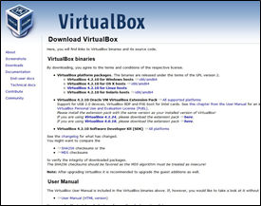
  - Save the file to your downloads directory.
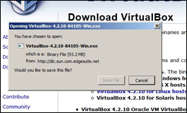
  - Open your download directory and double click on the VirtualBox executable, then follow the steps.
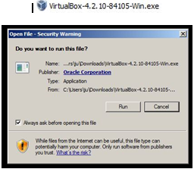
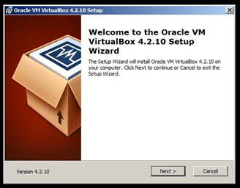
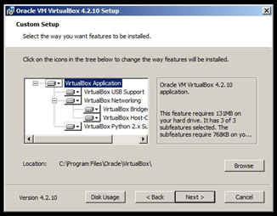
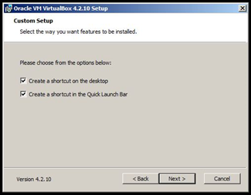
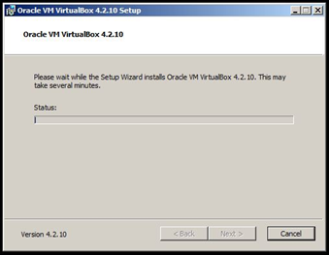
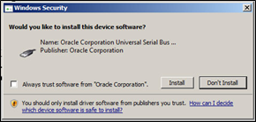
  - At this point you may receive some Windows security boxes popping up to ask you confirmation to install device software. Click the “install” button for all of these.
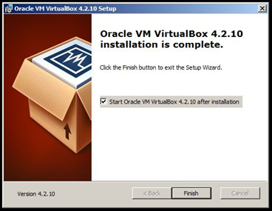
  - At this point VirtualBox has been installed. The Administration screen will be displayed. (Similar to the following)
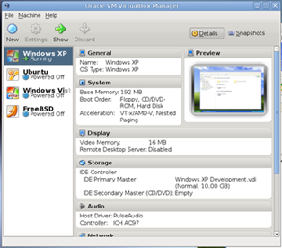
Install a Linux Image onto VirtualBox:
  - Next, Download a preconfigured Virtual Image from http://download.oracle.com/otn/other/virtualbox/dd/Oracle_Developer_Day.ova
  - Import your VM: File > Import Appliance to launch Appliance Import Wizard. Click Choose... to browse to the directory you re-assembled all the files in and select the Oracle Developer Day.ova then click Next> to begin importing the virtual machine. It will prompt you to agree to the appropriate developer licenses while importing. You will see 'Oracle Developer Days (Powered Off)' when it is finished importing.
  - Finally, Test your VM: Once the import has completed, double-click the OTN Developer Days VM. Click OK to close the Virtualbox Information dialogs. When you get to the Enterprise Linux 5 screen you can now login. (Username and password is oracle.) Allow the process to complete; it is ready when you see a terminal window, which you can close. Once you are finished working in the guest VM you can shut it down via System > Shut Down; this will return the guest VM to the Powered Off state.
Install a Webserver Image onto VirtualBox:
  - Next, Download a preconfigured Virtual Image from http://bitnami.com/stack/lamp/virtual-machine; Select LAMP Stack
  - Import your VM: File > Import Appliance to launch Appliance Import Wizard. Click Choose... to browse to the directory you re-assembled all the files in and select the *.ova then click Next> to begin importing the virtual machine.
  - Finally, Test your VM: Once the import has completed, double-click the VM. Click OK to close the Virtualbox Information dialogs. Once you are finished working in the guest VM you can shut it down via System > Shut Down; this will return the guest VM to the Powered Off state.
Capturing the Screen Image:
  - Press the PrntScn key to copy whole screen (Showing the VirtualBox Admin Screen) to the clipboard. Open Paint and paste in the image. Save it as a JPEG, with the filename Your Name IS211 – LAB 2-VM.
Reflection:
  - What are some of the benefits to using a virtualized environment? What are some of the risks? Include this in your lab write up.
  - How was your experience with this install? Did you have any issues?
Turning in your Project:
  - Include these things with your file:
    - A lab write up answering the questions in the reflection section.
    - The image you captured above, as an attachment
  - Submit to the dropbox, save a save for yourself.

