MOD 16

Question 1
Which of the following is a discrete random variable?
- Blood types for Boreal owls.
- Number of eggs found in a Boreal owl nest.
- Length of a Boreal owl egg.

Question 2
Select one answer.
10 points
The probability distribution gives the potential cost of routine maintenance and major repairs in the first 5 years you own a new car.
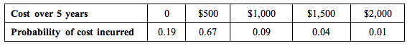
What is the expected cost of routine maintenance and major repairs for the 1st 5 years you own the car? (Recall: the expected value is the mean.)
- $101
- $505
- $1000

Question 3
Select one answer.
10 points
The US Bureau of Labor Statistics predicts the US economy will add more than 7,371,900 million jobs from 2012 to 2022. More importantly, of the occupations predicted to add jobs, 1,044,600 of those new jobs will likely come from the four highest paying occupations.
The number of new jobs predicted for each of the four highest paying occupations was used to compute the probabilities below.
Occupation | General and operations managers | Management analysts | Software developers, applications | Registered nurses
Probability | 0.234 | 0.128 | 0.134 | ?
Suppose we randomly select one of the new jobs. Is it more likely that the new job is from the occupation registered nurses, that the new job is from the occupation general and operations managers, or that the two events are equally likely?
- It is more likely that the new job is from the occupation general and operations managers.
- It is more likely that the new job is from the occupation registered nurses.
- These events are equally likely.

Question 4
Select one answer.
10 points
Consider the probability distribution of X, where X is the number of job applications completed by a college senior through the school’s career center.
X | 0 | 1 | 2 | 3 | 4 | 5 | 6 | 7
P(X) | 0.002 | 0.011 | 0.115 | 0.123 | 0.144 | 0.189 | 0.238 | 0.178
We collect a random sample of 1000 college seniors who complete job applications through the career center. Based on the probability distribution, which result would be surprising?
- 14 seniors completed 1 job application through the career centers.
- 15 seniors completed 2 job applications through the career center.
- 130 seniors completed 3 job applications through the career center.

Question 5
Select one answer.
10 points
A couple plans to have no more than three children, and they will keep having children until they have a girl. So, if their first child is a girl, they will stop and have only one child. However, if their first child is a boy, they will try again and have a second child.
As it turns out, the probability of having a boy is slightly greater than having a girl. Here is the probability distribution for the number of boys the couple could have.
Boys | 0 boys | 1 boy | 2 boys | 3 boys
Probability | 0.490 | 0.250 | 0.127 | 0.133
What is the probability that the couple will have at least 1 boy?
- 0.740
- 0.250
- 0.377
- 0.260
- 0.510

Question 6
Select one answer.
10 points
Consider the probability distribution of X, where X is the number of times a college graduate changed majors.
X | 0 | 1 | 2 | 3 | 4 | 5 | 6 | 7 | 8
P(X) | 0.135 | 0.271 | 0.271 | 0.180 | 0.090 | 0.036 | 0.012 | 0.003 | 0.002
What is the probability that a randomly selected college graduate has changed majors at most twice?
- 0.594
- 0.271
- 0.406
- 0.677

Question 7
Select one answer.
10 points
This data reflects Honda sales at a car dealership in Northern California.
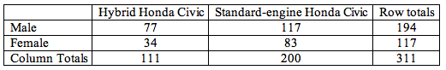
Is the probability that someone purchases a Hybrid Honda independent of whether the buyer is female? Which two proportions are NOT a useful comparison for addressing this question?
- 117 / 311 and 34 / 111
- 111 / 311 and 34 / 117
- 117 / 311 and 111 / 311

MOD 17

Question 1
Select one answer.
10 points
A battery has a lifetime that is approximately normally distributed with a mean of 600 hours and a standard deviation of 50 hours. Suppose you purchased one of these batteries and it only lasted for 400 hours. Which of the following conclusions is the most appropriate given this information?
- Your battery is likely defective since such poor performance is extremely unlikely.
- Your battery is definitely below average since it is below the mean.
- There is a 50-50 chance of a battery having a worse than average performance, so the performance of your battery is not surprising.

Question 2
Select one answer.
10 points
According to the World Health Organization (WHO) Child Growth Standards, the head circumference for boys at birth is normally distributed with a mean of 34.5cm and a standard deviation of 1.3cm. For girls, the mean is 33.9cm with a standard deviation of 1.2cm. Eddie and Sue are twins. Eddie was born with a head circumference of 33.2cm and Sue was born with a head circumference of 32.7cm.
Which child’s head circumference is smaller relative to other children of the same sex?
- Eddie
- Sue
- They are the same size relative to other children of the same sex.

Question 3
Select one answer.
10 points
The new science and math building on campus has four elevators each designed to carry a maximum of 8 people. A building safety study has found that the combined weight of 8 people can be modeled by a normal distribution with mean of 1400 pounds and a standard deviation of 120 pounds.
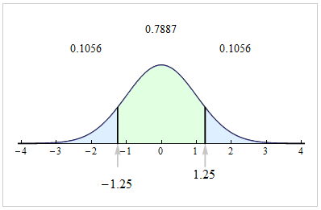
Using the figure of a standard normal distribution, is the following statement valid or not valid?
We would expect the total weight of 8 people to be more than 1500 pounds less than 10% of the time.
- valid
- not valid

Question 4
Select one answer.
10 points
Given the graph of the normal curve shown below with a mean = 35, what is the corresponding standard deviation?
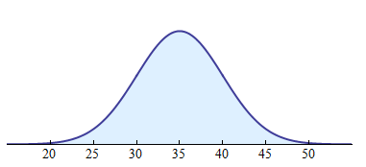
- 10
- 15
- 5
MOD 18

Question 1
Select one answer.
10 points
Pregnancy length (in days) is a normally distributed random variable with a mean of 266 days and a standard deviation of 16 days. Births that occur before 245 days are considered premature. What is the probability that a randomly selected newborn baby is premature?
Click here to open the applet.
- About 19% of babies
- About 9.5% of babies
- About 90.5% of babies

Question 2
Select one answer.
10 points
Which of the following is a discrete random variable for a randomly selected person in the U.S.?
- blood type
- number of pets owned
- weight

Question 3
Select one answer.
10 points
Light bulbs used for the exterior walkways of a college campus have an average lifetime of 500 hours. Assume that the lifetime of bulbs is normally distributed with standard deviation 50 hours. Suppose all of the bulbs were replaced at the same time and they have been turned on for a total of 550 hours. What is the probability that a randomly chosen light bulb lasts less than 550 hours?
- 16%
- 68%
- 84%
- 95%

Question 4
Select one answer.
10 points
Which of the following is the standard deviation of the normal probability curve shown below?
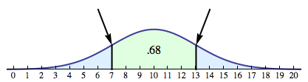
- 7
- 3
- 6

Question 5
Select one answer.
10 points
Assume that the distribution of weights of adult men in the United States is normal with mean 190 pounds and standard deviation 30 pounds. Bill’s weight has a z-score of 1.5.
Which of the following is true?
- Bill’s weight is in the upper 2.5% of men’s weights.
- Bill weighs less than 220 pounds.
- Bill weighs more than 230 pounds.

Question 6
Select one answer.
10 points
Which of the following is the appropriate interpretation for when an event has a probability of 1?
- We are absolutely certain that the event will occur.
- The event will never occur.
- The relative frequency will be more than 1.

Question 7
Select one answer.
10 points
We created a probability distribution with data from a survey of 1200 college students. The variable is the student’s perception of his or her body weight.
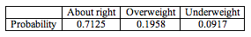
What is the probability that a randomly selected student does not feel their body weight is “about right?”
- 0.7125
- 0.1958
- 0.2875

Question 8
Type numbers in the boxes.
10 points
Consider the probability distribution of X, where X is the number of job applications completed by a college senior through the Career Center before getting a job.
X | 0 | 1 | 2 | 3 | 4 | 5 | 6 | 7
P(X) | 0.002 | 0.011 | 0.115 | 0.123 | 0.144 | 0.189 | 0.238 | 0.178
What is the probability that a randomly selected college senior who uses the career center completed at most one job application? Report your answer to three decimal places.

Question 9
Type numbers in the boxes.
10 points
Consider the probability distribution of X, where X is the number of job applications completed by a college senior through the Career Center before getting a job.
X | 0 | 1 | 2 | 3 | 4 | 5 | 6 | 7
P(X) | 0.002 | 0.011 | 0.115 | 0.123 | 0.144 | 0.189 | 0.238 | 0.178
What is the probability that a randomly selected college senior who uses the career center completed at least one job application? Report your answer to three decimal places.

Question 10
Select one answer.
10 points
We want to determine if the probability that a student feels overweight is independent of gender.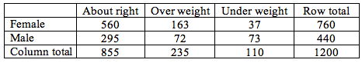
Which of the following pairs of probabilities is NOT a useful comparison?
- 235 / 1200 and 760 / 1200
- 235 / 1200 and 163 / 760
- 760 / 1200 and 163 / 235
- 440 / 1200 and 72 / 235
MOD 19
Community college tuition: In an ABC News/Washington Post Poll in January 2015, 1,003 adults nationwide answered the following question, “Obama has proposed providing free tuition to attend community colleges at a cost to the federal government of sixty billion dollars over 10 years. Do you support or oppose this proposal?” 53% supported the proposal with a margin of error of 3.5% at a 95% level of confidence.
http://www.washingtonpost.com/politics/polling/washington-postabc-news-poll-january-1215/2015/01/22/9eba07b0-9f19-11e4-91fc-7dff95a14458_page.html
Which of the following statements is correct about the 95% confidence interval?
- We are 95% confident that between 46% and 60% of all adults nationwide will support the free community college tuition proposal.
- We are 95% confident that between 49.5% and 56.5% of all adults nationwide will support the free community college tuition proposal.
- We are 95% confident that 53% of the 1,003 adults in the sample will support the free community college tuition proposal.
- We are confident that 95% of the 1,003 adults in the sample will support the free community college tuition proposal.

Question 2
Select one answer.
10 points
STD study: A 2008 CDC study estimated that 26% of young women between the ages of 14 and 19 in the U.S. were infected with at least one of the most common sexually transmitted diseases (human papillomavirus [HPV]), chlamydia, herpes simplex virus, and trichomoniasis). Is the percentage higher in your community?
Suppose that we plan to select a random sample of 100 young women in your community. If we use the national figure of 26%, we estimate that the standard error is about 0.04 for results from random samples of 100 young women.
When we select a random sample of 100 young women in your community, we find that 20% are infected with at least one of the most common STDs. Which gives the best interpretation of the 95% confidence interval to estimate the percentage of young women in your community who are infected with at least one of the most common STDs?
- We are 95% confident that 20% of the young women in your community are infected with at least one of the most common STDs.
- We are 95% confident that 16% to 24% of the young women in your community are infected with at least one of the most common STDs.
- We are 95% confident that 12% to 28% of the young women in your community are infected with at least one of the most common STDs.
- We are 95% confident that 18% to 34% of the young women in your community are infected with at least one of the most common STDs.

Question 3
Select one answer.
10 points
Tutoring Services: The Community College Survey of Student Engagement reports that 46% of the students surveyed rarely or never use peer or other tutoring resources. Suppose that in reality 40% of community college students never use tutoring services available at their college.
In a simulation we select random samples from a population in which 40% do not use tutoring. For each sample we calculate the proportion who do not use tutoring.
For which of the following sample sizes will a normal model be a good fit for the sampling distribution?
- Any sample size
- All sample sizes greater than 20
- All sample sizes greater than 25

Question 4
Select one answer.
10 points
SAT scores: According to the College Board website, 1,672,395 students from the class of 2014 took the SAT, a globally recognized college admissions test. The mean mathematics score was 513 with a standard deviation of 120.
SAT College Board 2014 College Bound Seniors Total Group Profile Report (2014). College Board. http://research.collegeboard.org/programs/sat/data/cb-seniors-2014
True or false? The mean mathematics score of 513 is a statistic, representing the mean score for the sample of 1,672,395 students.
- True
- False

Question 5
Select one answer.
10 points
Tutoring Services: The Community College Survey of Student Engagement reports that 46% of the students surveyed rarely or never use peer or other tutoring resources. Suppose that in reality 40% of community college students never use tutoring services available at their college. In a simulation we select random samples from a population in which 40% do not use tutoring. For each sample we calculate the proportion who do not use tutoring.
If we randomly sample 500 students at a time, what will be the mean and standard error of the sampling distribution of sample proportions?
- mean = 0.46, SE = 0.00048
- mean = 0.40, SE = 0.022
- mean = 0.40, SE = 0.00048
- mean = 0.46, SE = 0.022

Question 6
Select one answer.
10 points
Smartphone use: In a Pew Research report titled, “U.S. Smartphone Use in 2015” the author states that 48% of smartphone-dependent Americans had to cancel or shut off their cell phone service for a period of time because the cost of maintaining that service was a financial hardship. “Smartphone dependent” is defined as owning a smartphone, but lacking any other type of high-speed access at home and having limited options for going online other than their cell phone.
Let’s assume this is true and set up a simulation to randomly sample 50 adults from this population. For each sample, we calculate the proportion of smartphone-dependent adults who had to cancel or shut off their cell phone service. We’ll repeat this process 1,000 times. The dotplot of the resulting 1,000 proportion calculations is displayed below.
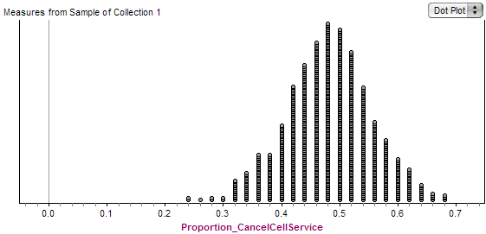
Now suppose that we randomly select another sample of 50 adults from this population. We find that 64% (32 out of 50) had to cancel or shut off their cell phone service.
What can we conclude from the sampling distribution?
- This result is not surprising because we expect to see many samples with more than 64% who had to cancel or shut off their cell phone service.
- This result is not surprising because random samples are expected to vary.
- This result is surprising because it is unlikely that 64% of a random sample had to cancel or shut off their cell phone service if we choose from a population with only 48% who had to cancel or shut off their cell phone service.
- This result is surprising because we expect only 48% of the sample who had to cancel or shut off their cell phone service.

Question 7
Select one answer.
10 points
Tutoring Services: The Community College Survey of Student Engagement reports that 46% of the students surveyed rarely or never use peer or other tutoring resources. Suppose that in reality 40% of community college students never use tutoring services available at their college.
In a simulation we select 3 random samples of 500 community college students.
True or false? In each sample, we expect to see 200 (40% of 500) of the student do not use college tutoring services.
- True
- False

Question 8
Select one answer.
10 points
Tutoring Services: The Community College Survey of Student Engagement reports that 46% of the students surveyed rarely or never use peer or other tutoring resources. Suppose that in reality 40% of community college students never use tutoring services available at their college. In a simulation we select random samples from a population in which 40% do not use tutoring. For each sample we calculate the proportion who do not use tutoring.
If we randomly sample 100 students from this population, the standard error is approximately 5%. Would it be unusual to see 46% who do not use tutoring in a random sample of 100 students?
- Yes, this would be unusual because 46% is more than one standard error from the mean. It is very rare for a sample to be more than one standard error from mean.
- Yes, this would be unusual because 46% is 6% higher than 40%.
- No, this would not be unusual because the error is only 6%.
- No, this would not be unusual because 46% is only 1.2 standard errors from 40%.

Question 9
Select one answer.
10 points
Living at Home: According to a 2011 report from the U.S. Census, 59% of young men (age 18-24) are living at home with their parents. Is the percentage lower in your community?
Suppose that we select a random sample of 100 young men from your community. We can use a normal model for the sampling distribution because the conditions are met. We expect 59 of the 100 to be living at home and 41 to not be living at home. So we can find the Z-score and use the applet to assess the evidence provided by the data. (The standard error is about 0.049.) Here is a link to the applet.
Suppose that in a random sample of 100 young men from your community half are living at home. True-or-false? We can conclude that the percentage of all young men in your community who are living at home is not less than 59%.
- True
- False

Question 10
Select one answer.
10 points
STD study: A 2008 CDC study estimated that 26% of young women between the ages of 14 and 19 in the U.S. were infected with at least one of the most common sexually transmitted diseases (human papillomavirus [HPV]), chlamydia, herpes simplex virus, and trichomoniasis). Is the percentage higher in your community?
Suppose that we select a random sample of 25 young women from your community. We cannot use a normal model for the sampling distribution because one of the conditions is not met since n(1-p) is not 10 or greater. That is, 0.26(25) = 6.5. Thus, we ran a simulation with p = 0.26 and n = 25.
Suppose that the sample of 25 young women from your community has 8 who are infected with at least one of the most common STDs. This is 32% of the sample.
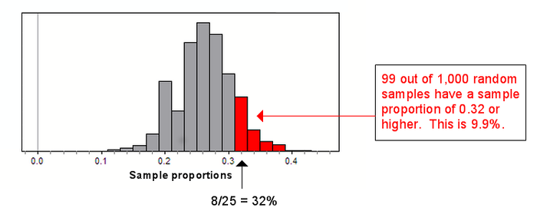
Centers for Disease Control and Prevention Press Release (2008) http://www.cdc.gov/stdconference/2008/press/release-11march2008.htm
Does the data suggest that the percentage of young women infected with at least one of the most common STDs in your community is higher than 26%?
- Yes, because 32% is an error of 6%.
- Yes, because it is unlikely that 32% or more of the sample of 25 young women will be infected with at least one of the most common STDs, given the population percentage is 26%.
- No, because it is not surprising to see 32% or more of the sample of 25 young women will be infected with at least one of the most common STDs, given the population percentage is 26%
- No, because we expect results from random samples to vary. Thus, 32% is not surprising.

MOD 20

Question 1
Select one answer.
10 points
The National Sleep Foundation sponsors an annual poll. In a March 2011 press release they stated “... 63% of Americans say their sleep needs are not being met during the week.” The following is an excerpt from the Poll Methodology and Definitions section of the article.
“The 2011 Sleep in America® annual poll was conducted for the National Sleep Foundation by WB&A Market Research, using a random sample of 1,508 adults between the ages of 13-64. The margin of error is 2.5 percentage points at the 95% confidence level.”
Which of the following statements is correct?
- We are 95% confident that 63% of Americans say their sleep needs are not being met during the week.
- We are 95% confident that between 60.5% and 65.5% of Americans say their sleep needs are not being met during the week.
- We are 95% confident that between 63% and 65.5% of Americans say their sleep needs are not being met during the week.
- We are confident that 95% of the 1,508 adults in the sample say their sleep needs are not being met during the week.

Question 2
Select one answer.
10 points
Teen obesity: The 2013 National Youth Risk Behavior Survey (YRBS) reported that 13.7% of U.S. students in grades 9 through 12 who attend public and private school were obese. Suppose that 15% of a random sample of 300 U.S. public high school students were obese.
Kann, L., Kinchen, S., Shanklin, S.L., Flint, K.H., Hawkins, J., Harris, W.A., et. al.(2013) YRBS 2013 Report. http://www.cdc.gov/healthyyouth/yrbs/index.htm
Using the estimate from the 2013 YRBS, we calculate a standard error of 0.020. Since the data allows the use of the normal model, we can determine an approximate 95% confidence interval for the percentage of all U.S. public high school students who are obese. Which interval is the approximate 95% confidence interval?
- 0.097 to 0.177
- 0.117 to 0.157
- 0.110 to 0.190
- 0.013 to 0.170

Question 3
Select one answer.
10 points
Single adults: According to a Pew Research Center analysis of census data, in 2012, 20% of American adults ages 25 and older had never been married. Is the percentage higher for American men compared to all American adults? Suppose that we select a random sample of 100 male adults.
Suppose that 26% of our sample of 50 men had never been married.
Note: The conditions are met for use of a normal model since we expect about 13 of the 50 sample (26% of 50) had never been married while 37 had been married. Both expected counts are at least 10.
Find the z-score and use the applet to assess the evidence provided by the data. The standard error is about 0.057) Here is a link to the applet.
True or false? We can conclude that the percentage of men who had never been married is greater than 20%
Wang, W. and Parker, K. (2014). Record Share of Americans Have Never Been Married. Pew Research Center. http://www.pewsocialtrends.org/2014/09/24/record-share-of-americans-have-never-married/.
- True
- False

Question 4
Select one answer.
10 points
Adult diabetes: A National Center for Health Statistics data brief states that in 2013 9% of U.S. adults aged 18 and over have diagnosed diabetes.
Suppose that this year, we select a random sample of 100 adults. The conditions are not met for use of a normal model since the expected number of adults with diagnosed diabetes is only 9 (9% of 100). Therefore, we ran a simulation with p = 0.09.
Suppose that the sample has 15 adults (or 15%) who have diagnosed diabetes.
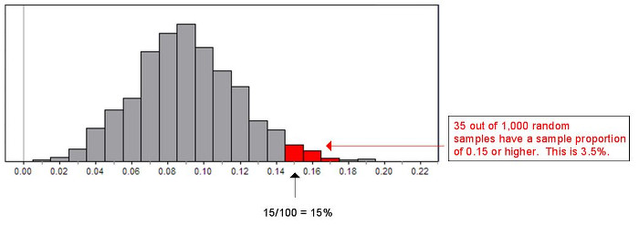
Does the data suggest that the percentage of U.S. adults is higher than 9% this year?
Villarroel MA, Vahratian A, Ward BW. (2015) Health Care Utilization Among U.S. Adults With Diagnosed Diabetes. National Center for Health Statistics. http://www.cdc.gov/nchs/data/databriefs/db183.htm
- Yes, because 15% of the sample of adults have diagnosed diabetes, which is higher than 9%.
- Yes, because sample proportions of 15% or more are unusual, given the population proportion is 9%.
- No, because sample proportions of 15% or more are not unusual if the proportion of adults with diagnosed diabetes is 9%.
- No, because 3.5% of adults are diagnosed with diabetes this year, which is much lower than 9%.

