Individual Assignment

Due March 21, 2019 (submission via Bb assignment link ONLY)

Objective 1: Learn to analyze the consumer decision making process using Multi-attribute Attitude Model

Objective 2: Learn to analyze retailer’s financial performance using income statement, balance sheet and strategic profit model.

- Construct a multi-attribute model for ONE purchase decision of your choice

Below is an Example of Multi-attribute Model

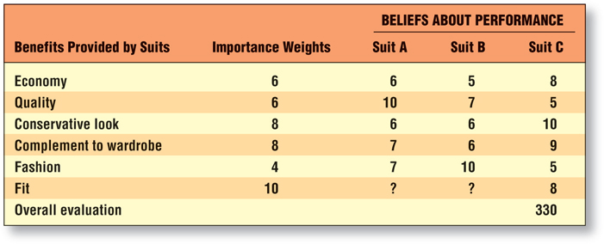

- Given the following information, construct an income statement for the Neiman Marcus Group, Inc. and determine if there was a profit or loss in 2001 (Figures are in $000).

Sales $3,015,534
Cost of Goods Sold $2,020,954
Operating Expenses $ 193,628
Interest Expense $ 15,188
Taxes $ 67,807

Hint: please provide both columns in dollar amount and in percentage.

- Using the following information taken from the 2001 balance sheet and 2001 income statement for Lands’ End, Inc., develop a strategic profit model (figures are in $000).

Sales $1,448,230
Cost of Goods Sold 758,792
Operating Expenses 575,662
Interest Expense 1,350
Inventory 227,220
Accounts Receivable 13,297
Other Current Assets 162,067
Accounts Payable 83,363
Notes Payable 0
Other Current Liabilities 102,201
Fixed Assets 196,536
Long-term Liabilities 0

Follow these steps for question #2:
- make an income statement and calculate net profit margin
- calculate total asset and asset turnover
- Calculate return on asset.

