The degree of the polynomial function f(x) is 4.
The roots of the equation f(x)=0 are −6, −2, 1, and 3.
Which graph could be the graph of f(x)?

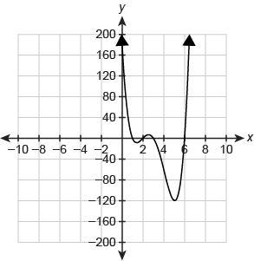

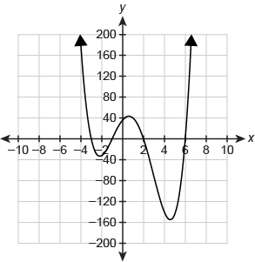
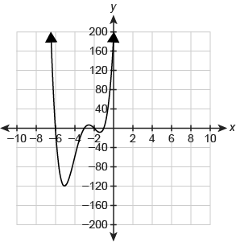
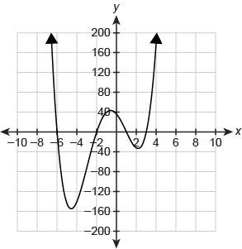

The degree of the polynomial function f(x) is 3.
The roots of the equation f(x)=0 are −1 , 0, and 4.
Which graph could be the graph of f(x) ?

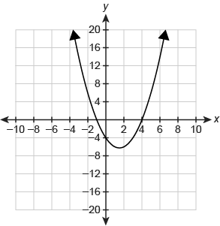
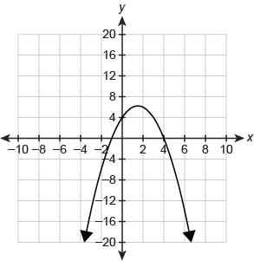
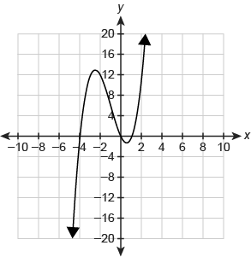
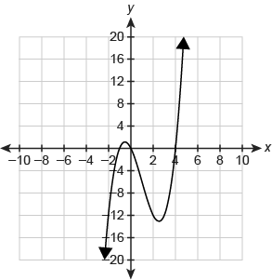

Which graph represents the polynomial function g(x)=x^3+x^2−17x+15?

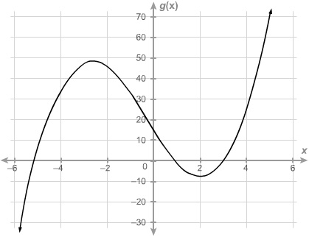
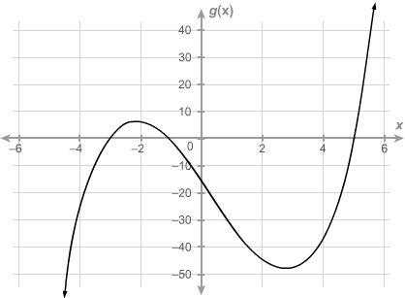
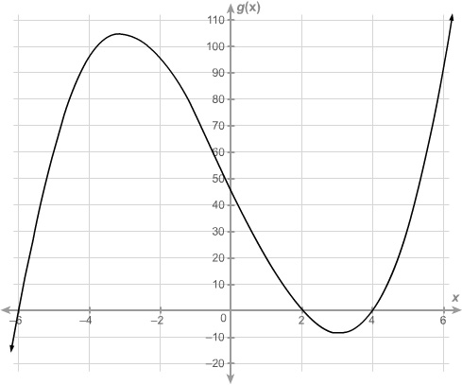
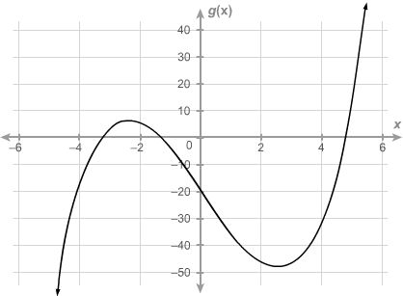

Which graph represents the polynomial function f(x)=x^3+3x^2−10x−24?

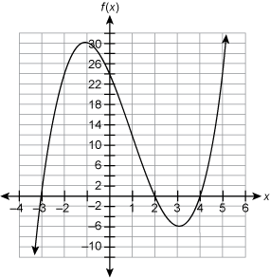
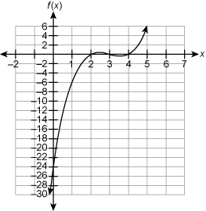
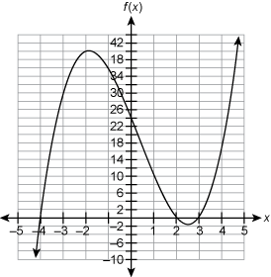
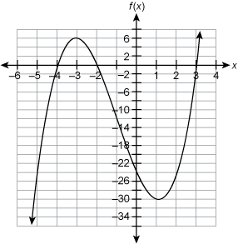

Which graph represents the function f(x)=x^4+8x^3+6x^2−40x+25?

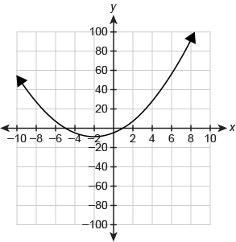
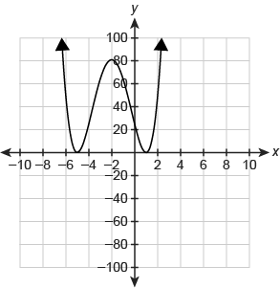
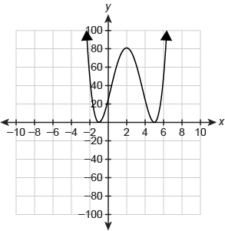
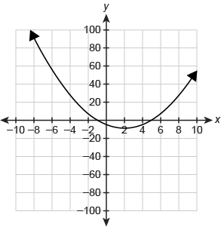

How many complex roots does the polynomial equation have?
5x^3−4x+1=0

Which answer best describes the complex zeros of the polynomial function?
f(x)=x^4−3x^3+5x^2−27x−36

The function has 4 real zeros. The graph of the function intersects the x-axis at exactly 4 locations.
The function has 4 non-real zeros. The graph of the function does not intersect the x-axis.
The function has 1 real zero and 3 non-real zeros. The graph of the function intersects the x-axis at exactly 1 location.
The function has 2 real zeros and 2 non-real zeros. The graph of the function intersects the x-axis at exactly 2 location

How many complex roots does the equation f(x)=4x^4−x^3−5x+3 have?

3

4

5

6

What is the completely factored form of f(x)=x^3−7x^2+2x+4?

f(x)=(x−1) (x−(3+52−−√)) (x−(3−52−−√))
f(x)=(x+1) (x−(3+13−−√)) (x−(3−13−−√))
f(x)=(x+1) (x−(3+52−−√)) (x−(3−52−−√))
f(x)=(x−1) (x−(3+13−−√)) (x−(3−13−−√))

What is the complete factorization of the polynomial function over the set of complex numbers?
f(x)=x^3−4x^2+4x−16

