- The table shows ordered pairs for a polynomial function, f.
x | f(x)
−3 | −32
−2 | −9
−1 | 0
0 | 1
1 | 0
2 | 3
3 | 16
What is the degree of f?

Enter your answer in the box.

Which graph represents f(x)=1/2x2 ?
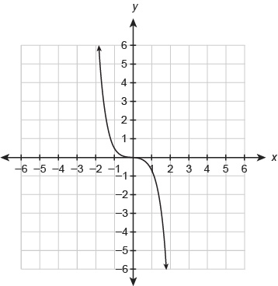
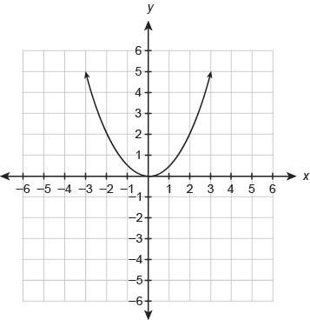
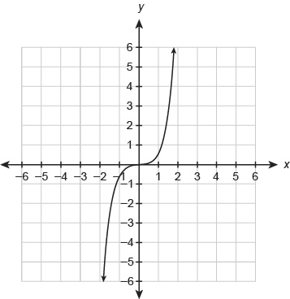
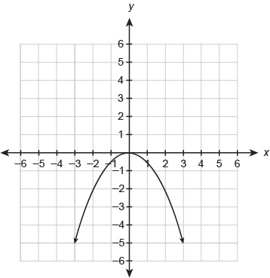

3. Which graph represents f(x)=x^6 ?
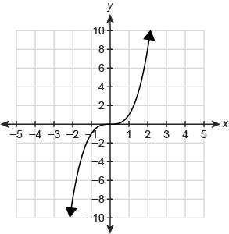
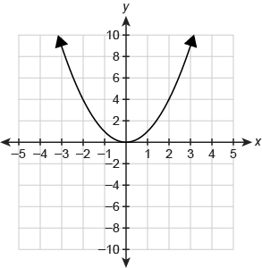
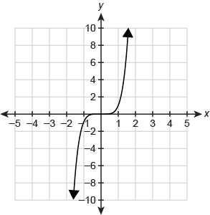
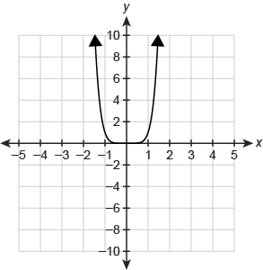

4. Anjelica is using synthetic division to divide 2x^3−9x^2−21x+10 by x+2 .

Which answer is correct?

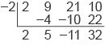
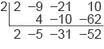
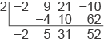
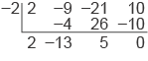

5. Is the binomial a factor of the polynomial function?

f(x)=x^3+4x^2−9x−36

Select Yes or No for each binomial.
 | Yes | No
(x−1)
(x−3)
(x+3)
(x−4)
(x+4)

6. Which statements are true about the polynomial function?

f(x)=x^3+5x^2+6x

Select each correct answer.

. (x+2) is a factor of f(x).
f(x)=0 when x=2
f(x) divided by (x−2) has a remainder of 0.
f (−2) =0

7. One of the zeros of the polynomial function is 3.
f(x)=x^4−x^3−7x^2+x+6

What is the factored form of the function?

f(x)=(x−3) (x+1) (x+2)2
f(x)=(x−3) (x+1)2(x+2)
f(x)=(x−3)2(x+1) (x+2)
f(x)=(x−3) (x+1) (x−1) (x+2)

8. What are the zeros of the polynomial function?
f(x)=x^4−2x^3−103x^2+200x+300
Select each correct answer.

−10
−3
−1
0
3
10
9. Enter the number of complex zeros for the polynomial function in the box.

f(x)=x^3−96x^2+400

10. Factor the polynomial function.

f(x)=x^4+3x^2−4

Enter your answer in the box.
f(x) =

