Graph y = log₅x and its inverse.

A. 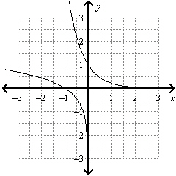

B. 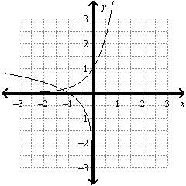

C. 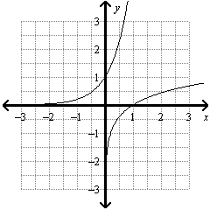

D. 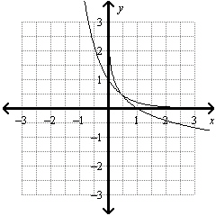

Question 2 of 20
0.0/ 5.0 Points
Write the equation in logarithmic form.
2⁵ = 32

A. log32 = 5 • 2

B. log₂32 = 5

C. log32 = 5

D. log₅32 = 2

Question 3 of 20
0.0/ 5.0 Points
Use natural logarithms to solve the equation. Round to the nearest thousandth.
6e^{4x} - 2 = 3

A. –0.448

B. 0.327

C. 0.067

D. –0.046

Question 4 of 20
0.0/ 5.0 Points
Use the graph of y = e^{x} to evaluate e^{1.7} to four decimal places.

A. 5.4739

B. 4.6211

C. 2.7183

D. 0.1827

Question 5 of 20
0.0/ 5.0 Points
Graph the exponential function.
y = 4^{x}

A. 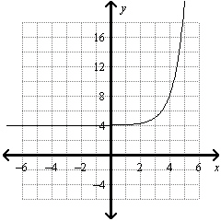

B. 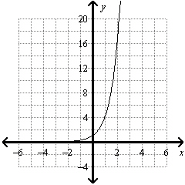

C. 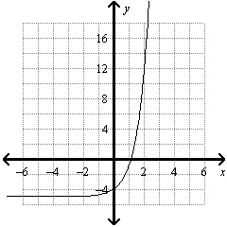

D. 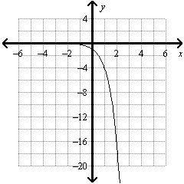

Question 6 of 20
0.0/ 5.0 Points
The generation time G for a particular bacteria is the time it takes for the population to double. The bacteria increase in population is shown by the formula 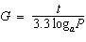, where t is the time period of the population increase, a is the number of bacteria at the beginning of the time period, and P is the number of bacteria at the end of the time period. If the generation time for the bacteria is 6 hours, how long will it take 8 of these bacteria to multiply into a colony of 7681 bacteria? Round to the nearest hour.

A. 177 hours

B. 76 hours

C. 4 hours

D. 85 hours

Question 7 of 20
0.0/ 5.0 Points
Write the expression as a single natural logarithm.
3ln3 + 3lnc

A. ln(27 + c³)

B. ln9c³

C. ln27c

D. ln27c³

Question 8 of 20
0.0/ 5.0 Points
Evaluate the logarithm
log₅25

A. 1

B. -2

C. 5

D. 2

Question 9 of 20
0.0/ 5.0 Points
Write the equation in exponential form.
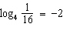

A.

B. 4² = 16

C.

D. 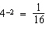

Question 10 of 20
0.0/ 5.0 Points
Graph the exponential function.
y = 3(1.9)^{x}

A. 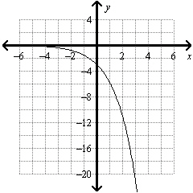

B. 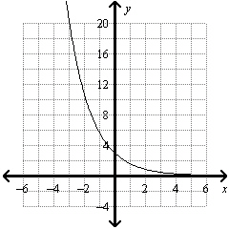

C. 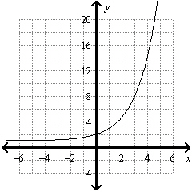

D. 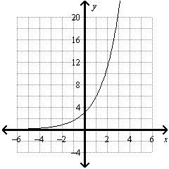

Question 11 of 20
0.0/ 5.0 Points
Solve 15^{2x} = 36. Round to the nearest ten-thousandth.

A. 0.6616

B. 2.6466

C. 1.7509

D. 1.9091

Question 12 of 20
0.0/ 5.0 Points
Write the expression as a single natural logarithm.
3 ln x - 2 ln c

A.

B. ln(x³ + c²)

C. ln(x³ - c²)

D. lnx³c²

Question 13 of 20
5.0/ 5.0 Points
Graph the exponential function.

A.
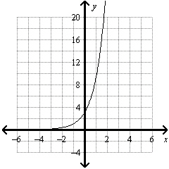

B.
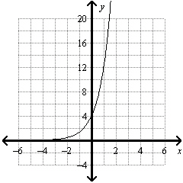

C.
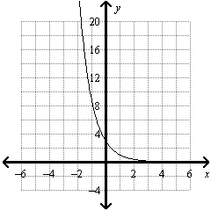

D.
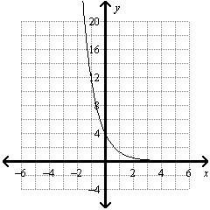

Question 14 of 20
0.0/ 5.0 Points
Evaluate the logarithm
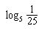

A. 2

B. -2

C. -1

D. 5

Question 15 of 20
5.0/ 5.0 Points
The half-life of a certain radioactive material is 71 hours. An initial amount of the material has a mass of 722 kg. Write an exponential function that models the decay of this material. Find how much radioactive material remains after 17 hours. Round your answer to the nearest thousandth.

A. 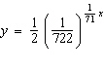; 0.103 kg

B. 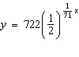; 611.589 kg

C. 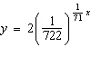; 0.414 kg

D. 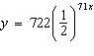; 0 kg

Question 16 of 20
0.0/ 5.0 Points
Expand the logarithmic expression.
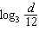

A. log₃d - log₃12

B. 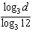

C. -dlog₃12

D. log₃12 - log₃d

Question 17 of 20
0.0/ 5.0 Points
Graph the function.
y = 7(6)^{x+2} + 1

A. 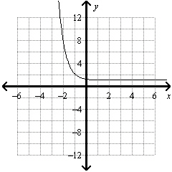

B. 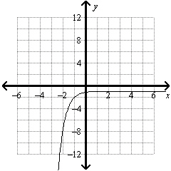

C. 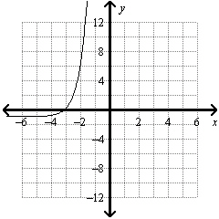

D. 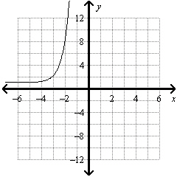

Question 18 of 20
0.0/ 5.0 Points
Graph the function.
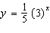

A. 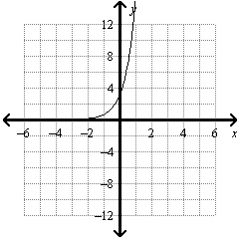

B. 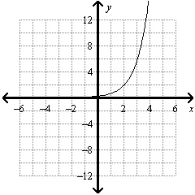

C. 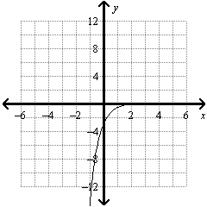

D. 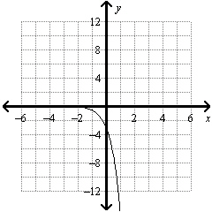

Question 19 of 20
0.0/ 5.0 Points
Graph the logarithmic equation.
y = log₅x

A. 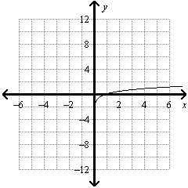

B. 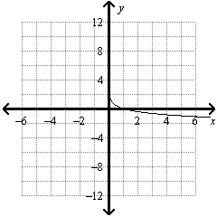

C. 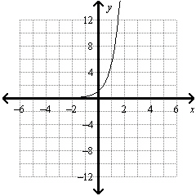

D. 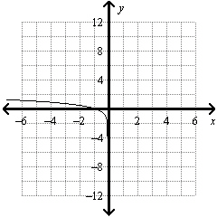

Question 20 of 20
0.0/ 5.0 Points
Graph and its inverse.

A. 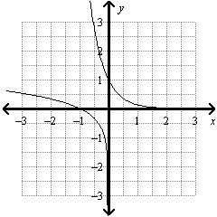

B. 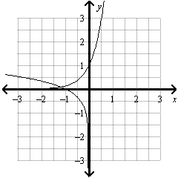

C. 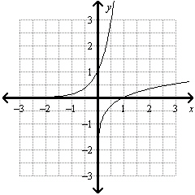

D. 