Score: ______ / ______

Name: _____________________________
Student Number: ____________________

Answer the questions below. Make sure to show your work and provide complete geometric explanations for full credit.

1 | Label the net for the figure below with its dimensions.  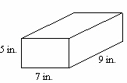  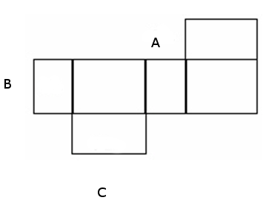  - __________  - __________  - __________
2 | Name four rays shown.  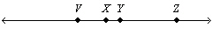
3 | You live in Carson City, Nevada, which has approximate (latitude, longitude) coordinates of (39N, 120W). Your friend lives in Ottawa, Ohio, with coordinates of (41N, 84W). You plan to meet halfway between the two cities. Find the coordinates of the halfway point. Show your work.
4 | Write the conditional statement that the Venn diagram illustrates.  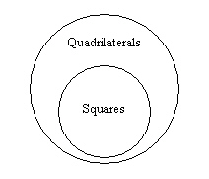
5 | Is the following conditional true or false? If it is true, explain why. If it is false, give a counterexample.  If it is snowing in Dallas, Texas, then it is snowing in the United States.
6 | What is the value of x? Justify each step using proof reasoning.  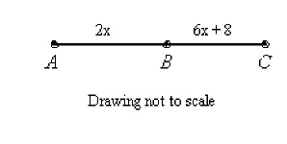  AB + BC = AC a.__________________________  2x + 6x + 8 = 32 b. __________________________  8x + 8 = 32 c. __________________________  8x = 24 d. __________________________  X = 3 e. __________________________
7 | Give the missing reasons in this proof of the Alternate Interior Angles Theorem.  Given:  Prove:  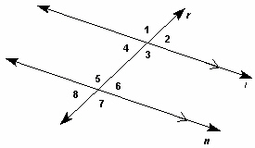  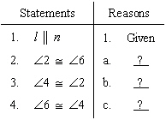  - ________________________  - ________________________  - ________________________
8 | Based on the given information, can you conclude that $∆QRS≅∆TUV$ ? Explain.  Given: $\overline{QR}≅\overline{TU}, \overline{QS}≅\overline{TV}$ and , prove $∆QRS≅∆TUV$
9 | Write the missing reasons to complete the proof.  Given: , , and  Prove:  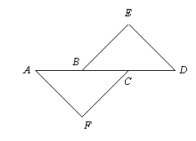  Step 5: _______________  Step 8: _______________
  Statement | Reason
  1. | 1. Given
  2. | 2. Given
  3. | 3. Given
  4. | 4. Definition of congruent segments
  5. | 5. ?
  6. | 6. Segment Addition Postulate
  7. | 7. Definition of congruent segments
  8. | 8. ?
10 | Fill in the missing reasons to complete the proof.  Given: , UY || TX  Prove:  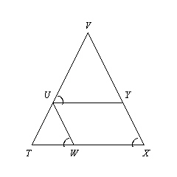  Step 3: ________________  Step 6: ________________
  Statement | Reason
  1. | 1. Given
  2. 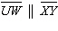 | 2. Converse of the Corresponding Angles Postulate
  3. | 3. ?
  4. | 4. Given
  5. | 5. Transitive Property
  6. | 6. ?
11 | Is by HL? If so, name the legs that allow the use of HL.  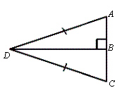
12 | Complete the proof by providing the missing reasons.  Given: ,  Prove:  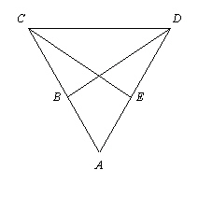  Step 3: ____________________  Step 4: ____________________  Step 5: ____________________
  Statement | Reason
  1. , , and | 1. Given
  2. are right angles | 2. Definition of perpendicular segments
  3. | 3. ?
  4. | 4. ?
  5. | 5. ?
13 | Write a paragraph proof to show that .  Given: and  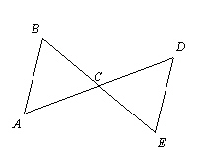
14 | Given: is the perpendicular bisector of IK. Name two lengths that are equal.  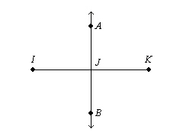
15 | Li went for a mountain-bike ride in a relatively flat wooded area. She rode for 6 km in one direction and then turned and pedaled 16 km in another. Finally she turned in the direction of her starting point and rode 8 km. When she stopped, was it possible that Li was back at her starting point? Explain.
16 | Find the measures of ∠PMN and ∠NMR if bisects ∠PMR. The measure of ∠PMR is 136°. Explain your answer.
17 | Judging by appearance, classify the figure in as many ways as possible using rectangle, square, quadrilateral, parallelogram, rhombus. Please justify your answers  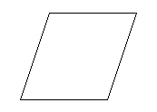
18 | For a regular n-gon:  a. What is the sum of the measures of its angles?  b. What is the measure of each angle?  c. What is the sum of the measures of its exterior angles, one at each vertex?  d. What is the measure of each exterior angle?  e. Find the sum of your answers to parts b and d. Explain why this sum makes sense.  a.  b.  c.  d.  e.
19 | Find the midpoint of each side of the trapezoid. Connect the midpoints. What is the most precise classification of the quadrilateral formed by connecting the midpoints of the sides of the trapezoid?  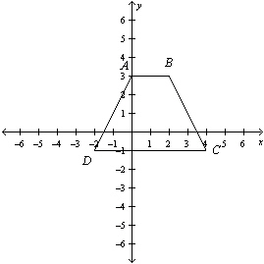
20 | Use the Distance Formula and the x-axis of the coordinate plane. Show why the distance between two points on a number line (the x-axis) is | a – b |, where a and b are the x-coordinates of the points.

