MATH 115 QUIZ 2 July, 2017 Instructor: I. Izmirli

NAME: _______________________________

I have completed this assignment myself, working independently and not consulting anyone except the instructor.

INSTRUCTIONS
- The quiz is worth 100 points. There are 10 problems.
- Each problem is worth 10 points
- This quiz is open book and open notes. This means that you may refer to your textbook, notes, and online classroom materials, but you must work independently and may not consult anyone (and confirm this with your submission). You may take as much time as you wish, provided you turn in your quiz no later than Sunday, July 9.
- Show work/explanation. Answers without any work may earn little, if any, credit. You may type or write your work in your copy of the quiz, or if you prefer, create a document containing your work. Scanned work is acceptable also. In your document, be sure to include your name and the assertion of independence of work.
- General quiz tips and instructions for submitting work are posted in the Quizzes module.
- If you have any questions, please contact me by e-mail.

1. Which of the following equations does the graph represent?
A. $y=-\frac{4}{3}x+8$  B. $y=-\frac{3}{4}x+6$  C. $y=\frac{3}{4}x+6$  D. $y=\frac{4}{3}x+6$ | 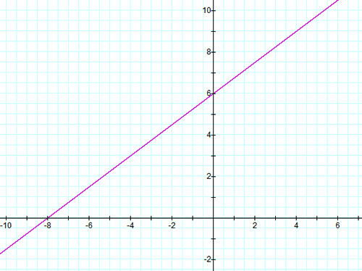

2. Consider the points (– 2, 1) and (4, -3).
(a) Find the slope-intercept equation of the line passing through the two given points. Show work.

(b) Graph the line you found in (a).

3. Find the equation of the line that passes through the point (1, 1) and is perpendicular to the line you obtained in problem 2

4. The amount of gas g in gallons in a car's gas tank t days after a fill-up is modeled by g(t) = –0.5t² – 1.5t + 20 for 0 ≤ t ≤ 4.
Find and interpret the average rate of change of g over the interval [0, 4].

5. Look at the graph of the quadratic function and complete the table.
Graph | Fill in the blanks | Equation
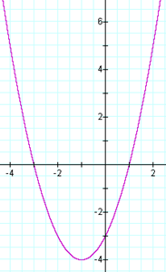 | (a) State the vertex:  ____________  (b) State the range:  _____________  (c) State the interval on which the function is increasing:  _____________ | (d) The graph represents which of the following equations?  Choice:____  A. y = –x² + 4x – 3  B. y = –2x² – x + 3  C. y = x² – 2x – 3  D. y = x² + 2x – 3

6. Look at the graph of the polynomial function and complete the table.
Graph | Fill in the blanks
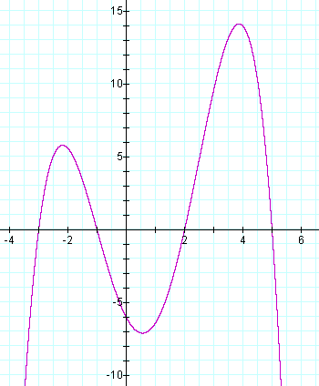 | (a) State the y-intercept: ________________  (b) State the real-number zeros:  ___________________  (c) Is the degree of the polynomial odd or even? (choose one)  (d) Is the leading coefficient of the polynomial positive or negative? (choose one)  (e) The graph represents which of the following polynomials, shown in factored form? Choice:____  A. f (x) = – 0.2(x + 3)(x + 1)(x – 2)(x –5)  B. f (x) = 0.2(x + 3)(x + 1)(x – 2)(x –5)  C. f (x) = – 0.2(x –3)(x – 1)(x + 2)(x + 5)  D. f (x) = 0.03(x – 6)(x –3)(x – 1)(x + 2)(x + 5)

7. Solve the inequality x² ≥ 3x and write the solution set in interval notation.

A. (–∞, 3]
B. (–∞, 0] ∪ [3, ∞)
C. (–∞, 3] ∪ [0, ∞)
D. [0, 3]

8. For f (x) = x³ – x² – 2, use the Intermediate Value Theorem to determine which interval must contain a zero of f.
A. Between 0 and 1
B. Between 1 and 2
C. Between 2 and 3
D. Between 3 and 4

9. For z = 4 + 3i and w = 5 - 2i, find zw. That is, determine (4 + 3i) (5 - 2i) and simplify as much as possible, writing the result in the form a + bi, where a and b are real numbers.

10. For z = 8 + 3i and w = 7 + 2i, find $\frac{z}{w}$. That is, determine (8 + 3i) / (7 + 2i) and simplify as much as possible, writing the result in the form a + bi, where a and b are real numbers.

11. (8 pts) Consider the equation 5x² + 1 = 2x. Find the complex solutions (real and non-real) of the equation, and simplify as much as possible. Show algebraic work.

13. (18 pts)
The cost, in dollars, for a company to produce x widgets is given by C(x) = 5000 + 3.00x for
x ≥ 0, and the price-demand function, in dollars per widget, is p(x) = 28 − 0.02x for 0 ≤ x ≤ 1400.

In Quiz 1, problem #9(d), we saw that the profit function for this scenario is

P(x) = ______________________________. (fill in with the profit function given in the Quiz 1 solutions)

(a) The profit function is a quadratic function and so its graph is a parabola.

Does the parabola open up or down? __________

(b) Find the vertex of the profit function P(x) using algebra. Show algebraic work.

(c) State the maximum profit and the number of widgets which yield that maximum profit:

The maximum profit is _______________ when ____________ widgets are produced and sold.

(d) Determine the price to charge per widget in order to maximize profit.

(e) Find and interpret the break-even points. Show algebraic work.

