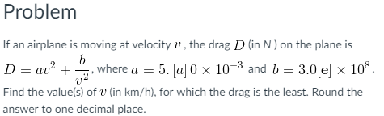

a=5.20 x 10^-3 and b=3.06 x 10^8

