Fitting Polynomial Curves to data
Regression Example Using Excel:
Height Weight

170 65
167 55
189 85
175 70
166 55
174 55
169 69
170 58
184 84
161 56
170 75
182 68
167 51
187 85
178 62
173 60
172 68
178 55
175 65
176 70

Background
A regular linear regression is calculated (with your data) as:
=LINEST(B2:B21,A2:A21)
which returns a single value, the linear slope (m) according to the formula:
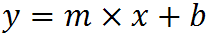
which for your data:
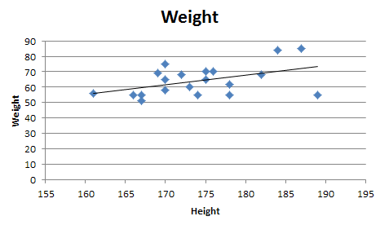is:
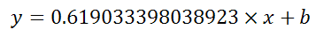
Note:
You can also Excel to calculate a regression with a formula that uses an exponent for x different from 1, e.g.:
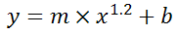
using the formula:
=LINEST(B2:B21, A2:A21^1.2)

You're not limited to one exponent
Excel's LINEST function can also calculate multiple regressions, with different exponents on x at the same time, e.g.:
=LINEST(B2:B21,A2:A21^{1,2})
Now Excel will calculate regressions using both x¹ and x² at the same time:
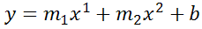

How to actually do it:
- select the cell that contains your formula:
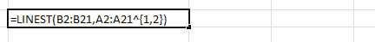
- extend the selection the left 2 spaces (you need the select to be at least 3 cells wide):
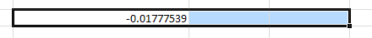
- press F2
- press Ctrl+Shift+Enter
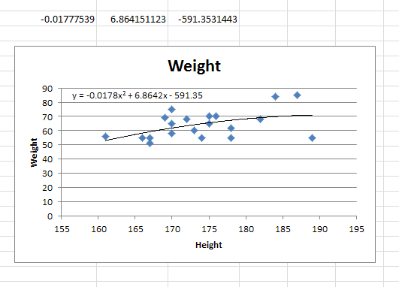
You will now see your 3 regression constants:
y = -0.01777539x^2 + 6.864151123x + -591.3531443

