You have been asked to compare 4 styles of father’s parenting style with an anxiety score (GAD7). Determine if there is a relationship between the variables (Questions 1 – 6).
Report
Anxiety Score
How you were fathered (Father's parenting style)? | Mean | Std. Deviation | N
Authoritarian | 6.86 | 5.203 | 83
Authoritative | 5.46 | 4.762 | 138
Permissive | 5.49 | 4.163 | 75
Uninvolved | 5.61 | 3.610 | 49
Total | 5.83 | 4.623 | 345

- What are the assumptions and conditions for this problem?

  - Unbiased sampling, normality, and equal variances
  - Biased samples, normality, and no expected value < 1
  - Unbiased sample and no expected value < 1
  - No more than 20% of the expected values < 5
  - All of the above

- Were any assumptions violated?

  - No, all assumptions were met
  - Yes, assumption of normality (see outliers in boxplot)
  - Yes, assumption of equal variances (see standard deviations)
  - Yes, see sample sizes
  - None of the above

- What is the p-value for the One-way ANOVA (F-test)?

  - 1.832
  - .141
  - .182
  - .386
  - .810

- Were the results statistically significant and what is your decision?

  - Yes, Reject Ho
  - Yes, Fail to reject Ho
  - No, Fail to reject Ho
  - No, Reject Ho
  - Both ‘a’ and ‘d’
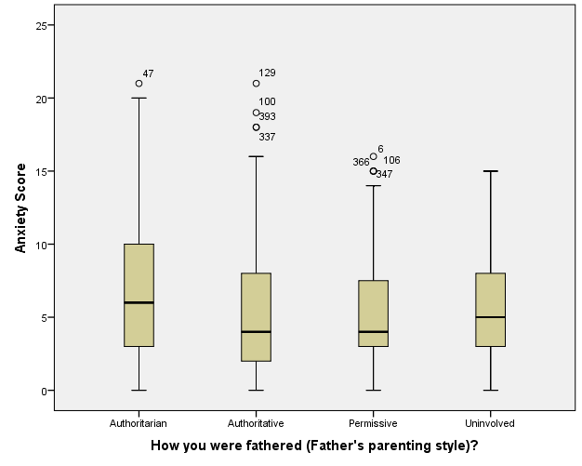

ANOVA
Anxiety Score
 | Sum of Squares | df | Mean Square | F | Sig.
Between Groups | 116.602 | 3 | 38.867 | 1.832 | .141
Within Groups | 7234.963 | 341 | 21.217
Total | 7351.565 | 344

- How would you write the overall results for the above statistics?

  - F(3,341) = 1.83, p = .141
  - F(3,344) = 38.87, p = .141
  - F(344) = 1.83, p = 141
  - F(3,341) = 1.83, p < .05
  - None of the above

- Is the follow-up analysis below this question appropriate?

  - Yes, because Ho was rejected
  - No, because Ho was rejected
  - Yes, because we failed to reject Ho
  - No, because we failed to reject Ho
  - Both ‘a’ and ‘b’

Multiple Comparisons
Dependent Variable: Anxiety Score
Bonferroni
(I) How you were fathered (Father's parenting style)? | (J) How you were fathered (Father's parenting style)? | Mean Difference (I-J) | Std. Error | Sig. | 95% Confidence Interval
 |  |  |  |  | Lower Bound | Upper Bound
Authoritarian | Authoritative | 1.392 | .640 | .182 | -.31 | 3.09
Authoritarian | Permissive | 1.362 | .734 | .386 | -.59 | 3.31
Authoritarian | Uninvolved | 1.243 | .830 | .810 | -.96 | 3.45
Authoritative | Authoritarian | -1.392 | .640 | .182 | -3.09 | .31
Authoritative | Permissive | -.030 | .661 | 1.000 | -1.78 | 1.72
Authoritative | Uninvolved | -.148 | .766 | 1.000 | -2.18 | 1.88
Permissive | Authoritarian | -1.362 | .734 | .386 | -3.31 | .59
Permissive | Authoritative | .030 | .661 | 1.000 | -1.72 | 1.78
Permissive | Uninvolved | -.119 | .846 | 1.000 | -2.36 | 2.13
Uninvolved | Authoritarian | -1.243 | .830 | .810 | -3.45 | .96
Uninvolved | Authoritative | .148 | .766 | 1.000 | -1.88 | 2.18
Uninvolved | Permissive | .119 | .846 | 1.000 | -2.13 | 2.36

You have also been asked to see if a relationship exists between first adult attachment style and anxiety scores. Use tables and graphs below for questions 7 – 15.
- Check to see if the assumptions of normality have been violated. Is there a violation?

  - Yes, see the outliers in the boxplots below
  - No, see the outliers in the boxplots below
  - Yes, because the samples sizes total more than 40
  - No, because the sample sizes total more than 40
  - Both ‘a’ and ‘b’

Report
Anxiety Score
First Adult Attachment Style (a "1" is put next to the description) | Mean | Std. Deviation | N
Dismissing Avoidant | 5.59 | 4.463 | 100
Preoccupied | 6.70 | 4.735 | 40
Fearful Avoidant | 7.80 | 5.084 | 108
Secure | 4.62 | 4.047 | 125
Total | 6.02 | 4.714 | 373
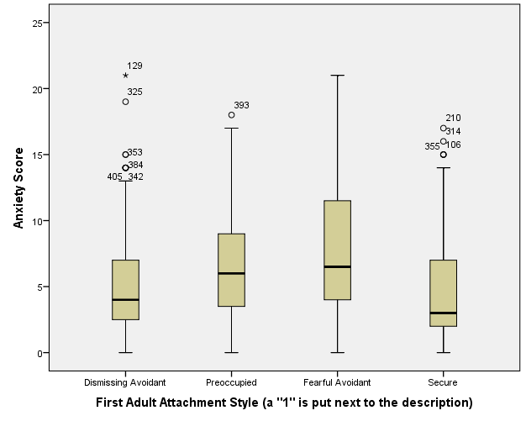
- Was there a violation for equal variances?

  - Yes, because the largest SD is more than twice the size of the smallest SD
  - No, because the largest SD is less than twice the size of the smallest SD
  - Yes, because the largest SD is less than twice the size of the smallest SD
  - No, because the largest SD is more than twice the size of the smallest SD
  - Not enough information
- What is the appropriate nonparametric test to use if one violates the assumption of normality?

  - Kruskal-Wallis H test
  - Wilcoxon Rank Sum test
  - Mann-Whitney U test
  - Both ‘b’ and ‘c’
  - None of the above

- How would you write the results for this output in terms of the F-statistic?

  - F(207,20) = 9.999, p = .000
  - F(3,369) = 10, p < .001
  - F(207,20) = 10, p < .001
  - F(3,369) = 9.999, p = .000
  - F(3,369) = 10, p = .000

- What is your overall decision?

  - Reject Ho, at least one adult attachment style is different from one other
  - Fail to reject Ho, at least one adult attachment style is different from one other
  - Reject Ho, no adult attachment style is different from another
  - Fail to reject Ho, no adult attachment style is different from another
  - Both ‘a’ and ‘c’
ANOVA
Anxiety Score
 | Sum of Squares | df | Mean Square | F | Sig.
Between Groups | 621.346 | 3 | 207.115 | 9.999 | .000
Within Groups | 7643.437 | 369 | 20.714
Total | 8264.783 | 372

- Is it appropriate to do and look at the follow-up analysis (Bonferroni t and Cohen’s d)?

  - Yes, but only Bonferroni t
  - Yes, but only Cohen’s d
  - No follow-up analysis is necessary
  - Yes, do both Bonferroni t and Cohen’s d
  - None of the above

Multiple Comparisons
Dependent Variable: Anxiety Score
Bonferroni
(I) First Adult Attachment Style (a "1" is put next to the description) | (J) First Adult Attachment Style (a "1" is put next to the description) | Mean Difference (I-J) | Std. Error | Sig. | 95% Confidence Interval
 |  |  |  |  | Lower Bound | Upper Bound
Dismissing Avoidant | Preoccupied | -1.110 | .851 | 1.000 | -3.37 | 1.15
Dismissing Avoidant | Fearful Avoidant | -2.206* | .632 | .003 | -3.88 | -.53
Dismissing Avoidant | Secure | .966 | .611 | .687 | -.65 | 2.59
Preoccupied | Dismissing Avoidant | 1.110 | .851 | 1.000 | -1.15 | 3.37
Preoccupied | Fearful Avoidant | -1.096 | .842 | 1.000 | -3.33 | 1.14
Preoccupied | Secure | 2.076 | .827 | .075 | -.12 | 4.27
Fearful Avoidant | Dismissing Avoidant | 2.206* | .632 | .003 | .53 | 3.88
Fearful Avoidant | Preoccupied | 1.096 | .842 | 1.000 | -1.14 | 3.33
Fearful Avoidant | Secure | 3.172* | .598 | .000 | 1.59 | 4.76
Secure | Dismissing Avoidant | -.966 | .611 | .687 | -2.59 | .65
Secure | Preoccupied | -2.076 | .827 | .075 | -4.27 | .12
Secure | Fearful Avoidant | -3.172* | .598 | .000 | -4.76 | -1.59
*. The mean difference is significant at the 0.05 level.

- Looking at the Bonferroni t table above, what adult attachments styles have a larger mean anxiety score than “Fearful Avoidant”?

  - Dismissive Avoidant
  - Preoccupied
  - Secure
  - Both ‘a’ and ‘c’
  - None of the above

- Looking at the Bonferroni t table above, what adult attachments styles have a smaller mean anxiety score than “Fearful Avoidant”?

  - Dismissive Avoidant
  - Preoccupied
  - Secure
  - Both ‘a’ and ‘c’
  - None of the above

- Is it appropriate to compute Cohen’s d in comparing Secure and Fearful Avoidant? If so, what is Cohen’s d and the effect size?

  - No, it is not appropriate
  - Yes, it is appropriate, p < .001, d = .70, medium to large effect
  - Yes, it is appropriate, p = .000, d = .70, medium to large effect
  - Yes, it is appropriate, p < .001, d = .22, small effect
  - Yes, it is appropriate, p = .000, d = .22, small effect

