Question 1
A sample of 81 account balances of a credit company showed an average balance of $1,200 with a standard deviation of $126.
Formulate the hypotheses that can be used to determine whether the mean of all account balances is significantly different from $1,150.
Compute the test statistic.
Using the p-value approach, what is your conclusion? Let α = .05.

Question 2
During the recent primary elections, the democratic presidential candidate showed the following pre-election voter support in Alabama and Mississippi.

We want to determine whether or not the proportions of voters favoring the Democratic candidate were the same in both states. Provide the hypotheses.
Compute the test statistic.
Determine the p-value; and at 95% confidence, test the above hypotheses.

Question 3
In order to estimate the difference between the yearly incomes of marketing managers in the East and West of the United States, the following information was gathered.
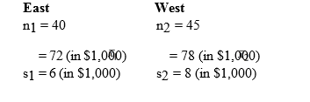
Develop an interval estimate for the difference between the average yearly incomes of the marketing managers in the East and West. Use α = 0.05.
At 95% confidence, use the p-value approach and test to determine if the average yearly income of marketing managers in the East is significantly different from the West.

