1. The production department of Celltronics International wants to explore the relationship between the number of employees who assemble a subassembly and the number produced. As an experiment, 2 employees were assigned to assemble the subassemblies. They produced 13 during a one-hour period. Then 4 employees assembled them. They produced 22 during a one-hour period. The complete set of paired observations follows.
Number of One-Hour
Assemblers Production (units)
2 13
4 22
1 9
5 36
3 25

The dependent variable is production; that is, it is assumed that different levels of production result from a different number of employees.
- A scatter diagram is provided below. Based on it, does there appear to be any relationship between the number of assemblers and production?
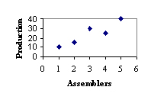
(yes or no), as the number of assemblers (decreases or increases), so does the production.
- Compute the correlation coefficient. (Negative amounts should be indicated by a minus sign. Round s_{x}, s_{y} and r to 3 decimal places.)
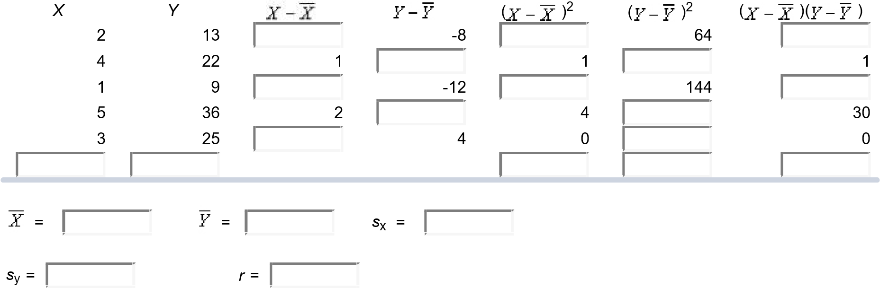
Worksheet Objective: Calculate a correlation coefficient to test and interpret the relationship between two variables.
2. The following sample observations were randomly selected. (Round your answers to 2 decimal places.)
X: 4 5 3 6 10
Y: 9.8 12.6 8 15.4 19.6

- The regression equation is
=
+
=
X
- When X is 7 this gives

3. Bi-lo Appliance Super-Store has outlets in several large metropolitan areas in New England. The general sales manager aired a commercial for a digital camera on selected local TV stations prior to a sale starting on Saturday and ending Sunday. She obtained the information for Saturday–Sunday digital camera sales at the various outlets and paired it with the number of times the advertisement was shown on the local TV stations. The purpose is to find whether there is any relationship between the number of times the advertisement was aired and digital camera sales. The pairings are:

Location of | Number of | Saturday–Sunday Sales
TV Station | Airings | ($ thousands)
Providence | 4 | 15
Springfield | 2 | 8
New Haven | 5 | 21
Boston | 6 | 24
Hartford | 3 | 17

a. What is the dependent variable?
(Number of Advertisements or Sales) is the dependent variable.
- Determine the correlation coefficient. (Round your answer to 2 decimal places.)
Coefficient of correlation
- Interpret these statistical measures.
The statistical measures obtained here indicate (a strong positive or a strong negative) correlation between the variables.
Worksheet Objective: Calculate a correlation Co-efficient to test and interpret the relationship between two variables.

4. The owner of Maumee Ford-Mercury-Volvo wants to study the relationship between the age of a car and its selling price. Listed below is a random sample of 12 used cars sold at the dealership during the last year.
Car Age (years) Selling Price ($000) Car Age (years) Selling Price ($000)
- 9 8.1 7 8 7.6
- 7 6.0 8 11 8.0
- 11 3.6 9 10 8.0
- 12 4.0 10 12 6.0
- 8 5.0 11 6 8.6
- 7 10.0 12 6 8.0

a. If we want to estimate selling price on the basis of the age of the car, which variable is the dependent variable and which is the independent variable?
(Selling price, Car, or Age) is the independent variable and (selling price, age, or car) is the dependent variable.
b-1. Determine the correlation coefficient. (Negative amounts should be indicated by a minus sign. Round your answers to 3 decimal places.)

X | Y |  |  | ( )² | ( )² | ( )( )
9.0 | 8.1 |  | 1.192 | 0.007 | 1.420 | 0.099
7.0 | 6.0 |  | -0.908 | 3.674 | 0.825 | 1.741
11.0 | 3.6 | 2.083 |  | 4.340 | 10.945 | -6.892
12.0 | 4.0 | 3.083 |  | 9.507 | 8.458 | -8.967
8.0 | 5.0 | -0.917 | -1.908 |  | 3.642 | 1.749
7.0 | 10.0 | -1.917 | 3.092 |  | 9.558 | -5.926
8.0 | 7.6 | -0.917 | 0.692 | 0.840 |  | -0.634
11.0 | 8.0 | 2.083 | 1.092 | 4.340 |  | 2.274
10.0 | 8.0 | 1.083 | 1.092 | 1.174 | 1.192
12.0 | 6.0 | 3.083 | -0.908 | 9.507 | 0.825
6.0 | 8.6 | -2.917 | 1.692 | 8.507 | 2.862 | -4.934
6.0 | 8.0 | -2.917 | 1.092 | 8.507 | 1.192 | -3.184
107.000 | 82.900
 | = |  |  | = |  | s_{x} | = |  | s_{y} | =
r | =

b-2. Determine the coefficient of determination. (Round your answer to 3 decimal places.) (?????)

c. Interpret the correlation coefficient. Does it surprise you that the correlation coefficient is negative? (Round your answer to nearest whole number.)

(Strong, No, or Moderate) correlation between age of car and selling price. So, (?????) % of the variation in the selling price is explained by the variation in the age of the car.

Worksheet Objective: Calculate a correlation coefficient to test and interpret the relationship between two variables.

5. Pennsylvania Refining Company is studying the relationship between the pump price of gasoline and the number of gallons sold. For a sample of 20 stations last Tuesday, the correlation was .78.
At the .01 significance level, is the correlation in the population greater than zero? (Round your answer to
3 decimal places.)
(?????)
The test statistic is

Decision: (Reject or Do not reject) Ho : p ≤ 0
Worksheet Objective: Calculate a correlation coefficient to test and interpret the relationship between two variables.

