Exam 1
Question 1 of 20 | 0.0/ 5.0 Points
The measure of two complementary angles are in the ratio 1 : 5. What are the degree measures of the two angles?

A.
15° and 75°
B.
36° and 144°
C.
18° and 72°
D.
30° and 150°

Question 2 of 20 | 0.0/ 5.0 Points
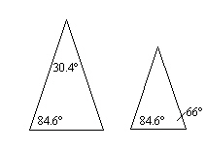
Are the triangles similar? How do you know?

A. yes, by SAS
B. yes, by SSS
C. yes, by AA
D. no

Question 3 of 20 | 0.0/ 5.0 Points
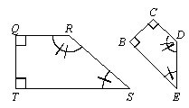
Figure . What are the pairs of congruent angles?

A. 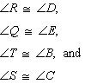
B. 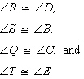
C. 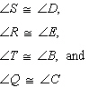
D. 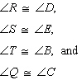

Question 4 of 20 | 5.0/ 5.0 Points
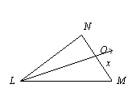
bisects , LM = 18, NO = 4, and LN = 10.
What is the value of x?

A. 7.2
B. 45
C. 5.43
D. 2.22

Question 5 of 20 | 0.0/ 5.0 Points
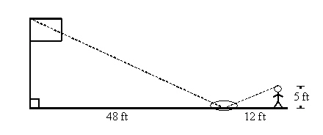
Michele wanted to measure the height of her school’s flagpole. She placed a mirror on the ground 48 feet from the flagpole, then walked backwards until she was able to see the top of the pole in the mirror. Her eyes were 5 feet above the ground and she was 12 feet from the mirror. Using similar triangles, find the height of the flagpole to the nearest tenth of a foot. Find the geometric mean of the pair of numbers.

A. 20 ft
B. 38.4 ft
C. 55 ft
D. 25 ft

Question 6 of 20 | 5.0/ 5.0 Points
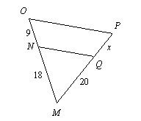
What is value of x, given that ?

A. x = 10
B. x = 20
C. x = 13
D. x = 25.5

Question 7 of 20 | 0.0/ 5.0 Points

Find the geometric mean of the pair of numbers.

242 and 8

A. 44
B. 49
C. 1872
D. 54

Question 8 of 20 | 0.0/ 5.0 Points
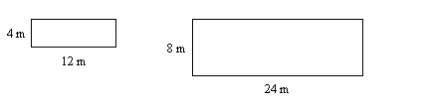
The two rectangles are similar. Which is the correct proportion for corresponding sides? Are the polygons similar? If they are, write a similarity statement and give the scale factor.

A. 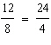
B. 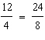
C. 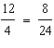
D. 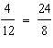

Question 9 of 20 | 0.0/ 5.0 Points
Are the triangles similar? If they are, write a similarity statement and give the scale factor.
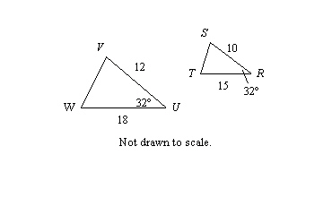

A. ;
B. ;
C. ;
D. The triangles are not similar.

Question 10 of 20 | 0.0/ 5.0 Points
A model is made of a car. The car is 10 feet long and the model is 7 inches long. What is the ratio of the length of the car to the length of the model?

A. 10 : 7
B. 7 : 120
C. 120 : 7
D. 7 : 10

Question 11 of 20 | 0.0/ 5.0 Points
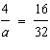
What is the solution of the proportion?

A. 32
B. 128
C. 8
D. 16

Question 12 of 20 | 0.0/ 5.0 Points
Red and grey bricks were used to build a decorative wall. The 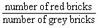 was There were 140 bricks used in all. How many red bricks were used?

A. 28
B. 40
C. 20
D. 100

Question 13 of 20 | 5.0/ 5.0 Points
The measures of the angles of a triangle are in the extended ratio 4 : 5 : 6. What is the measure of the smallest angle?

A. 48
B. 60
C. 72
D. 12

Question 14 of 20 | 0.0/ 5.0 Points
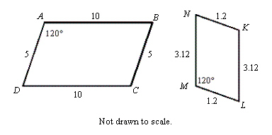
Which statement below is true regarding these two polygons?

A. ; 10 : 1.2
B. The polygons are not similar.
C. ; 5 : 1.2
D. ; 5 : 3.12

Question 15 of 20 | 0.0/ 5.0 Points
A model is made of a car. The car is 3 meters long and the model is 3 centimeters long. What is the ratio of the length of the car to the length of the model?

A. 3 : 3
B. 1 : 100
C. 1 : 3
D. 100 : 1

Question 16 of 20 | 0.0/ 5.0 Points
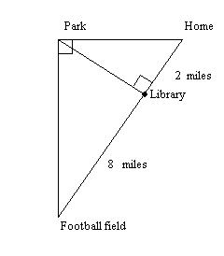
Kristen lives directly east of the park. The football field is directly south of the park. The library sits on the line formed between Kristen’s home and the football field at the exact point where an altitude to the right triangle formed by her home, the park, and the football field could be drawn. The library is 2 miles from her home. The football field is 8 miles from the library.
How far is library from the park?
How far is the park from the football field?

A. 4 miles; miles
B. miles; miles
C. 5 miles; 9 miles
D. 4 miles; miles

Question 17 of 20 | 5.0/ 5.0 Points
Which group contains triangles that are all similar?

A. 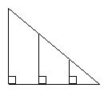
B. 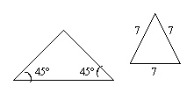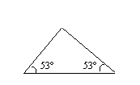
C. 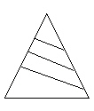
D. 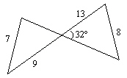

Question 18 of 20 | 5.0/ 5.0 Points
Are the two triangles similar? How do you know?
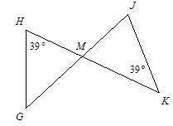

A. Yes, by SSS~
B. The triangles are not similar.
C. Yes, by AA~
D. Yes, by SAS~

Question 19 of 20 | 0.0/ 5.0 Points
An angle bisector of a triangle divides the opposite side of the triangle into segments 6 cm and 4 cm long. A second side of the triangle is 7.4 cm long. Find the longest and shortest possible lengths of the third side of the triangle. Round answers to the nearest tenth of a centimeter.

A. 44.4 cm, 11.1 cm
B. 44.4 cm, 3.2 cm
C. 11.1 cm, 4.9 cm
D. 24 cm, 4.9 cm

Question 20 of 20 | 0.0/ 5.0 Points
What is the solution of each proportion?
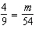

A. 24
B. 1/24
C. 6
D. 2/3

