Exam 3
Question 1 of 20 | 5.0/ 5.0 Points
What translation rule can be used to describe the result of the composition of and ?

A.
B.
C.
D.

Question 2 of 20 | 0.0/ 5.0 Points
Use the figures below.
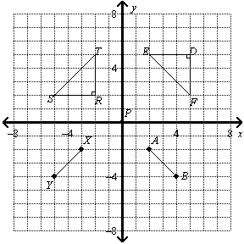
Write a sequence of rigid motions that maps to .

A.
B.
C.
D.

Question 3 of 20 | 0.0/ 5.0 Points
The dashed-lined figure is a dilation image of EFGH. Is an enlargement or a reduction? What is the scale factor n of the dilation?
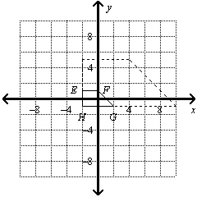

A. n = 6; enlargement
B. n = 3; enlargement
C. n = 3; reduction
D. n = ; reduction

Question 4 of 20 | 0.0/ 5.0 Points
Each triangle in the diagram is a reflection of another triangle across one of the given lines. How can you describe Triangle 2 by using a reflection rule?
I. (Triangle 3)
II. (Triangle 2)
III. (Triangle 1)
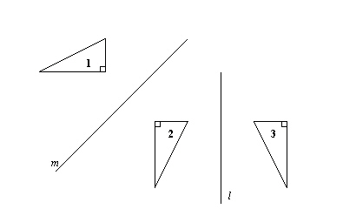

A. I only
B. I and III only
C. II and III only
D. I, II, and III

Question 5 of 20 | 0.0/ 5.0 Points
Which graph shows a triangle and its reflection image over the x-axis?

A. 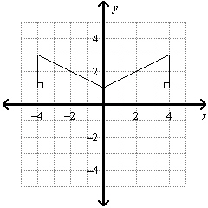
B. 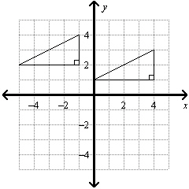
C. 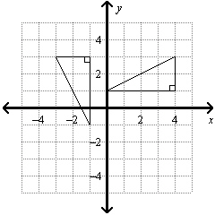
D. 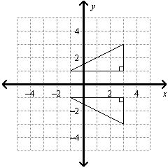

Question 6 of 20 | 0.0/ 5.0 Points
1. Which of these transformations appear to be a rigid motion?
(I) parallelogram EFGH parallelogram XWVU
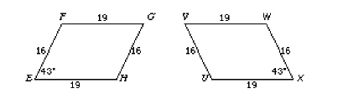
(II) hexagon CDEFGH hexagon YXWVUT
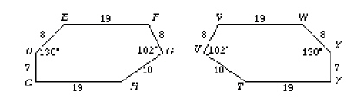
(III) triangle EFG triangle VWU
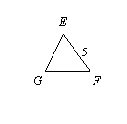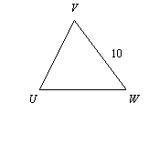

A. I only
B. II and III only
C. I and II only
D. I, II, and III

Question 7 of 20 | 0.0/ 5.0 Points
Which type of isometry is the equivalent of two reflections across intersecting lines?

A. glide reflection
B. rotation
C. reflection
D. none of these

Question 8 of 20 | 0.0/ 5.0 Points
Use the diagram.
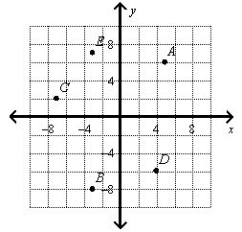
Find the translation rule that describes the translation B → D.

A.
T _{< -4, 10 >} (B)
B.
T _{< 7, 2 >} (B)
C.
T _{< 0, 15 >} (B)
D.
T _{< 8, 14 >} (A)

Question 9 of 20 | 0.0/ 5.0 Points
The vertices of a triangle are P(–8, 6), Q(1, –3), and R(–6, –3). Name the vertices of .

A.
B.
C.
D.

Question 10 of 20 | 0.0/ 5.0 Points
Write a sequence of rigid motions that maps to .

A. 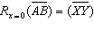
B. 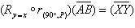
C. 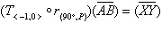
D. 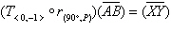

Question 11 of 20 | 0.0/ 5.0 Points
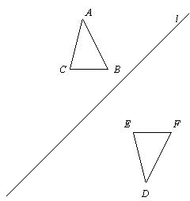
Which side has an equal measure to ?

A.
B.
C.
D.

Question 12 of 20 | 0.0/ 5.0 Points
Use the composition , shown below.
Which angle has an equal measure to ?

A.
B.
C.
D.

Question 13 of 20 | 0.0/ 5.0 Points
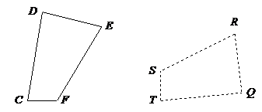

Name the image of

A.

B.

C.

D.

Question 14 of 20 | 5.0/ 5.0 Points
Which figures are congruent?
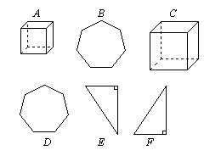

A. and
B.
C. and
D. and and

Question 15 of 20 | 0.0/ 5.0 Points
Describe in words the translation of X represented by the translation rule T _{< -7, -8 >} (X).

A. 7 units to the right and 8 units up
B. 8 units to the left and 7 units up
C. 7 units to the right and 8 units down
D. 7 units to the left and 8 units down

Question 16 of 20 | 5.0/ 5.0 Points
Find the image of P(–2, –1) after two reflections; first , and then .

A. (–2, –1)
B. (–1, –6)
C. (4, –9)
D. (1, –5)

Question 17 of 20 | 5.0/ 5.0 Points
A microscope shows you an image of an object that is 140 times the object’s actual size. So the scale factor of the enlargement is 140. An insect has a body length of 6 millimeters. What is the body length of the insect under the microscope?

A. 840 centimeters
B. 8,400 millimeters
C. 84 millimeters
D. 840 millimeters

Question 18 of 20 | 0.0/ 5.0 Points
Each triangle in the diagram is a reflection of another triangle across one of the given lines. How can you describe Triangle 3 by using a reflection rule?

A.
(Triangle 2)
B.
(Triangle 1)
C.
(Triangle 1)
D.
(Triangle 2)

Question 19 of 20 | 0.0/ 5.0 Points
Which graph shows ? 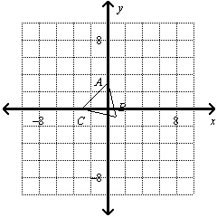

A. 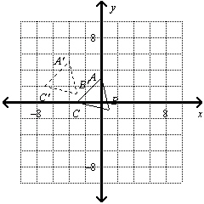
B. 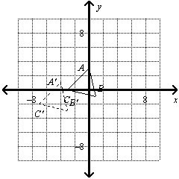
C. 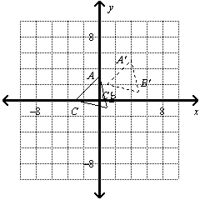
D. 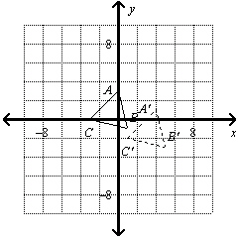

Question 20 of 20 | 0.0/ 5.0 Points
What is a rule that describes the translation ?
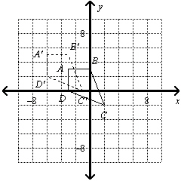

A.
B.
C.
D.

