Exam 5
Question 1 of 30 | 0.0/ 3.3333 Points
Find the area of a parallelogram with the given vertices.
P(1, 3), Q(3, 3), R(7, 8), S(9, 8)

A. 10 units²
B. 5 units²
C. 20 units²
D. none of these

Question 2 of 30 | 3.33/ 3.3333 Points
The area of sector AOB is . Find the exact area of the shaded region.
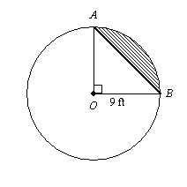

A.
B.
C. 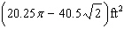
D. none of these

Question 3 of 30 | 3.33/ 3.3333 Points
A parallelogram has sides measuring 23.8 m and 35.3 m. The height corresponding to the 23.8-m base is 9.9 m. Find the height, to the nearest tenth of a meter, corresponding to the 35.3-m base.

A. 8317.4 m
B. 14.7 m
C. 6.7 m
D. none of these

Question 4 of 30 | 3.33/ 3.3333 Points
The delivery van arrives at an office every day between 3 PM and 5 PM. The office doors were locked between 3:15 PM and 3:35 PM. What is the probability that the doors were unlocked when the delivery van arrived?

A. 5/6
B. 5/12
C. 1/3
D. 1/6

Question 5 of 30 | 0.0/ 3.3333 Points
Find the area. The figure is not drawn to scale.
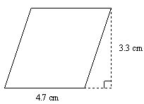

A.
31.02 cm²
B.
1.4 cm²
C.
8 cm²
D.
15.51 cm²

Question 6 of 30 | 3.33/ 3.3333 Points
Find the area of the regular polygon. Give the answer to the nearest tenth. decagon with a side of 4 cm

A. 123.1 cm²
B. 129.4 cm²
C. 246.2 cm²
D. 139.8 cm²

Question 7 of 30 | 0.0/ 3.3333 Points
You are planning to use a ceramic tile design in your new bathroom. The tiles are blue-and-white equilateral triangles. You decide to arrange the blue tiles in a hexagonal shape as shown. If the side of each tile measures 4 centimeters, what will be the exact area of each hexagonal shape?
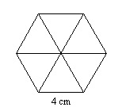

A. 12 cm²
B. 192 cm²
C. 32cm²
D. 24cm²

Question 8 of 30 | 0.0/ 3.3333 Points
Identify a semicircle that contains C.
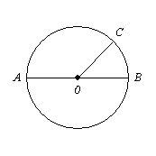

A.
B.
C.
D.

Question 9 of 30 | 0.0/ 3.3333 Points
Find the area. The figure is not drawn to scale.
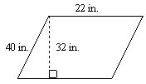

A.
704 in.²
B.
108 in.²
C.
54 in²
D.
880 in.²

Question 10 of 30 | 3.33/ 3.3333 Points
Name the major arc and find its measure.
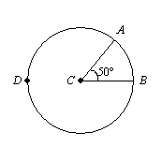

A. ; 50
B. ; 50
C. ; 310
D. ; 310

Question 11 of 30 | 3.33/ 3.3333 Points
Find the area of the shaded portion of the figure. Dimensions are in feet. Leave your answer in terms of p. The figure is not drawn to scale.
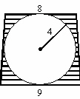

A.
B.
C.
D. none of these

Question 12 of 30 | 0.0/ 3.3333 Points
Find the area of the circle. Leave your answer in terms of .
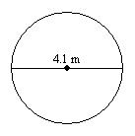

A. 4.2025 m²
B. 8.405m²
C. 16.81m²
D. 11.2m²

Question 13 of 30 | 0.0/ 3.3333 Points
Given a regular octagon, find the measures of the angles formed by (a) two consecutive radii and (b) a radius and a side of the polygon.

A. 72°; 252°
B. 36°; 216°
C. 45°; 67.5°
D. 40°; 230°

Question 14 of 30 | 0.0/ 3.3333 Points
The radius of the bull’s-eye of the dartboard is 8 inches. The radius of each concentric circle is 8 inches more than the radius of the circle inside it. If a dart lands at random on the dartboard, what is the probability that the dart will hit in area C?
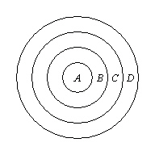

A. 9/16
B. 5/16
C. 1/4
D. 3/4

Question 15 of 30 | 0.0/ 3.3333 Points
Find the area. The figure is not drawn to scale.
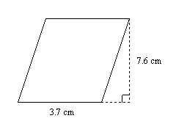

A.
B. 3.9 cm²
C. 11.3 cm²
D. 56.24 cm²

Part 2 of 2 - | 10.0/ 49.999508 Points

Question 16 of 30 | 3.33/ 3.3333 Points
Find the height of the cylinder.
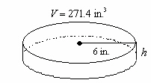

A. 2.4 in.
B. 7.2 in.
C. 14.4
D. 4.8 in.

Question 17 of 30 | 3.33/ 3.3333 Points
Use formulas to find the lateral area and surface area of the given prism. Round your answer to the nearest whole number.
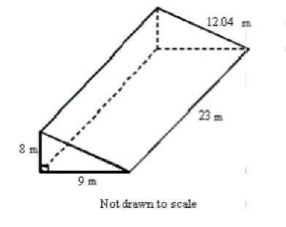

A. 645 m²; 740 m²
B. 645 m²; 812 m²
C. 668 m²; 740 m²
D. 668 m² ; 704m²

Question 18 of 30 | 0.0/ 3.3333 Points
Allison is planning to cover the lateral surface of a large cylindrical garbage can with decorative fabric for a theme party. The can has a diameter of 3 feet and a height of 3.5 feet. How much fabric does she need? Round to the nearest square foot.

A.
123 ft²
B.
61 ft²
C.
33 ft²
D.
66 ft²

Question 19 of 30 | 0.0/ 3.3333 Points
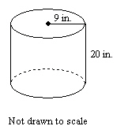
Find the surface area of the cylinder in terms of .

A. 396 in.²
B. 522 in.²
C. 360 in.²
D. 1008 in.²

Question 20 of 30 | 0.0/ 3.3333 Points
Find the surface area of a conical grain storage tank that has a height of 46 meters and a diameter of 16 meters. Round the answer to the nearest square meter.

A.
1375 m²
B.
3151 m²
C.
1173 m²
D.
2548 m²

Question 21 of 30 | 0.0/ 3.3333 Points
Find the surface area of the cylinder in terms of .
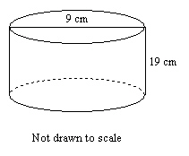

A. 504 cm²
B. 333 cm²
C. 382.5 cm²
D. 211.5 cm²

Question 22 of 30 | 0.0/ 3.3333 Points
If the similarity ratio of two similar solids is 3 : 14, what is the ratio of their corresponding areas? What is the ratio of their corresponding volumes?

A. The ratio of their corresponding areas is 27 : 2744. The ratio of their corresponding volumes is 9 : 196.
B. The ratio of their corresponding areas is 9 : 196. The ratio of their corresponding volumes is 27 : 2744.
C. The ratio of their corresponding areas is 6 : 28. The ratio of their corresponding volumes is 9 : 42.
D. The ratio of their corresponding areas is 3 : 196. The ratio of their corresponding volumes is 3 : 2744.

Question 23 of 30 | 0.0/ 3.3333 Points
Find the surface area of the figure to the nearest whole number.
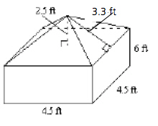

A. 310 ft²
B. 158 ft²
C. 135 ft²
D. 74 ft²

Question 24 of 30 | 0.0/ 3.3333 Points
Find the surface area of the cylinder in terms of

A.
B.
C.
D.

Question 25 of 30 | 0.0/ 3.3333 Points
Find the volume of the square pyramid shown. Round to the nearest tenth if necessary.
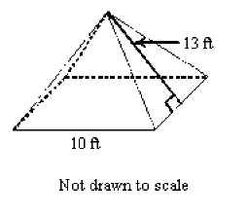

A. 600 ft³
B. 33.3 ft³
C. 1200 ft³
D. 400 ft³

Question 26 of 30 | 0.0/ 3.3333 Points
Find the surface area of the sphere with the given dimension. Leave your answer in terms of . radius of 60 m

A. 3,600 m²
B. 7,200 m²
C. 14,400 m²
D. 1,800 m²

Question 27 of 30 | 0.0/ 3.3333 Points
Describe the cross section.
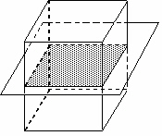

A. cube
B. trapezoid
C. pentagon
D. square

Question 28 of 30 | 3.33/ 3.3333 Points
Find the surface area of the cylinder in terms of
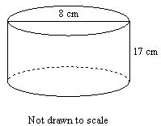

A.
B.
C.
D.

Question 29 of 30 | 0.0/ 3.3333 Points
Find the lateral area of a regular pentagonal pyramid that has a slant height of 14 in. and a base side length of 6 in.

A. 210 in.²
B. 240 in.²
C. 42 in.²
D. 420 in.²

Question 30 of 30 | 0.0/ 3.3333 Points
Mario’s company makes unusually shaped imitation gemstones. One gemstone had 12 faces and 10 vertices. How many edges did the gemstone have?

A. 23 edges
B. 22 edges
C. 25 edges
D. 20 edges

