Exam 2
Question 1 of 20 | 0.0/ 5.0 Points
For each triangle shown below, determine whether you would use the Law of Sines or Law of Cosines to find angle x. Then find angle x to the nearest tenth.
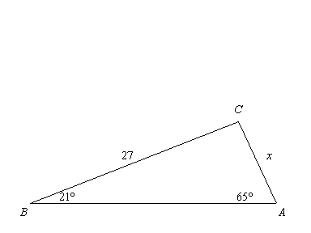

A. 8.8 by The Law of Sines (SSA)
B. 22.9 by The Law of Cosines (SAS)
C. 10.7 by The Law of Sines (SAS)
D. 68.3 by The Law of Cosines (SSS)

Question 2 of 20 | 0.0/ 5.0 Points
Find the measure of .
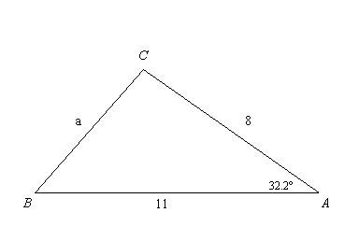

A. 3
B. 6
C. 8
D. 16

Question 3 of 20 | 0.0/ 5.0 Points
Write the ratios for sin X and cos X.
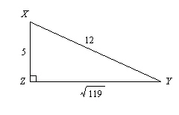

A. 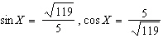
B.
C. 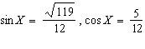
D. 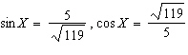

Question 4 of 20 | 0.0/ 5.0 Points
An airplane pilot over the Pacific sights an atoll at an angle of depression of 5. At this time, the horizontal distance from the airplane to the atoll is 4629 meters. What is the height of the plane to the nearest meter?
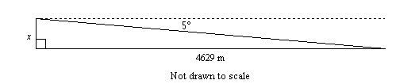

A. 403 m
B. 405 m
C. 4611 m
D. 4647 m

Question 5 of 20 | 0.0/ 5.0 Points
A slide 4.1 meters long makes an angle of 35 with the ground. To the nearest tenth of a meter, how far above the ground is the top of the slide?
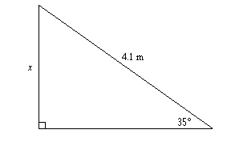

A. 7.1 m
B. 3.4 m
C. 5.0 m
D. 2.4 m

Question 6 of 20 | 0.0/ 5.0 Points
A triangle has sides of lengths 27, 79, and 84. Is it a right triangle? Explain.

A. yes;
B. yes;
C. no;
D. no;

Question 7 of 20 | 5.0/ 5.0 Points
The figure is drawn on centimeter grid paper. Find the perimeter of the shaded figure to the nearest tenth.
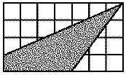

A. 17.6 cm
B. 10.8 cm
C. 15.6 cm
D. 18.0 cm

Question 8 of 20 | 5.0/ 5.0 Points
Find the length of the leg. If your answer is not an integer, leave it in simplest radical form.
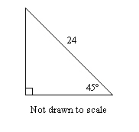

A.
B. 288
C. 24
D.

Question 9 of 20 | 0.0/ 5.0 Points
A triangle has side lengths of 20 cm, 99 cm, and 108 cm. Classify it as acute, obtuse, or right.

A. acute
B. obtuse
C. right

Question 10 of 20 | 0.0/ 5.0 Points
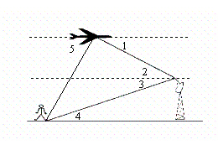
What is the description of as it relates to the situation shown?

A. is the angle of depression from the airplane to the radar tower.
B. is the angle of elevation from the airplane to the radar tower.
C. is the angle of elevation from the radar tower to the airplane.
D. is the angle of depression from the radar tower to the airplane.

Question 11 of 20 | 0.0/ 5.0 Points
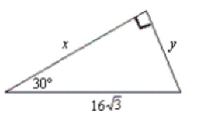
Solve for x and y.

A.
x = , y = 8
B.
x = 8, y =
C.
x = 24, y =
D.
x = , y = 24

Question 12 of 20 | 0.0/ 5.0 Points
Find the length of the missing side. The triangle is not drawn to scale.
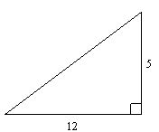

A. 60
B. 34
C. 169
D. 13

Question 13 of 20 | 5.0/ 5.0 Points
Find the value of x. Round to the nearest tenth.
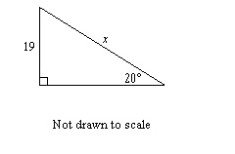

A. 55.6
B. 55.8
C. 6.7
D. 6.5

Question 14 of 20 | 0.0/ 5.0 Points
Find the value of the variable. If your answer is not an integer, leave it in simplest radical form.
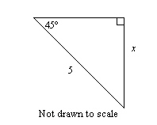

A. 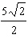
B.
C.
D. 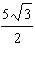

Question 15 of 20 | 0.0/ 5.0 Points
To approach the runway, a pilot of a small plane must begin a 10 descent starting from a height of 1983 feet above the ground. To the nearest tenth of a mile, how many miles from the runway is the airplane at the start of this approach?
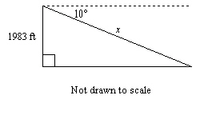

A. 2.2 mi
B. 0.4 mi
C. 11,419.6 mi
D. 2.1 mi

Question 16 of 20 | 0.0/ 5.0 Points
Find the lengths of the missing sides in the triangle. Write your answers as integers or as decimals rounded to the nearest tenth.
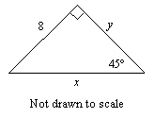

A. x = 5.7, y = 6.9
B. x = 6.9, y = 5.7
C. x = 11.3, y = 8
D. x = 8, y = 11.3

Question 17 of 20 | 0.0/ 5.0 Points
Use the Law of Sines to find the missing angle of the triangle. Find given that 83, 44, and 31.

A. 76.3°
B. 15.8°
C. 72.7°
D. 164.2°

Question 18 of 20 | 0.0/ 5.0 Points
A piece of art is in the shape of an equilateral triangle with sides of 6 in. Find the area of the piece of art. Round your answer to the nearest tenth.

A. 12.7 in.²
B. 15.6 in.²
C. 31.2 in.²
D. none of these

Question 19 of 20 | 5.0/ 5.0 Points
Triangle ABC has side lengths 3, 4, and 5. Do the side lengths form a Pythagorean triple? Explain.

A. No, they do not form a Pythagorean triple; although , the side lengths do not meet the other requirements of a Pythagorean triple.
B. No, they do not form a Pythagorean triple; .
C. Yes, they form a Pythagorean triple; and 3, 4, and 5 are all nonzero whole numbers.
D. Yes; they can form a right triangle, so they form a Pythagorean triple.

Question 20 of 20 | 0.0/ 5.0 Points
Find the value of x. Round the length to the nearest tenth.
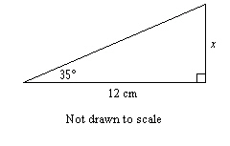

A. 6.9 cm
B. 9.8 cm
C. 8.4 cm
D. 17.1 cm

