Exam 8
Question 1 of 50 | 2.0/ 2.0 Points
Name an angle adjacent to ∠DGE.
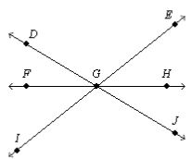

A. ∠FGI
B. ∠EGH
C. ∠HGJ
D. ∠JGI

Question 2 of 50 | 0.0/ 2.0 Points
Which point is the midpoint of ?
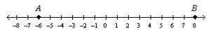

A. –0.5
B. 2
C. 1
D. 3

Question 3 of 50 | 2.0/ 2.0 Points
What is the name of the ray that is opposite ?
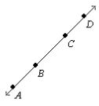

A.
B.
C.
D.

Question 4 of 50 | 2.0/ 2.0 Points
Alfred is practicing typing. The first time he tested himself, he could type 45 words per minute. After practicing for a week, he could type 48 words per minute. After two weeks he could type 51 words per minute. Based on this pattern, predict how fast Alfred will be able to type after 4 weeks of practice.

A. 61 words per minute
B. 57 words per minute
C. 54 words per minute
D. 51 words per minute

Question 5 of 50 | 2.0/ 2.0 Points
Which statement is the Law of Syllogism?

A. If p →q is a true statement and p is true, then q is true.
B. If p →q is a true statement and q is true, then p is true.
C. If p →q and q →r are true statements, then p →r is a true statement.
D. If p →q and q →r are true statements, then r →p is a true statement.

Question 6 of 50 | 0.0/ 2.0 Points
Find the values of x and y.
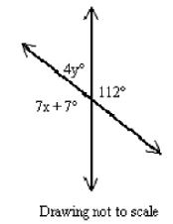

A. x = 15, y = 17
B. x = 112, y = 68
C. x = 68, y = 112
D. x = 17, y = 15

Question 7 of 50 | 2.0/ 2.0 Points
Based on the pattern, what are the next two terms of the sequence?
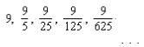

A.
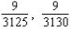
B.
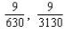
C.
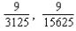
D.
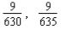

Question 8 of 50 | 0.0/ 2.0 Points
What is the graph of 6x + 3y= 18?

A.
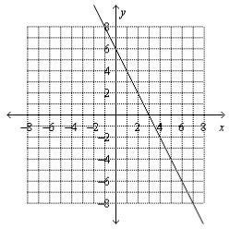
B.
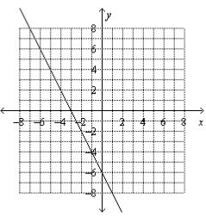
C.
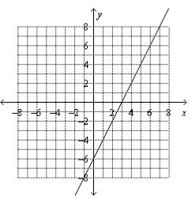
D.
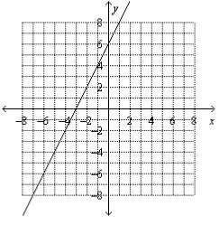

Question 9 of 50 | 2.0/ 2.0 Points
What is the slope of the line shown?
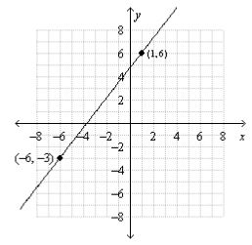

A.
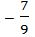
B.
C.
D.
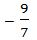

Question 10 of 50 | 0.0/ 2.0 Points
Which lines are parallel if m∠1+m∠2=180? Justify your answer.
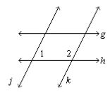

A. j ∥k , by the Converse of the Same-Side Interior Angles Postulate
B. j ∥k , by the Converse of the Alternate Interior Angles Theorem
C. g∥h, by the Converse of the Alternate Interior Angles Theorem
D. g∥h, by the Converse of the Same-Side Interior Angles Postulate

Question 11 of 50 | 0.0/ 2.0 Points
Given ΔABC≅ ΔPQR,m∠B = 3v+4 and m∠Q = 8v ― 6 , find m∠B and m∠Q.

A. 22
B. 11
C. 10
D. 25

Question 12 of 50 | 0.0/ 2.0 Points
The octagon in the figure is equiangular and
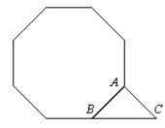

A. 135
B. 45
C. 30
D. 90

Question 13 of 50 | 0.0/ 2.0 Points
In an A-frame house, the two congruent sides extend from the ground to form a 34° angle at the peak. What angle does each side form with the ground?

A. 156
B. 146
C. 73
D. 78

Question 14 of 50 | 0.0/ 2.0 Points
What is the value of x?
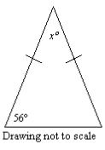

A. 68°
B. 62°
C. 112°
D. 124°

Question 15 of 50 | 2.0/ 2.0 Points
Which statement can you conclude is true from the given information? Given: is the perpendicular bisector of
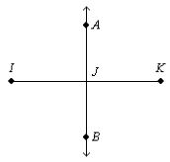

A.
AJ = BJ
B.
∠IAJ is a right angle.
C.
IJ = JK
D.
A is the midpoint of

Question 16 of 50 | 0.0/ 2.0 Points
Name the smallest angle of ∆ABC . The diagram is not to scale.
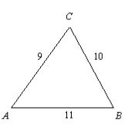

A. ∠A
B. ∠B
C. ∠C
D. Two angles are the same size and smaller than the third.

Question 17 of 50 | 2.0/ 2.0 Points
Where can the perpendicular bisectors of the sides of a right triangle intersect?
I. inside the triangle
II. on the triangle
III. outside the triangle

A. I only
B. II only
C. I or II only
D. I, II, or II

Question 18 of 50 | 0.0/ 2.0 Points
Which three lengths could be the lengths of the sides of a triangle?

A. 12 cm, 5 cm, 17 cm
B. 10 cm, 15 cm, 24 cm
C. 9 cm, 22 cm, 11 cm
D. 21 cm, 7 cm, 6 cm

Question 19 of 50 | 0.0/ 2.0 Points
WXYZ is a parallelogram. Name an angle congruent to ∠XYZ.
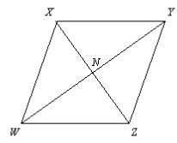

A. ∠XWY
B. ∠WZY
C. ∠XWZ
D. ∠ZWY

Question 20 of 50 | 0.0/ 2.0 Points
Find the values of a and b. The diagram is not to scale.
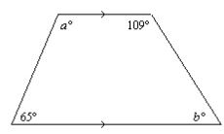

A. a = 115, b = 71
B. a = 115, b = 65
C. a = 109, b = 71
D. a = 109, b = 65

Question 21 of 50 | 0.0/ 2.0 Points
In the rhombus, Angle 1 = 140. What are Angles 2 and 3?
The diagram is not to scale.
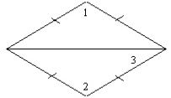

A. Angle 2 = 40 and Angle 3 = 70
B. Angle 2 = 140 and Angle 3 = 20
C. Angle 2 = 40 and Angle 3 = 20
D. Angle 2 = 140 and Angle 3 = 70

Question 22 of 50 | 0.0/ 2.0 Points
Complete this statement: A polygon with all sides the same length is said to be ____.

A. regular
B. equilateral
C. equiangular
D. convex

Question 23 of 50 | 0.0/ 2.0 Points
What is the solution of each proportion?
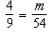

A. 24
B. 1/24
C. 6
D. 2/3

Question 24 of 50 | 0.0/ 2.0 Points
Which group contains triangles that are all similar?

A.
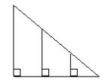
B.
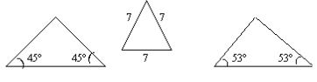
C.
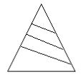
D.
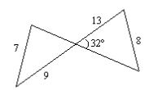

Question 25 of 50 | 0.0/ 2.0 Points
Use the information in the diagram to determine the height of the tree to the nearest foot.
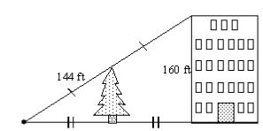

A. 80 ft
B. 264 ft
C. 60 ft
D. 72 ft

Question 26 of 50 | 0.0/ 2.0 Points
Find the measure of a.
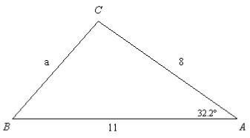

A. 3
B. 6
C. 8
D. 16

Question 27 of 50 | 0.0/ 2.0 Points
A slide 4.1 meters long makes an angle of 35° with the ground. To the nearest tenth of a meter, how far above the ground is the top of the slide?
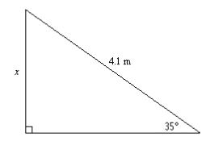

A. 7.1 m
B. 3.4 m
C. 5.0 m
D. 2.4 m

Question 28 of 50 | 0.0/ 2.0 Points
To approach the runway, a pilot of a small plane must begin a 10 degrees descent starting from a height of 1983 feet above the ground. To the nearest tenth of a mile, how many miles from the runway is the airplane at the start of this approach?
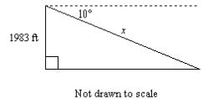

A. 2.2 mi
B. 0.4 mi
C. 11,419.6 mi
D. 2.1 mi

Question 29 of 50 | 0.0/ 2.0 Points
Find the length of the leg. If your answer is not an integer, leave it in simplest radical form.
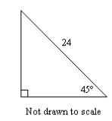

A.
B.
288
C.
24
D.

Question 30 of 50 | 0.0/ 2.0 Points
Which graph shows a triangle and its reflection image over the x-axis?

A.
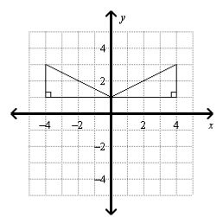
B.
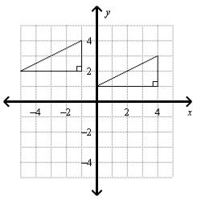
C.
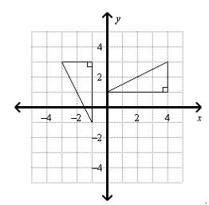
D.
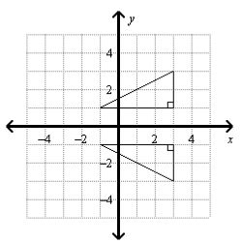

Question 31 of 50 | 2.0/ 2.0 Points
Which figures are congruent?
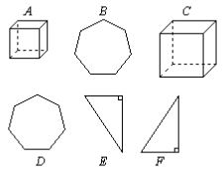

A. B ≅D and A ≅C
B. B ≅D
C. B ≅D and E ≅F
D. B ≅D and E ≅F and A ≅C

Question 32 of 50 | 0.0/ 2.0 Points
Which side has an equal measure to ?
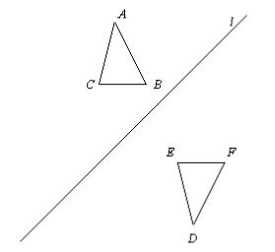

A.
B.
C.
D.

Question 33 of 50 | 0.0/ 2.0 Points
A microscope shows you an image of an object that is 140 times the object’s actual size. So the scale factor of the enlargement is 140. An insect has a body length of 6 millimeters. What is the body length of the insect under the microscope?

A. 840 centimeters
B. 8,400 millimeters
C. 84 millimeters
D. 840 millimeters

Question 34 of 50 | 2.0/ 2.0 Points
The area of a regular octagon is 35 cm². What is the area of a regular octagon with sides five times as long?

A.
625 cm²
B.
875 cm²
C.
175 cm²
D.
245 cm²

Question 35 of 50 | 0.0/ 2.0 Points
What is the height h of the parallelogram? Not drawn to scale.
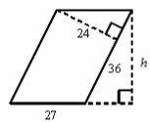
Not drawn to scale.

A. 32
B. 28
C. 40.5
D. 35

Question 36 of 50 | 2.0/ 2.0 Points
The radius of the bull’s-eye of the dartboard is 8 inches. The radius of each concentric circle is 8 inches more than the radius of the circle inside it. If a dart lands at random on the dartboard, what is the probability that the dart will hit in area C?
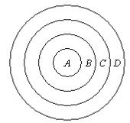

A. 9/16
B. 5/16
C. 1/4
D. 3/4

Question 37 of 50 | 0.0/ 2.0 Points
Find the area of the circle. Leave your answer in terms of
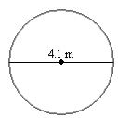

A.
B.
C.
D.

Question 38 of 50 | 0.0/ 2.0 Points
If the similarity ratio of two similar solids is 3 : 14, what is the ratio of their corresponding areas? What is the ratio of their corresponding volumes?

A. The ratio of their corresponding areas is 27 : 2744. The ratio of their corresponding volumes is 9 : 196.
B. The ratio of their corresponding areas is 9 : 196. The ratio of their corresponding volumes is 27 : 2744.
C. The ratio of their corresponding areas is 6 : 28. The ratio of their corresponding volumes is 9 : 42.
D. The ratio of their corresponding areas is 3 : 196. The ratio of their corresponding volumes is 3 : 2744.

Question 39 of 50 | 0.0/ 2.0 Points
The radius of the base of a cylinder is 38 mm and its height is 51 mm. Find the surface area of the cylinder in terms of

A.
B.
C.
D.

Question 40 of 50 | 0.0/ 2.0 Points
Find the volume of a square pyramid with base edges of 48 cm and a slant
height of 26 cm.

A.
11,520 cm³
B.
23,040 cm³
C.
7,680 cm³
D.
768 cm³

Question 41 of 50 | 2.0/ 2.0 Points
Find the lateral area of a regular pentagonal pyramid that has a slant
height of 14 in. and a base side length of 6 in.

A.
210 in.²
B.
240 in.²
C.
42 in.²
D.
420 in.²

Question 42 of 50 | 2.0/ 2.0 Points
Find m∠BAC in circle O. (The figure is not drawn to scale.)
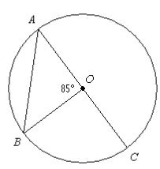

A. 170
B. 95
C. 47.5
D. 42.5

Question 43 of 50 | 0.0/ 2.0 Points
A low-wattage radio station can be heard only within a certain distance from the station. On the graph below, the circular region represents that part of the city where the station can be heard, and the center of the circle represents the location of the station. Which equation represents the boundary for the region where the station can be heard?
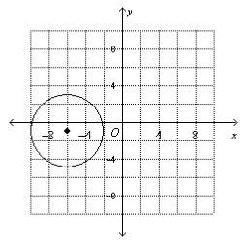

A.
(x – 6)² + (y – 1)² = 32
B.
(x + 6)² + (y + 1)² = 32
C.
(x – 6)² + (y – 1)² = 16
D.
(x + 6)² + (y + 1)² = 16

Question 44 of 50 | 0.0/ 2.0 Points
Write the standard equation for the circle.
center (10, –6), r = 6

A.
(x + 10)² + (y – 6)² = 6
B.
(x + 6)² + (y – 10)² = 36
C.
(x – 10)² + (y + 6)² = 36
D.
(x – 10)² + (y + 6)² = 6

Question 45 of 50 | 0.0/ 2.0 Points
Describe the locus in space.
points 4 mm from

A.
an endless cylinder with radius 4 mm and centerline
B.
a sphere of radius 4 cm
C.
two lines parallel to , each 4 mm from
D.
two planes parallel to , each 4 mm from

Question 46 of 50 | 0.0/ 2.0 Points
A sixteen-sided number cube has the numbers 1 through 16 on each face. Each face is equally likely to show after a roll. What is the probability that you will roll an even number or an odd prime number? Round to the nearest thousandth.

A. 0.063
B. 0.813
C. 0.219
D. 0.875

Question 47 of 50 | 0.0/ 2.0 Points
One-hundred students were allowed to re-take an exam for their math course. The probability distribution shows how studying for the latest exam affected their grade when compared with the first time they took the exam. What is the probability that a student who studied for the exam saw an increase in their exam grade? Round to the nearest thousandth.
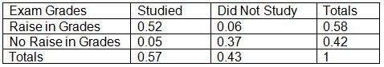

A. 0.088
B. 0.897
C. 0.912
D. 0.570

Question 48 of 50 | 2.0/ 2.0 Points
Suppose Ruth Ann has 3 routes she can choose from to get from school to the library, and 5 routes from the library to her home. How many routes are there from Ruth Ann’s school to her home with a stop at the library?

A. 9
B. 60
C. 15
D. 25

Question 49 of 50 | 0.0/ 2.0 Points
In a batch of 280 water purifiers, 12 were found to be defective. What is the probability that a water purifier chosen at random will be defective? Write the probability as a percent. Round to the nearest tenth of a percent if necessary.

A. 4.3%
B. 5.6%
C. 95.7%
D. 71.8%

Question 50 of 50 | 0.0/ 2.0 Points
This is a spinner used in a board game. What is the probability that the spinner will land on a multiple of 3 and 4?
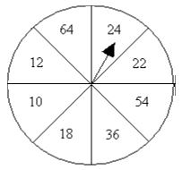

A. 1/4
B. 1/2
C. 1/8
D. 3/8

