Name/Student Number: ________________________

Geometry Quarter 4 Exam
Answer the questions below. Make sure to show your work and provide complete geometric explanations for full credit.
- A triangle has side lengths 10, 15, and 7. Is the triangle acute, obtuse, or right? Show your work and explain.

- A highway makes an angle of 6 with the horizontal. This angle is maintained for a horizontal distance of 5 miles.
To the nearest hundredth of a mile, how high does the highway rise in this 5-mile section? Show the steps you use to find the distance.

- A forest ranger spots a fire from a 28-foot tower. The angle of depression from the tower to the fire is 11.
To the nearest foot, how far is the fire from the base of the tower? Show the steps you use to find the solution.

- State whether the transformation appears to be a rigid motion. Explain. 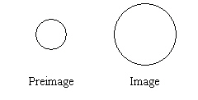

- How can you verify Euler’s formula for this net of a cube?

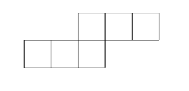

- Jason designed an arch made of wrought iron for the top of a mall entrance. The 11 segments between the two concentric circles are each 1.25 m long. Find the total length of wrought iron used to make the structure. Round the answer to the nearest meter. Show your work.

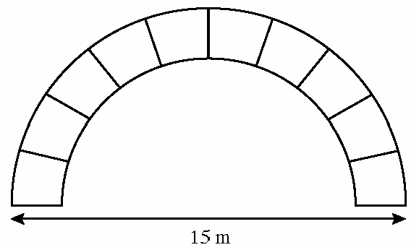

- Consider the prism shown below.
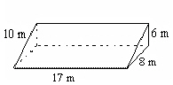
Find the surface area of the prism. Show your work

- Janine made a cylindrical vase in which the sum of the lateral area and area of one base was about 3000 square centimeters. The vase had a height of 50 centimeters. Find the radius of the vase. Explain the method you would use to find the radius.

- A design on the surface of a balloon is 5 cm wide when the balloon holds 71 cm of air. How much air does the balloon hold when the design is 10 cm wide? Explain the method you use to find the amount of air.

- In circle O, and are tangents. (The figure is not drawn to scale.)
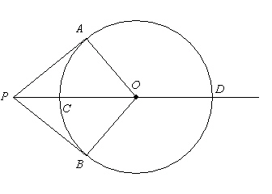
a. | Prove that .
b. | Find mBOD for mAOP = 64. Explain your reasoning.

- Determine whether a tangent line to circle O is shown in the diagram, for AB = 7.75, OB = 4, and AO = 8.75. Explain your reasoning. (The figure is not drawn to scale.)
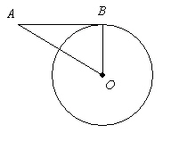

- In circle O, CD = 44, OM = 20, ON = 19, , (The figure is not drawn to scale.) Show your work.
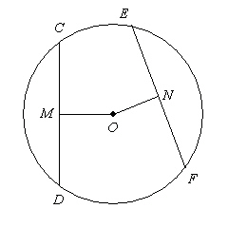
a. | Find the radius. If your answer is not an integer, express it in radical form.
b. | Find FN. If your answer is not an integer, express it in radical form.
c. | Find EF. Express it as a decimal rounded to the nearest tenth.

13.
is tangent to the circle at B. mA = 14 and (The figure is not drawn to scale.) Show your work.
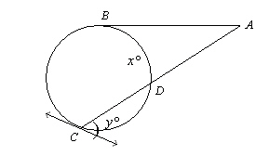
a. | Find x.
b. | Find y.

- At a track meet, 50 people ran the 100-meter dash. 2 people finished in 11 seconds, 5 people finished in 12 seconds, 8 people finished in 13 seconds, 10 people finished in 14 seconds, 21 people finished in 15 seconds, 2 people finished in 16 seconds, and 2 people finished in 17 seconds. What is the probability distribution for the finish times?

- Is there a similarity transformation that maps to ? If so, identify the similarity transformation and write a similarity statement. Explain your answer.

- Janine wants to paint just the sides of a cylindrical pottery vase that has a height of 45 cm and a diameter of 14 cm. To the nearest whole number, find the number of square centimeters she will need to paint. Explain the method you would use to find the lateral area.

- Determine whether a tangent line is shown in the diagram, for AB = 7, OB = 3.75, and AO = 8. Explain your reasoning. (The figure is not drawn to scale.)

- The equation (x + 5) + (y + 3) = 169 models the position and range of the source of a radio signal. Describe the position of the source and the range of the signals.

- An hourglass, composed of two identical cones, is 12 cm tall. The radius of each cone is 3 cm. If you want to fill the bottom half of the hourglass full of salt, how much salt will you need? Explain the method you would use to find the amount of salt.

- Three balls are packaged in a cylindrical container as shown below. The balls just touch the top, bottom, and sides of the cylinder. The diameter of each ball is 13 cm.
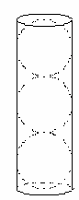

a. What is the volume of the cylinder? Explain your method for finding the volume.
b. What is the total volume of the three balls? Explain your method for finding the total volume.
c. What percent of the volume of the container is occupied by the three balls? Explain how you would find the percent.

