Group Names ___________________________________________________________________________________
Section 9.1 Group Problems
- Determine the critical value, , that corresponds to the given level of confidence.  - 98%  - b) 92% | - Determine the point estimate of the population proportion, the margin of error for each confidence interval and the number of individuals in the sample with the specified characteristic, x, for the sample size provided.
- Construct a confidence interval of the population prop. At the given level of confidence. | - Construct a confidence interval of the population prop. At the given level of confidence
- A random sample of 1003 adult Americans was asked, “Do you think televisions are a necessity or a luxury you could do without?” Of the 1003 adults surveyed, 521 indicated that televisions are a luxury they could do without. Answer the following questions: | 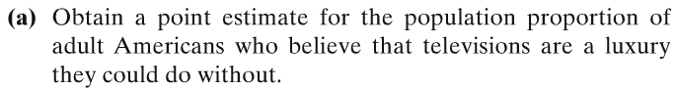
 | 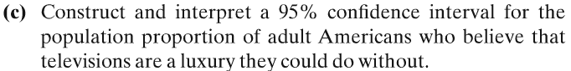
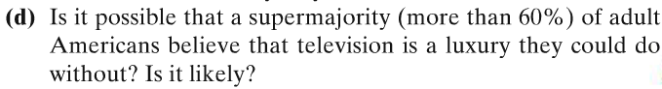 | 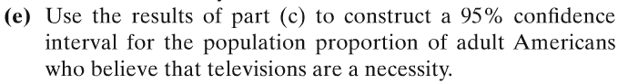
- Credit-Card Debt: A school administrator is concerned about the amount of credit-card debt that college students have. She wishes to conduct a poll to estimate the percentage of full-time college students who have credit-card debt of $2000 or more. What size sample should be obtained if she wishes the estimate to be within 2.5 percentage points with 94% confidence if

(a) a pilot study indicates that the percentage is 34%

