Travel Risk Scenarios

What if a salesman came to your door and offered to sell you a product that is guaranteed to make your life easier? It only costs $20,000 dollars and has a 1 in 100 chance of killing you. Would you buy it? You probably already did! It is an automobile! The graphic below shows probability of deaths in various ways, but there are other factors to take into account. Your goal for this scenario is to assess the risk of travel. You need to decide which mode of travel has the most risk: planes, trains, or automobiles.
There are three main roles in this scenario. Select a role and complete the task listed under the role.
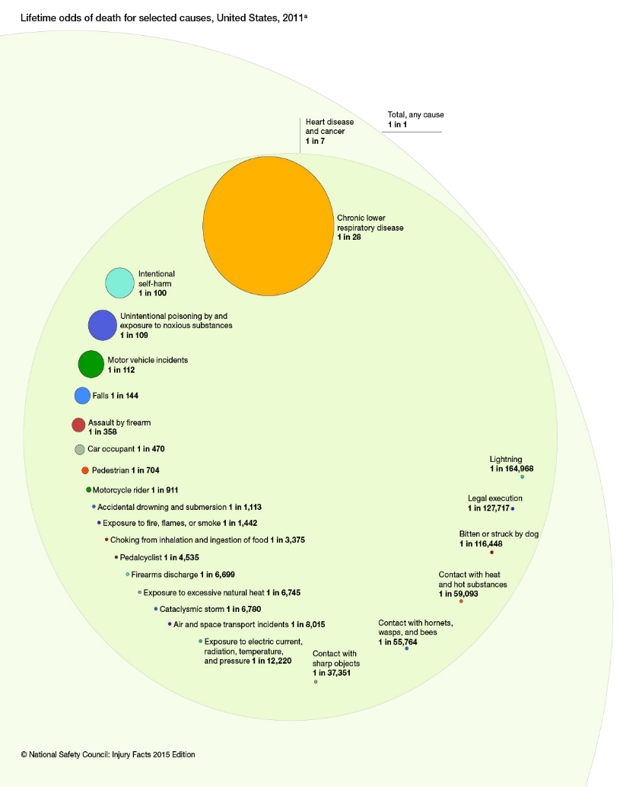
(Continued on next page)
Role #1 Automobile Analyst
The probability of deaths by car accidents only shows how many automobile fatalities came from of all automobile deaths. It does not take into account how much time people spend in their car. Your goal is to find the highway deaths per mile.
  - Use the following data tables to calculate automobile fatalities per mile in each year from 1994 to 2013.
  - Create a scatterplot of your value versus the year, including trendline, equation, and R square value. Is the trend increasing? decreasing? What is the predicted value for this year?
  - Include your calculations, graphics, analyses, and results.

Road Fatalities per year 1994-2013: http://www-fars.nhtsa.dot.gov/Main/index.aspx
Miles traveled per year: http://www.rita.dot.gov/bts/sites/rita.dot.gov.bts/files/publications/national_transportation_statistics/html/table_01_40.html

Role #2 Plane Analyst
Plane crashes are among the most sensationalized in the media. Although horrific, are they common? Your goal is to find the plane deaths per mile.
- Use the following data tables to calculate plane fatalities per mile in each year from 1994 to 2013.
- Create a scatterplot of your value versus the year, including trendline, equation, and R square value. Is the trend increasing? Decreasing? What is the predicted value for this year?
- Include your calculations, graphics, analyses, and results.

Miles travelled by air: http://www.rita.dot.gov/bts/sites/rita.dot.gov.bts/files/publications/national_transportation_statistics/html/table_01_40.html
Accidents involving fatalities of Major U.S. Airlines 1982-present: http://www.ntsb.gov/investigations/data/Pages/paxfatal.aspx
Accidents involving fatalities of U.S. Commuter Flights 1982-present: http://www.ntsb.gov/investigations/data/Pages/paxftl35.aspx

Role #3 Train Analyst
Trains do get derailed, but how often? Are they safer than planes or cars? Your goal is to find the train deaths per mile.
- Use the following data tables to calculate train fatalities per mile in each year from 1994 to 2013.
- Create a scatterplot of your value vs. the year, including trendline, equation, and R square value. Is the trend increasing? Decreasing? What is the predicted value for this year?
- Include your calculations, graphics, analyses, and results.
(Continued on next page)
Miles travelled by rail: http://www.rita.dot.gov/bts/sites/rita.dot.gov.bts/files/publications/national_transportation_statistics/html/table_01_40.html
Railroad casualties per year (enter in the date range of 1/1/94 to 12/31/2013): http://safetydata.fra.dot.gov/OfficeofSafety/publicsite/Query/castab.aspx

Click the Assignment Files tab to submit your assignment.

