Instructions for QUIZ 3:
The quiz is worth 100 points. There are 10 problems; each problem is worth 10 points.

QUIZ 3 is based on Chapter 1 (Sections 1.6 and 1.7) and Chapter 2 (Sections 2.1, 2.2 and 2.5) of the “College Algebra, 3rd Corrected Edition” text. It is open book and open notes. This means that you may refer to your textbook, notes, and online classroom materials, but you must work independently and may not consult anyone (and confirm this with your submission). YOU MAY USE YOUR GRAPHING CALCULATOR (TI-83/84 or EQUIVALENT, nothing more sophisticated) TO ASSIST IN GRAPHING OR ANY NUMERICAL CALCULATIONS).

You must show your work. Answers without any work may earn little, if any, credit. You may type or write your work in your copy of the quiz, or if you prefer, create a document containing your work. Scanned work is acceptable also.

When you have completed the quiz, upload your solutions file to the Quiz 3 assignment in the Assignment folder. DUE DATE is NLT 11:59pm EST, November 20.

If you have any questions, please contact me by e-mail.

1. Sketch the graph of the following function, and state the DOMAIN and RANGE of the function.

7

Domain: ___________

Range: ____________

2. Sketch the graph of the following piece-wise function:

x² if x ≤ -2;
f(x) = 3 – 2x if -2 < x < 2;
6 if x ≥ 2

3. Determine the correct equation for the line passing through the point (30, –8) and parallel to the line
x + 5y = 20

Equation: _______________________________

4. For the function f(x) whose graph is shown below, do the following:

(a). Sketch the graph of f(x) – 2. LABEL the 4 key points (the ones analogous to the 4 dark dots shown for f(x)).

(b). Sketch the graph of f(x – 2). LABEL the 4 key points (the ones analogous to the 4 dark dots shown for f(x)).

(c). Sketch the graph of 2f(x). LABEL the 4 key points (the ones analogous to the 4 dark dots shown for f(x)).

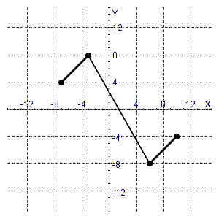
(a)
(b)
(c)

5. Choose the correct answer to explain how the graph of g is obtained from the graph of f :
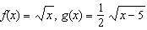

a. | The graph of 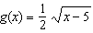 is obtained by shifting the graph of upward 5 units, and then shrinking the graph vertically by a factor of .
b. | The graph of is obtained by shifting the graph of to the left 5 units, and then shrinking the graph vertically by a factor of .
c. | The graph of is obtained by shifting the graph of to the right 5 units.
d. | The graph of is obtained by shifting the graph of to the right 5 units, and then shrinking the graph vertically by a factor of .
e. | The graph of is obtained by shifting the graph of downward 5 units.  Ans

Answer: __________________________________

6. Determine the correct equation for the line whose graph is sketched below.

Equation: _______________________________

7. Write the equation IN SLOPE-INTERCEPT FORM for the line passing through the point (7, 5) which is perpendicular to the line shown below:

2x + y = –15

Equation: _______________________________

8. The graph of a function g is given below.

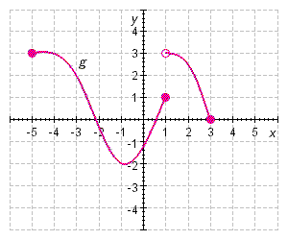

(a) Find g(–5) = _____.

(b) Find g(–3) = _____.

(c) Find g(–1) = _____.

(d) Find g(1) = _____.

(e) Find g(3) = _____.

(f) Find the domain of g: ____________________

(g) Find the range of g:_____________________.

9. Determine whether the function f (x) = 5x ⁵ + 7x +8 is even, odd, or neither. GIVE YOUR REASON.

Answer: ___________________________________________________________________________

10. Consider the function f(x) = 3|x – 5| + 5. Graph the function, and then answer the following:

(a). Find the x-intercept(s) of the function: ________________.

(b). Find the y-intercept of the function: __________________.

(c). Find the domain of the function: ______________________.

(d). Find the range of the function: ________________________.

(e). List the interval(s) where the function is increasing: __________________________.

(f). List the interval(s) where the function is decreasing: ____________________________.

(g). Determine the relative and absolute minimum (if any exist): _________________________________.

(h). Determine the relative and absolute maximum (if any exist): _________________________________.

