Question 1
The following shows the temperatures (high, low) and weather conditions in a given Sunday for some selected world cities. For the weather conditions, the following notations are used: c = clear; cl = cloudy; sh = showers; pc = partly cloudy.
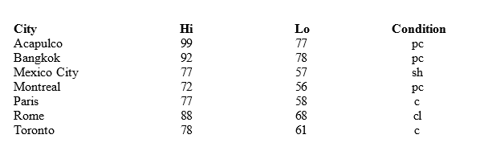
How many elements are in this data set?
How many variables are in this data set?
How many observations are in this data set?
Name the variables and indicate whether they are categorical or quantitative.

Question 2
A student has completed 20 courses in the School of Arts and Sciences. Her grades in the 20 courses are shown below.
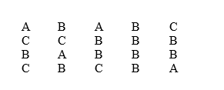
Develop a frequency distribution and a bar chart for her grades.
Develop a relative frequency distribution for her grades and construct a pie chart.

Question 3
The number of hours worked per week for a sample of ten students is shown below.
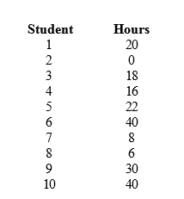
Determine the median and explain its meaning.
Compute the 70th percentile and explain its meaning.
What is the mode of the above data? What does it signify?

Question 4
You are given the following information on Events A, B, C, and D.
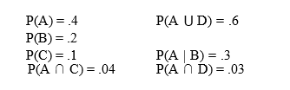
Compute P(D).
Compute P(A ∩ B).
Compute P(A | C).
Compute the probability of the complement of C.
Are A and B mutually exclusive? Explain your answer.
Are A and B independent? Explain your answer.
Are A and C mutually exclusive? Explain your answer.
Are A and C independent? Explain your answer.

Question 5
When a particular machine is functioning properly, 80% of the items produced are non-defective.
If three items are examined, what is the probability that one is defective?
Use the binomial probability function to answer this question.

Question 6
The average starting salary of this year’s graduates of a large university (LU) is $20,000 with a standard deviation of $8,000. Furthermore, it is known that the starting salaries are normally distributed.
What is the probability that a randomly selected LU graduate will have a starting salary of at least $30,400?
Individuals with starting salaries of less than $15,600 receive a low income tax break. What percentage of the graduates will receive the tax break?
What are the minimum and the maximum starting salaries of the middle 95.4% of the LU graduates?

Question 7
A simple random sample of 6 computer programmers in Houston, Texas revealed the sex of the programmers and the following information about their weekly incomes.
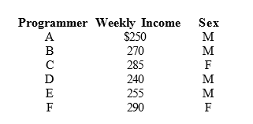
What is the point estimate for the average weekly income of all the computer programmers in Houston?
What is the point estimate for the standard deviation of the population?
Determine a point estimate for the proportion of all programmers in Houston who are female.

Question 8
Students of a large university spend an average of $5 a day on lunch. The standard deviation of the expenditure is $3. A simple random sample of 36 students is taken.
What are the expected value, standard deviation, and shape of the sampling distribution of the sample mean?
What is the probability that the sample mean will be at least $4?
What is the probability that the sample mean will be at least $5.90?

