Signature Assignment: Creating Visuals From Data
Dion Thomas
MTH/216
March 13, 2017
Professor Dawn McNair

I chose the business scenario.
This scenario interests me since I will be able to understand business interactions among different variables and factors. It will provide me with a platform to analyze and understand changes in business trends overtime, and be able to generate valuable insight from it. Hampering interests in business analytics, this scenario will be an important point of reference, as I will be able to understand important concept in analysis and forecasting. In addition, I will be able to fathom and express interaction between people, factors and time in making business decisions. The ability to hold that conversation between different objects, theories and tools in making predictions in business makes this scenario ideal.
In the analysis I hope to find the correlation between the time changes and the change in purchase of tires. I hope to get valuable information regarding the data as well useful insights on customer and market preferences over time. The historical review on purchase of tires will provide critical insight on how the tread could change in the future, thereby enabling prediction on future stock.

Year | Number of tires purchase
2010 | 54500
2011 | 57500
2012 | 58000
2013 | 63000
2014 | 66000
2015 | 69000
2016 | 75000

Scatter plot
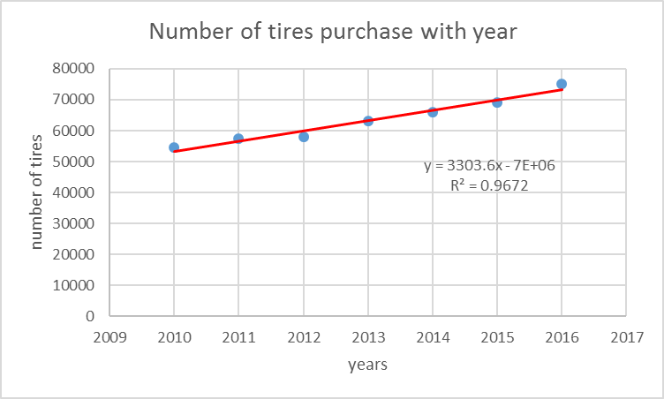
Variation of the purchasing tire with the time in year approximately liner. This plot can be use to predict the future demand of the tires.
Prediction of 2017,
$$Y=3303.6x-7*e^{6}$$
$$Y=6660537$$
Predicted number of tires selling in 2017 = 6,660,537
The prediction is 96.72% confident because the r² value of the following equation is 0. 9762. So it is very strong correlation value. If the correlation value is small we cannot predict the future demand very confidently. But if the correlation value is high, we can predict the future demand with high confident level.so as the above calculations the demand of the 2017 will be 6,660,537 tires.
Bar chart
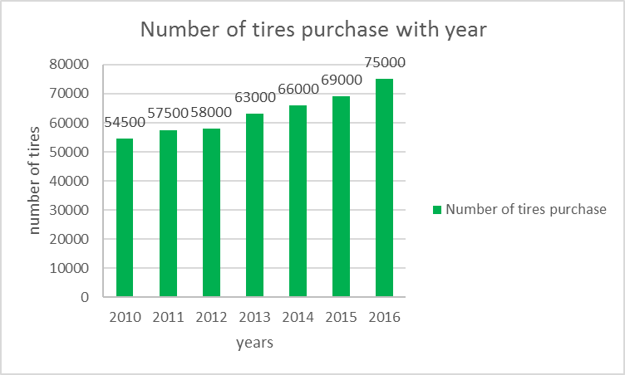
Bar chart shows some relation between the purchased tires and the years. We can clearly see the number of tiers sold is increased with the years.so comparing with the pie charts. Bar charts give more idea about the relation of the variation parameters.

Mean of sample data
$$Mean=\frac{Sum of all data}{Number of data}$$
$$Mean=\frac{54500+57500+58000+63000+66000+69000+75000}{7}$$
$$Mean=63285.71$$
This is something that must be added.
It might be helpful to include a scatterplot with the exponential regression and r^2 to determine which of the two models is more reliable; linear or exponential.

