Question 1
Compute the weighted mean for the following data.
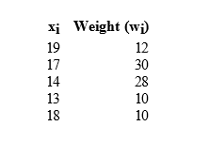

Question 2
If P(A) = 0.50, P(B) = 0.40, and P(A ∪ B) = 0.88, then P(B | A) =

Question 3
Six vitamin and three sugar tablets identical in appearance are in a box. One tablet is taken at random and given to Person A. A tablet is then selected and given to Person B. What is the probability that
*Person A was given a vitamin tablet?
*Person B was given a sugar tablet given that Person A was given a vitamin tablet?
*neither was given vitamin tablets
*both were given vitamin tablets?
*exactly one person was given a vitamin tablet?
*Person A was given a sugar tablet and Person B was given a vitamin tablet?
*Person A was given a vitamin tablet and Person B was given a sugar tablet?

