Test 1
Question 1 of 20 | 0.0/ 5.0 Points
____ two points are collinear.

A. Any
B. Sometimes
C. No

Question 2 of 20 | 5.0/ 5.0 Points
Name an angle adjacent to
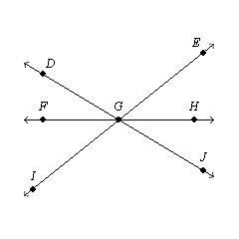

A.
B.
C.
D.

Question 3 of 20 | 0.0/ 5.0 Points
Miriam has 62 feet of fencing to make a rectangular vegetable garden. Which dimensions will give Miriam the garden with greatest area? The diagrams are not to scale.

A. 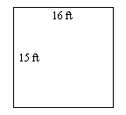
B. 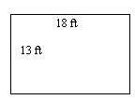
C. 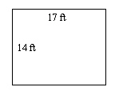
D. 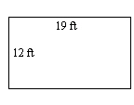

Question 4 of 20 | 0.0/ 5.0 Points
What is the length of

A. 13
B. 16
C. 15
D. 3

Question 5 of 20 | 0.0/ 5.0 Points
What is the intersection of plane STXW and plane SVUT?
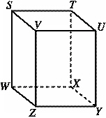

A.
B.
C.
D.

Question 6 of 20 | 0.0/ 5.0 Points
Which diagram shows plane PQR and plane QRS intersecting only in ?

A. 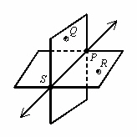
B. 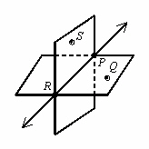
C. 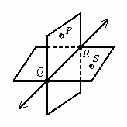
D. 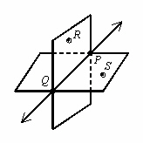

Question 7 of 20 | 0.0/ 5.0 Points
Which angle is a right angle?

A. 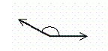
B. 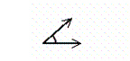
C. 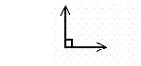
D. 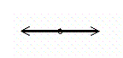

Question 8 of 20 | 5.0/ 5.0 Points
Plane ABC and plane BCE ____ be the same plane.

A. must
B. may
C. cannot

Question 9 of 20 | 0.0/ 5.0 Points
bisects and Solve for x and find The diagram is not to scale.
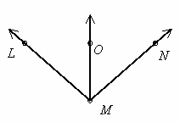

A. x = 13,
B. x = 13,
C. x = 14,
D. x = 14,

Question 10 of 20 | 0.0/ 5.0 Points
Find the coordinates of the midpoint of the segment whose endpoints are H(6, 4) and K(2, 8).

A. (4, 4)
B. (2, 2)
C. (8, 12)
D. (4, 6)

Question 11 of 20 | 5.0/ 5.0 Points
Which three-dimensional figure matches this net?
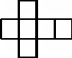

A. 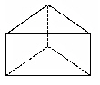
B. 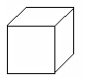
C. 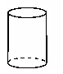
D. 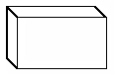

Question 12 of 20 | 0.0/ 5.0 Points
How are the two angles related?
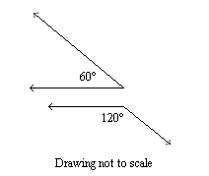

A. supplementary
B. adjacent
C. vertical
D. complementary

Question 13 of 20 | 0.0/ 5.0 Points
If Z is the midpoint of what are x, RZ, and RT?
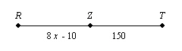

A. x = 18, RZ = 134, and RT = 268
B. x = 22, RZ = 150, and RT = 300
C. x = 20, RZ = 150, and RT = 300
D. x = 20, RZ = 300, and RT = 150

Question 14 of 20 | 0.0/ 5.0 Points
If EF = 7 and EG =19 , find the value of FG. The drawing is not to scale.
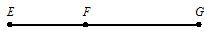

A. 14
B. 11
C. 7
D. 12

Question 15 of 20 | 0.0/ 5.0 Points
What plane contains points C, D, and G?
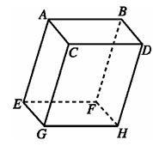

A. The plane on the bottom of the figure
B. The plane on the top of the figure
C. The plane on the side of the figure
D. The plane that passes at the slant through the figure

Question 16 of 20 | 0.0/ 5.0 Points
In the figure shown, . Which of the following statements is false?
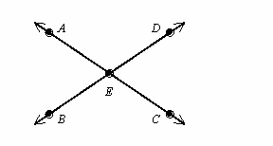

A.
B. BEC and AED are vertical angles.
C. AEB and BEC are vertical angles.
D.

Question 17 of 20 | 0.0/ 5.0 Points
What is the name of the ray that is opposite ?
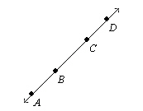

A.
B.
C.
D.

Question 18 of 20 | 5.0/ 5.0 Points
Name a fourth point in plane WXV.
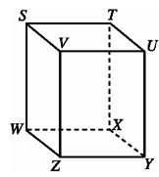

A.
X
B.
Z
C.
U
D.
T

Question 19 of 20 | 0.0/ 5.0 Points
Which point is the midpoint of ?
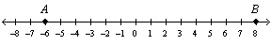

A. –0.5
B. 2
C. 1
D. 3

Question 20 of 20 | 5.0/ 5.0 Points
Name the intersection of plane ACG and plane BCG.

A.

B.

C.

D.
The planes need not intersect.

