Test 2
Question 1 of 20 | 5.0/ 5.0 Points
What is a counterexample for the conjecture? Conjecture: Any number that is divisible by 4 is also divisible by 8.

A. 24
B. 40
C. 12
D. 26

Question 2 of 20 | 0.0/ 5.0 Points
Identify the hypothesis and conclusion of this conditional statement: If two lines intersect at right angles, then the two lines are perpendicular.

A. Hypothesis: The two lines are perpendicular. Conclusion: Two lines intersect at right angles.
B. Hypothesis: Two lines intersect at right angles. Conclusion: The two lines are perpendicular.
C. Hypothesis: The two lines are not perpendicular. Conclusion: Two lines intersect at right angles.
D. Hypothesis: Two lines intersect at right angles. Conclusion: The two lines are not perpendicular.

Question 3 of 20 | 0.0/ 5.0 Points
What is a counterexample for the conjecture? Conjecture: The product of two positive numbers is greater than the sum of the two numbers.

A. 3 and 5
B. 2 and 2
C. A counterexample exists, but it is not shown above.
D. There is no counterexample. The conjecture is true.

Question 4 of 20 | 0.0/ 5.0 Points
Another name for an if-then statement is a ____. Every conditional has two parts. The part following if is the ____ , and the part following then is the ____.

A. conditional; conclusion; hypothesis
B. hypothesis; conclusion; conditional
C. conditional; hypothesis; conclusion
D. hypothesis; conditional; conclusion

Question 5 of 20 | 0.0/ 5.0 Points
Find the values of x and y.
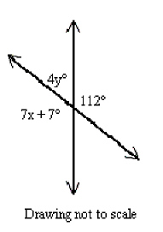

A. x = 15, y = 17
B. x = 112, y = 68
C. x = 68, y = 112
D. x = 17, y = 15

Question 6 of 20 | 0.0/ 5.0 Points
Substitution Property of Equality If , then ______.

A.
B.
C.
D.

Question 7 of 20 | 0.0/ 5.0 Points
Which statement is a counterexample for the following conditional? If you live in Springfield, then you live in Illinois.

A. Sara Lucas lives in Springfield.
B. Jonah Lincoln lives in Springfield, Illinois.
C. Billy Jones lives in Chicago, Illinois.
D. Erin Naismith lives in Springfield, Massachusetts.

Question 8 of 20 | 0.0/ 5.0 Points
Name the Property of Equality that justifies this statement: If l=m , then m=l .

A.
Multiplication Property
B.
Symmetric Property
C.
Subtraction Property
D.
Transitive Property

Question 9 of 20 | 0.0/ 5.0 Points
Alfred is practicing typing. The first time he tested himself, he could type 45 words per minute. After practicing for a week, he could type 48 words per minute. After two weeks he could type 51 words per minute. Based on this pattern, predict how fast Alfred will be able to type after 4 weeks of practice.

A.
61 words per minute
B.
57 words per minute
C.
54 words per minute
D.
51 words per minute

Question 10 of 20 | 5.0/ 5.0 Points
Which conditional has the same truth value as its converse?

A. If x = 7, then .
B. If a figure is a square, then it has four sides.
C. If x – 17 = 4, then x = 21.
D. If an angle has a measure of 80, then it is acute.

Question 11 of 20 | 0.0/ 5.0 Points
Which choice shows a true conditional, with the hypothesis and conclusion identified correctly?

A. Yesterday was Monday if tomorrow is Thursday. Hypothesis: Tomorrow is Thursday. Conclusion: Yesterday was Monday.
B. If tomorrow is Thursday, then yesterday was Tuesday. Hypothesis: Yesterday was Tuesday. Conclusion: Tomorrow is not Thursday.
C. If tomorrow is Thursday, then yesterday was Tuesday. Hypothesis: Yesterday was Tuesday. Conclusion: Tomorrow is Thursday.
D. If yesterday was Tuesday then tomorrow is Thursday. Hypothesis: Yesterday was Tuesday. Conclusion: tomorrow is Thursday.

Question 12 of 20 | 0.0/ 5.0 Points
Draw a Venn diagram to illustrate this conditional:
Cars are motor vehicles.

A.
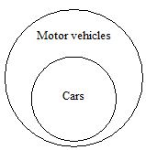
B.
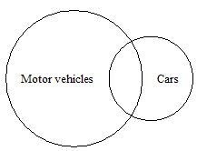
C.
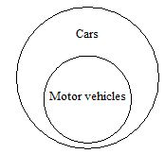
D.
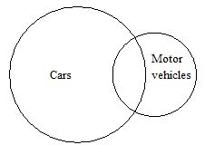

Question 13 of 20 | 5.0/ 5.0 Points
What is the conclusion of the following conditional?
A number is divisible by 2 if even.

A. The sum of the digits of the number is divisible by 2.
B. If a number is even, then the number is divisible by 2.
C. The number is even.
D. The number is divisible by 2.

Question 14 of 20 | 0.0/ 5.0 Points
Based on the pattern, what are the next two terms of the sequence? 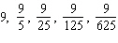 . . .

A. 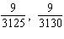
B. 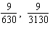
C. 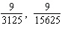
D. 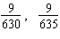

Question 15 of 20 | 0.0/ 5.0 Points
Which statement is an example of the Addition Property of Equality? Use the given property to complete the statement.

A. If p = q then
B. If p = q then
C. If p = q then
D. p = q

Question 16 of 20 | 5.0/ 5.0 Points
What conjecture can you make about the fourteenth figure in this pattern?
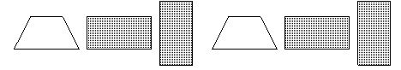

A.
The fourteenth figure in the pattern is 
B.
The fourteenth figure in the pattern is 
C.
The fourteenth figure in the pattern is 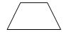
D.
There is not enough information.

Question 17 of 20 | 0.0/ 5.0 Points
Which statement is the Law of Syllogism?

A. If is a true statement and p is true, then q is true.
B. If is a true statement and q is true, then p is true.
C. If and are true statements, then is a true statement.
D. If and are true statements, then is a true statement.

Question 18 of 20 | 5.0/ 5.0 Points
Which statement is the Law of Detachment?

A. If is a true statement and q is true, then p is true.
B. If is a true statement and q is true, then is true.
C. If and are true, then is a true statement.
D. If is a true statement and p is true, then q is true.

Question 19 of 20 | 0.0/ 5.0 Points
Write this statement as a conditional in if-then form: All triangles have three sides.

A. If a triangle has three sides, then all triangles have three sides.
B. If a figure has three sides, then it is not a triangle.
C. If a figure is a triangle, then all triangles have three sides.
D. If a figure is a triangle, then it has three sides.

Question 20 of 20 | 0.0/ 5.0 Points
Transitive Property of Congruence If ______.

A.
B.
C.
D.

