Is the use of vaccinations necessary?

FDA Regulations- who’s in control, standards

Benefits- progress on diseases, effectiveness, and harmful claims
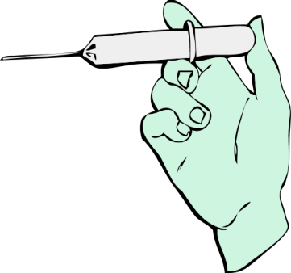
Cures- population statistics, today’s usage
Invention- Edward Jenner info and tests
Research-ingredients and tests
Safety- side effects

From all the questions on my map I do feel that these three are the most important for a good research? (All are still valuable.)
- Why was vaccines invented?
- Is it enough research on vaccines?
- Do vaccines cure or diminish diseases?

