Imagine you are a manager at a major bottling company. Customers have begun to complain that the bottles of the brand of soda produced in your company contain less than the advertised sixteen (16) ounces of product. Your boss wants to solve the problem at hand and has asked you to investigate. You have your employees pull thirty (30) bottles off the line at random from all the shifts at the bottling plant. You ask your employees to measure the amount of soda there is in each bottle. Note: Use the data set provided by your instructor to complete this assignment.
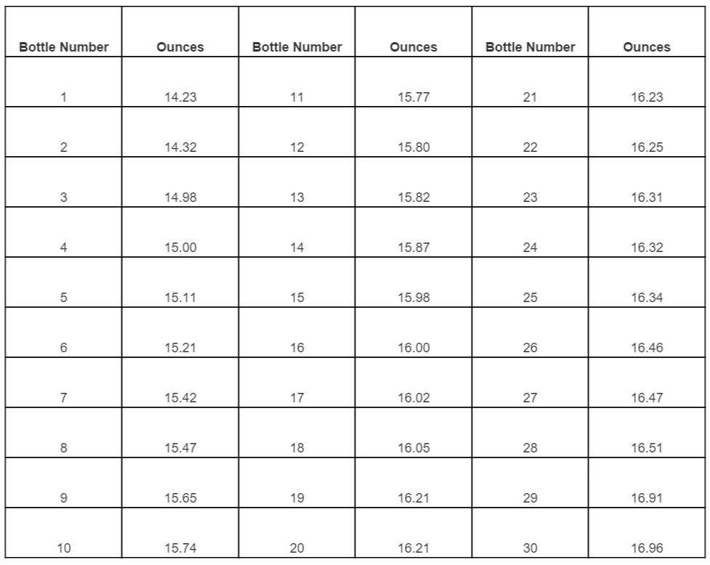
Write a two to three (2-3) page report in which you:
- Calculate the mean, median, and standard deviation for ounces in the bottles.
- Construct a 95% Confidence Interval for the ounces in the bottles.
- Conduct a hypothesis test to verify if the claim that a bottle contains less than sixteen (16) ounces is supported. Clearly state the logic of your test, the calculations, and the conclusion of your test.
- Provide the following discussion based on the conclusion of your test:
a. If you conclude that there are less than sixteen (16) ounces in a bottle of soda, speculate on three (3) possible causes. Next, suggest the strategies to avoid the deficit in the future.
Or
b. If you conclude that the claim of less soda per bottle is not supported or justified, provide a detailed explanation to your boss about the situation. Include your speculation on the reason(s) behind the claim, and recommend one (1) strategy geared toward mitigating this issue in the future.
Your assignment must follow these formatting requirements:
- Be typed, double spaced, using Times New Roman font (size 12), with one-inch margins on all sides. No citations and references are required, but if you use them, they must follow APA format. Check with your professor for any additional instructions.
- Include a cover page containing the title of the assignment, the student’s name, the professor’s name, the course title, and the date. The cover page and the reference page are not included in the required assignment page length.

