HESC 360 First Homework July 2016 Name____ _______________
1.- A RN performed a two groups clinical trial with for A1C patients that were controlling its diabetes with Metformin ( group A) and Metformin with Glyburide (group B), after 3 month taking the tablets, with the following A1C results:
Group A | 5.2 | 5.8 | 5.4 | 4.2 | 4.7 | 5.7 | 5.3 | 5.6 | 5.4 | 6.0
Group B | 4.8 | 4.9 | 5.0 | 4.4 | 5.1 | 5.9 | 5.8 | 5.2 | 5.7 | 5.6
Normal ranges for hemoglobin A1c in people without diabetes is about 4% to 5.9%. People with diabetes with poor glucose control have hemoglobin A1c levels above 7%
The data was analyzed by SPSS obtaining:
Statistics
 |  | A1CGroupA | A1CGropupB
N | Valid | 10 | 10
N | Missing | 0 | 0
Mean |  | 5.330 | 5.240
Std. Error of Mean |  | .1693 | .1558
Median |  | 5.400 | 5.150
Mode |  | 5.4 | 4.4ª
Std. Deviation |  | .5355 | .4926
Variance |  | .287 | .243
Skewness |  | -1.103 | -.147
Std. Error of Skewness |  | .687 | .687
Kurtosis |  | 1.135 | -.996
Std. Error of Kurtosis |  | 1.334 | 1.334
Range |  | 1.8 | 1.5
Percentiles | 25 | 5.075 | 4.875
Percentiles | 50 | 5.400 | 5.150
Percentiles | 75 | 5.725 | 5.725
a. Multiple modes exist. The smallest value is shown

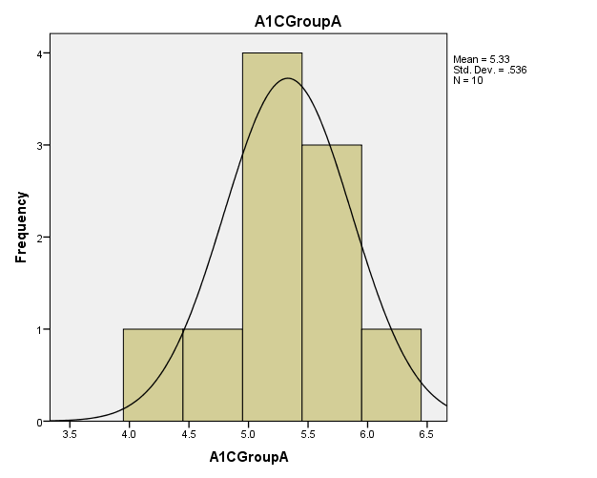
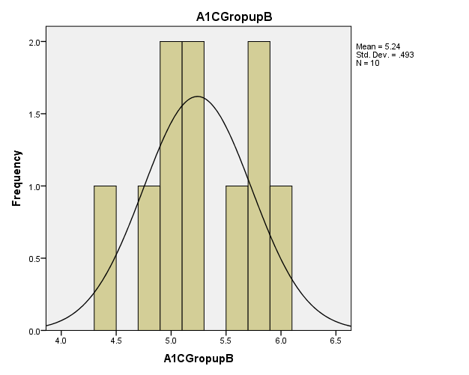

a.- Explain why a multimode result was reported for group B and from its graph report the values of both modes.
b.- Can we reject that the data of both groups depart from Normality?. Explain your conclusion with the corresponding values.
c.- The following table shows the t test comparing both independent groups:

Independent Samples Test
 |  | Levene's Test for Equality of Variances |  | t-test for Equality of Means
 |  | F | Sig. | t | df | Sig. (2-tailed) | Mean Difference | Std. Error Difference | 95% Confidence Interval of the Difference
 |  |  |  |  |  |  |  |  | Lower | Upper
A1Cbothgroups | Equal variances assumed | .032 | .860 | .391 | 18 | .700 | .09000 | .23010 | -.39342 | .57342
A1Cbothgroups | Equal variances not assumed |  |  | .391 | 17.876 | .700 | .09000 | .23010 | -.39366 | .57366
c-1- Express the null and the alternative hypothesis for this situation.
c.2.-Report the value of the t test: ____________
c.3.-Can we conclude that the results for both groups are significantly different? ____________
c.4- Conclude about the hypothesis that support your results._____________
c.5.- Discuss the meaning of the 95% confidence interval of the difference:_
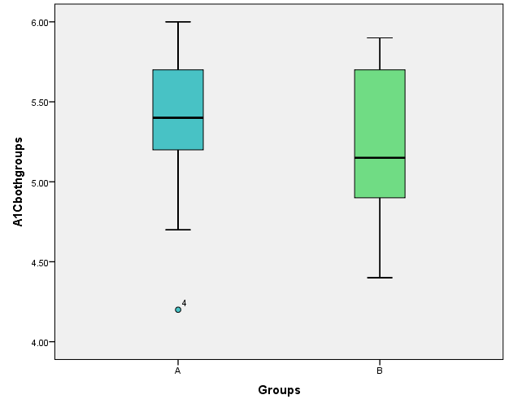

c.4.- Mark in both graphs the upper and lower quartile, the median and the 95% confidence interval for each group and if there is an outlier.

Note the t _{critical}, for df=18, sig.=0.05 and two tail test = 2.101
2.- The following glucose results came from 36 females selected from a Hospital.
The average value of the group = 144.8 mg/dL . with a variance (S² ) = 9.0
Is that value significantly higher than the limit for prediabetes historically expected 140 mg/dL.?
Calcule the Z_{score} =
b.-Select the proper Z_{critical} for your comparison: Z_{critical} = 1.645 (one tail) or Z_{critical} =2.0 (two tails)
c.- Can you tell that the group should be considered prediabetic and deserves a proper treatment?
3.- The historical proportion of a certain disease in a South American tropical town is 0.9 % (group A) but in a rainy season the RN found 12 cases in a population of 1255 inhabitants (group B). Should the nurse recommend special measures?
Determine the Z_{score}, and answer yes or no.
Can she support that there is a significant difference between group A and B?

