Module 8 Problem Set Solutions
Factorial (2 x 3) MANOVA
1. | Is there a sufficient correlation between the dependent variables to justify the use of MANOVA?  YES! THE DEPENDENT VARIABLES ARE BOTH CONCEPTUALLY AND STATISTICALLY (r = .513) RELATED.
2. | Was the assumption of Equality of Covariance Matrices violated? Explain.  NO! RESULT OF THE BOX'S TEST OF EQUALITY OF COVARIANCE MATRICES INDICATED NO VIOLATION (p = .463).
3. | Is there a statistically significant multivariate interaction effect?  YES!  Identify the dependent variable(s) of this interaction effect.  EMOTION ONLY
4. | What would be the proper follow-up tests for a statistically significant interaction effect?  CONDUCT TWO SEPARATE ONE-WAY ANOVAs WITH TREATMENT AS THE INDEPENDENT VARIABLE FOR MALES AND FEMALES. IF THE ONE-WAY ANOVAs REPORT A STATISTICALLY SIGNIFICANT OMNIBUS, THEN PERFORM THE APPROPRIATE POST-HOC.
5. | Identify the proper post hoc analyses for any statistically significant univariate effects. Explain your answer.  THE LSD IS ONE OF THE PROPER POST-HOCS BECAUSE THE EQUAL VARIANCES ASSUMPTION IS NOT VIOLATED.
6. | Is there a statistically significant multivariate gender effect on the dependent variate?  YES! BUT BECAUSE THERE IS AN INTERACTION EFFECT, THIS MAIN EFFECT IS OF LITTLE INTEREST.
7. | Why would a researcher conduct a MANOVA instead of several ANOVAs?  THERE ARE AT LEAST TWO REASONS TO CONDUCT A MANOVA INSTEAD OF A SERIES OF ANOVAs. (1) MANOVA IS A MORE POWERFUL STATISTICAL TECHNIQUE (I.E., IT IS BETTER ABLE TO DETECT DIFFERENCES IF THEY REALLY EXIST), (2) MANOVA CONTROLS FOR AN INFLATED TYPE I ERROR.
8. | Write a Results section for this research.

Correlations
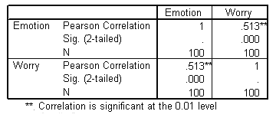
General Linear Model
Box's Test of Equality of Covariance Matricesª
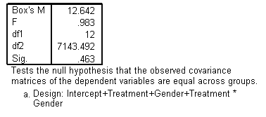

Multivariate Tests ^{c}
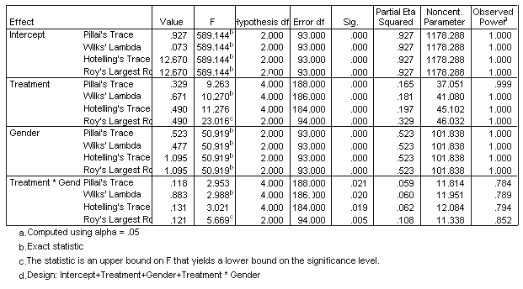

Levene's Test of Equality of Error Variances ª
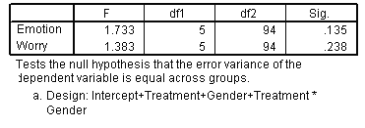

Tests of Between-Subjects Effects
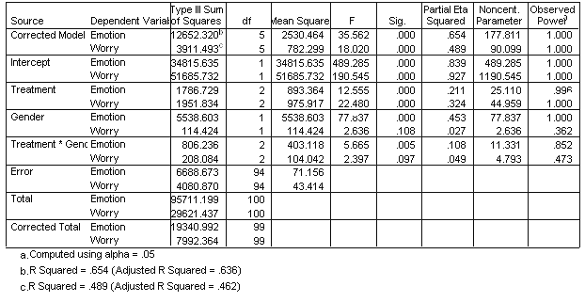
General Linear Model
1. Treatment
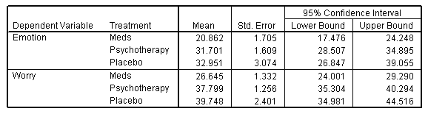

2. Gender
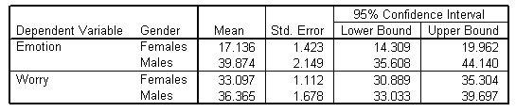

3. Treatment * Gender
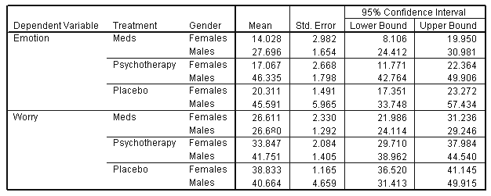
Univariate Analysis of Variance
Tests of Between-Subjects Effects
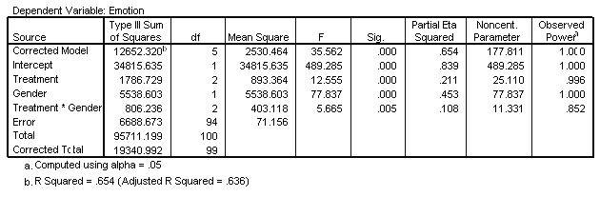
Estimated Marginal Means
1. Treatment
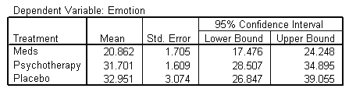

2. Gender
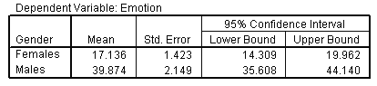

3. Treatment * Gender
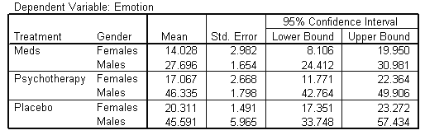
Univariate Analysis of Variance for MALES
Tests of Between-Subjects Effects
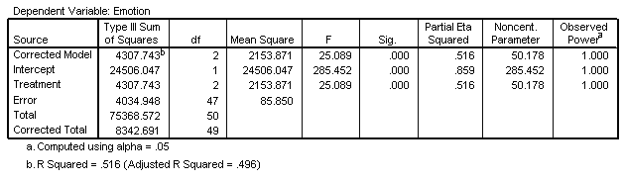
Estimated Marginal Means
Treatment
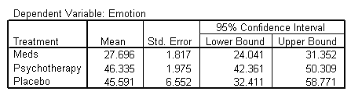
Post Hoc Tests
Multiple Comparisons
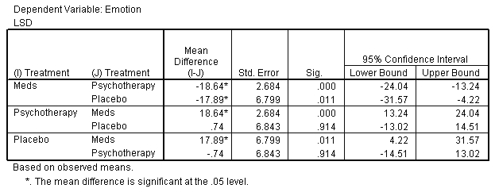
Univariate Analysis of Variance for FEMALES
Tests of Between-Subjects Effects
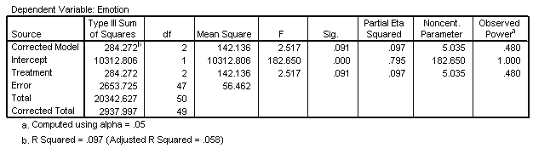
Estimated Marginal Means
Treatment
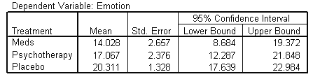
Post Hoc Tests Treatment
Multiple Comparisons
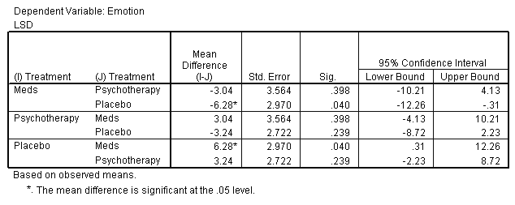
Univariate Analysis of Variance for TREATMENT Main Effect
Tests of Between-Subjects Effects
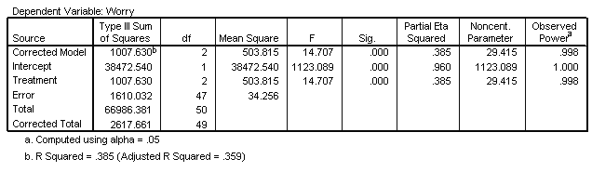
Estimated Marginal Means
Treatment
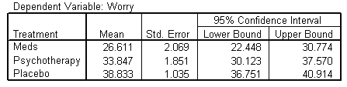
Post Hoc Tests
Treatment
