- Midterm
There are 8 questions in total, each worth 12.5 points. Please upload your answers to the dropbox below.
Question 1
The following shows the temperatures (high, low) and weather conditions in a given Sunday for some selected world cities. For the weather conditions, the following notations are used: c = clear; cl = cloudy; sh = showers; pc = partly cloudy.
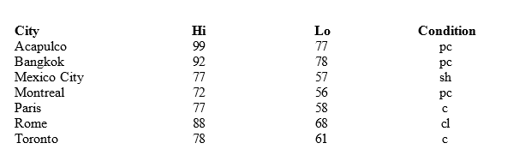
  - How many elements are in this data set?
  - How many variables are in this data set?
  - How many observations are in this data set?
  - Name the variables and indicate whether they are categorical or quantitative.

Question 2
A student has completed 20 courses in the School of Arts and Sciences. Her grades in the 20 courses are shown below.
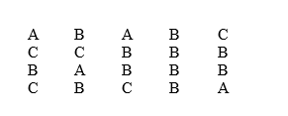
  - Develop a frequency distribution and a bar chart for her grades.
  - Develop a relative frequency distribution for her grades and construct a pie chart.

Question 3
The number of hours worked per week for a sample of ten students is shown below.
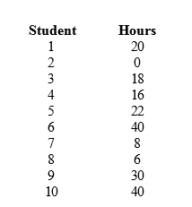
  - Determine the median and explain its meaning.
  - Compute the 70th percentile and explain its meaning.
  - What is the mode of the above data? What does it signify?

Question 4
You are given the following information on Events A, B, C, and D.
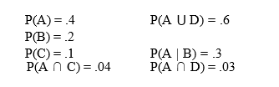
  - Compute P(D).
  - Compute P(A ∩ B).
  - Compute P(A | C).
  - Compute the probability of the complement of C.
  - Are A and B mutually exclusive? Explain your answer.
  - Are A and B independent? Explain your answer.
  - Are A and C mutually exclusive? Explain your answer.
  - Are A and C independent? Explain your answer.

Question 5
  - When a particular machine is functioning properly, 80% of the items produced are non-defective.
  - If three items are examined, what is the probability that one is defective?
  - Use the binomial probability function to answer this question.

Question 6
The average starting salary of this year’s graduates of a large university (LU) is $20,000 with a standard deviation of $8,000. Furthermore, it is known that the starting salaries are normally distributed.
  - What is the probability that a randomly selected LU graduate will have a starting salary of at least $30,400?
  - Individuals with starting salaries of less than $15,600 receive a low income tax break. What percentage of the graduates will receive the tax break?
  - What are the minimum and the maximum starting salaries of the middle 95.4% of the LU graduates?

Question 7
A simple random sample of 6 computer programmers in Houston, Texas revealed the sex of the programmers and the following information about their weekly incomes.
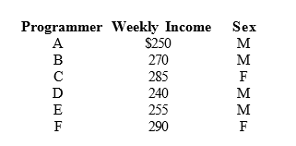
  - What is the point estimate for the average weekly income of all the computer programmers in Houston?
  - What is the point estimate for the standard deviation of the population?
  - Determine a point estimate for the proportion of all programmers in Houston who are female.

Question 8
Students of a large university spend an average of $5 a day on lunch. The standard deviation of the expenditure is $3. A simple random sample of 36 students is taken.
  - What are the expected value, standard deviation, and shape of the sampling distribution of the sample mean?
  - What is the probability that the sample mean will be at least $4?
  - What is the probability that the sample mean will be at least $5.90?

