1. The Area of a rectangle is represented by​ 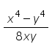 ​and its length is represented by 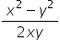a. What is the width of the rectangle?
b. If you double the length of the rectangle but keep the same width, what is the new area of the rectangle?

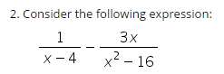
- Subtract the rational expressions

- Given the equation ​, 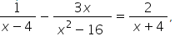
solve the equation using your solution from part a.

- Solve the equation 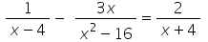 using LCD.

- Compare the methods used to solve the equation in parts c and d. Which method do you think is better and why?

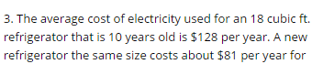
( Source: https://www.efficiencyvermont.com)
- Suppose a new refrigerator costs $500. Determine the total cost of having either refrigerator for 12 years, assuming the only costs associated with the refrigerator are its purchase cost and electricity.

- Determine the total annual cost for a new refrigerator that lasts 12 years, assuming the only costs associated with the refrigerator are its purchase cost and electricity.

- Write a function that gives the annual cost of a new refrigerator as a function of the number of years you own the refrigerator.

- What are the asymptotes of the rational function in part d? What does the horizontal asymptote mean in the context of this problem?

- Sketch the graph of the rational function from part c.

- If you plan on owning your refrigerator for 12 years, would it be more cost effective to keep your old refrigerator or purchase a new one? Explain.

