53) | 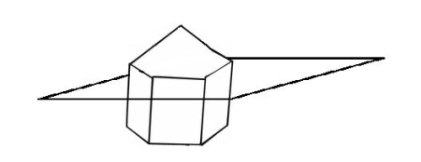  This pentagonal prism is cut by the plane shown. The plane is parallel to the base of the pentagonal prism. What is the shape of the cross-section?

 | A) | hexagon.
 | B) | pentagon.
 | C) | rectangle.
 | D) | triangle.
54) | 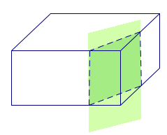  A plane intersects a rectangular prism as shown. Describe the cross-section.

 | A) | circle
 | B) | rectangle
 | C) | trapezoid
 | D) | triangle
55) | Identify the center of the circle whose equation is  (x - 2)² + (y + 8)² = 16.

 | A) | (-2,-8)
 | B) | (-2,8)
 | C) | (2,-8)
 | D) | (2,8)
56) | On a coordinate grid, where is the center of this circle?  x² + y² = 2

 | A) | (-1, -1)
 | B) | (0, 0)
 | C) | (1, 1)
 | D) | (2, 2)
57) | 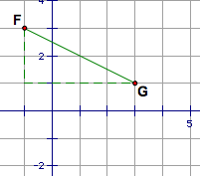  We can find the length of FG using the Distance Formula:  FG =  Which formula also represents the length of FG?
  (3 - 1)² + (-1 - 3)²
  (3 - 1)² + (-1-3)²

 | A) | FG = 4 + 2
 | B) | FG = (4 + 2)²
 | C) | FG = (4 - 2)²
 | D) | FG² = 4² + 2²
58) | The points (5, 3), (3, -4), (10, 3), and (8, -4) are the vertices of a polygon. What type of polygon is formed by these points?

 | A) | Kite
 | B) | Parallelogram
 | C) | Pentagon
 | D) | Trapezoid
59) | Find the slope of a line parallel to y =  x + 3.
  1
  2
  1
  2

 | A) | -2
 | B) | -
  1
  2
 | C)
  1
  2
 | D) | 2
60) | line j: y =  x +  line k: y =  x +  line l: y =  x +  line m: y =  x +  These four lines have been graphed on the same coordinate grid. Which lines are parallel to each other?
  1
  2
  1
  2
  2
  3
  1
  2
  1
  2
  2
  3
  2
  3
  3
  2
  3
  2
  1
  2

 | A) | j and l
 | B) | j amd m
 | C) | k and l
 | D) | k and m
61) | Find the point, M, that divides segment AB into a ratio of 3:2 if A is at (0, 15) and B is at (20, 0).

 | A) | (9, 6)
 | B) | (12, 6)
 | C) | (12, 9)
 | D) | (9, 12)
62) | Find the point, M, that divides segment AB into a ratio of 4:7 if A is at (-33, 0) and B is at (0, 44).

 | A) | (-22, 15)
 | B) | (-22, 16)
 | C) | (-21, 15)
 | D) | (-21, 16)
63) | 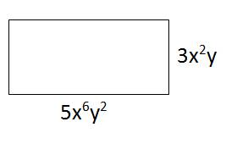  What is the area of this rectangle?

 | A) | 8x⁸ y³
 | B) | 8x⁸ y²
 | C) | 15x⁸ y²
 | D) | 15x⁸ y³
64) | What is the area of a square with a side whose length = x + 5?

 | A) | 2x + 10
 | B) | 4x + 20
 | C) | x² - 10x + 25
 | D) | x² + 10x + 25
65) | 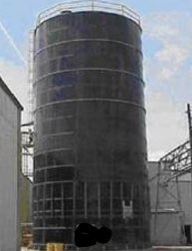  What shape is the bottom of this silo?

 | A) | circle
 | B) | rectangle
 | C) | square
 | D) | triangle
66) | 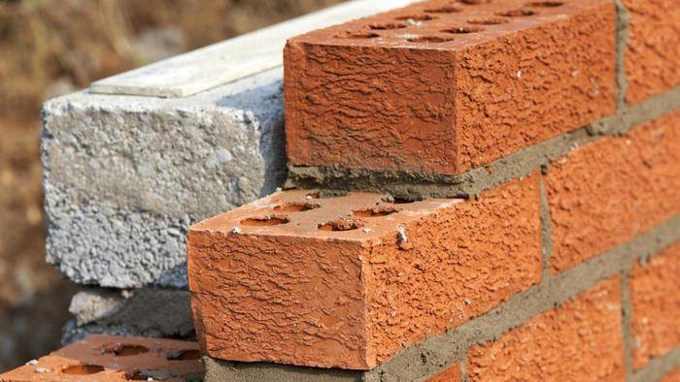  The object shown in this photo closely resembles what geometric solid?

 | A) | cone
 | B) | cube
 | C) | cylinder
 | D) | rectangular prism
67) | 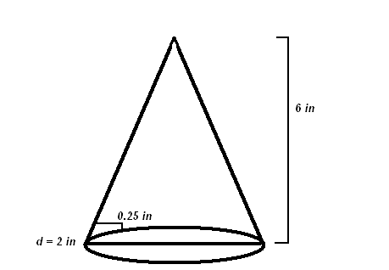  The base of a 6-inch long ice cream cone with a diameter of 2 inches, is cut 0.25 inches from the base. This cut creates two shapes, one is a cone, and the other one resembles a cylinder since it was cut so close to the base. What is the BEST estimate for the volume of the shape that resembles a cylinder?

 | A) | 0.26 cubic inches
 | B) | 0.52 cubic inches
 | C) | 0.79 cubic inches
 | D) | 2.66 cubic inches
68) | 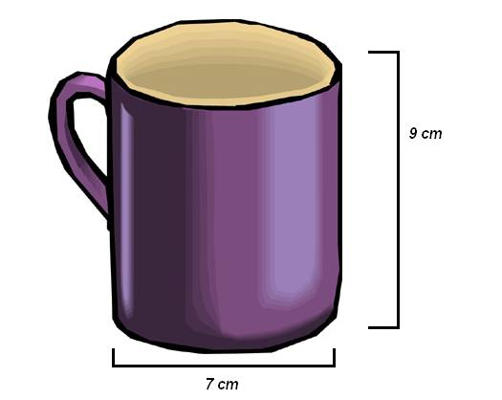  Ray is late for work, but would like to drink some coffee before he leaves. The coffee in the pot is too hot, so Ray puts 20 small ice cubes in a mug before pouring in the coffee. The ice cubes measure 1 cm per side. The mug is cylindrical, and has a height of 9 cm and a base of 7 cm. What is volume of the coffee that will fill the mug after the ice cubes have been added (round to the nearest whole number)?

 | A) | 113 cm³.
 | B) | 326 cm³.
 | C) | 346 cm³.
 | D) | 424 cm³.
69) | A steel plant has two sources of ore, source A and source B. In order to keep the plant running, at least three tons of ore must be processed each day. Ore from source A costs $20 per ton to process, and ore from source B costs $10 per ton to process. Costs must be kept to no more than $80 per day. Moreover, Federal Regulations require that the amount of ore from source B cannot exceed twice the amount of ore from source A. If ore from source A yields 300 lbs of steel per ton, and ore from source B yields 400 lbs of steel per ton, how many tons of ore from each source should be processed each day to maximize the amount of steel produced?

 | A) | 1 ton from source A, 2 tons from source B
 | B) | 2 tons from source A, 4 tons from source B
 | C) | 3 tons from source A, 0 tons from source B
 | D) | 4 tons from source A, 0 tons from source B
70) | Trina has $1000 to purchase an open-top cylindrical dog pen in her backyard. She wants the height of the pen to be 5 feet. If the pen costs $1 per square foot, what is the biggest pen (in terms of the radius) that she can afford? Round your answer to the nearest foot.

 | A) | 8 feet
 | B) | 16 feet
 | C) | 32 feet
 | D) | 64 feet

