Name: ______________
MA 132 Exercise 12a: Introduction to Regression
The most common and the simplest relationship between two variables is linear. This exercise explores linear relationships. That is, if I have two datasets, X (consisting of x₁, y_{x}, x₃…x_{n}) and
Y (consisting of y₁, y₂, y₃…y_{n}), then y₁ = mx₁ +b, y₂ = mx₂ +b, y₃ = mx₃ +b, … and y_{n} = mx_{n} +b. For example, if X = {1, 2, 3, 5, 6, 8} and Y = {5, 7, 9, 13, 15, 19}, I might argue that Y = 2X + 3.

- Let X = {1, 2, 3, 4, 5, 6} and Y = {3, 4, 5, 6, 7}. Find m and b such that Y = mX + b works perfectly for each of the data points.

- Let X = {1, 2, 3, 4, 5, …..} and Y = {5, 8, 11, 14, 17, ….} Find m and b such that Y = mX + b works perfectly for each of the data points.

- Plot the relationship in #2 on the grid below, putting the y values on the vertical axis and the x values on the horizontal.

We call m the slope, and b the y-intercept. These two quantities define a linear relationship completely. The intercept (or y-intercept) describes the y value where the line crosses the vertical axis.
The slope describes how steeply the plot of Y vs X rises. For every unit that x increases, y increases by m units. The slope is key; every linear function has a constant slope. No other function has a constant slope.
We often can find that slope by choosing two points on the data line and calculating the difference in the two y values divided by the difference in the two x values. For instance, if the points (3,6) and (7,8) are on the line, I calculate that the difference in the y values is 2 and the difference in the x values is 3, and therefore m = 2/3, or about 0.67.

- I plot my X and Y data and obtain the following graph.

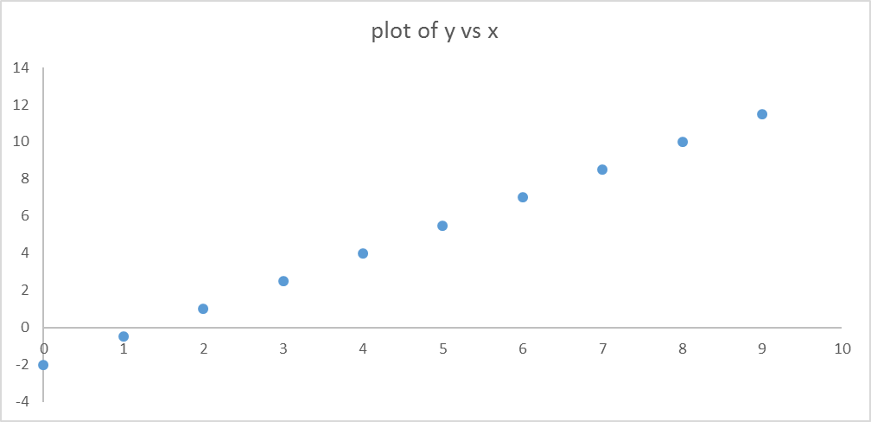

  - How much is m and how much is b?

  - What is the equation that represents this data line?

  - If x = 2.3, how much is y?

- Consider two data sets:
The picture painted above is of ideal data. That’s what you studied in basic algebra. Would that real life were so simple! But no, real data sets are noisy. We have to accept that not all points will lie precisely on our line, even when we are sure the relationship is fundamentally linear.

X = {0, 1, 2, 3, 4, 5}, Y = {1.1, 1.6, 1.9, 2.1, 2.7, 2.9}.

  - Plot these data below.
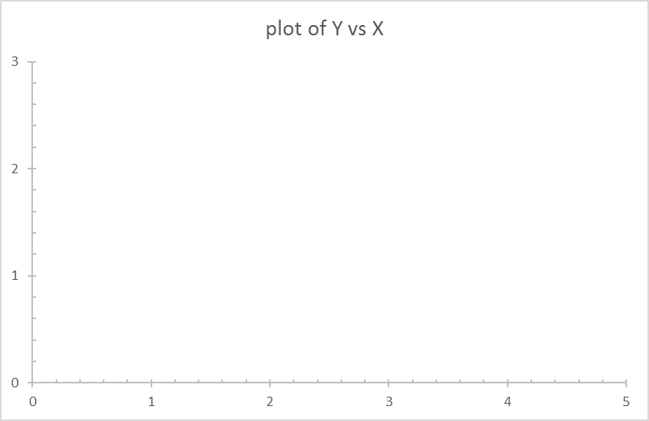

  - Take a straightedge (a ruler, the side of an envelope, an id card – I don’t care what you use, but it must be straight and have an edge) and construct your best estimate of a line through the data. Your line won’t hit every point – might hit no points – but should come close.

  - Find the best equation for the line you drew. (Hint: take two points on your line to calculate m, and find b where the line hits the y axis.)

Y = ___ X + ___

Since real data do not fit a precisely straight line, we need some measure of how far off they are. In fact, we are going to use several measures of goodness-of-fit. The one we’ll learn here is the SSE, or sum of the squares of the errors. It is exactly what it sounds like. The errors are the differences between our linear relationship (what the equation predicts) and what the data actually are.
For example, if our data are X = {1, 2, 3}, Y = {2.3, 3.2, 3.9}, and I am claiming the relationship is Y = 1.0X + 1.0, then my prediction for the Y values is {2.0, 3.0, 4.0}. Those predictions clearly aren’t right; they are off by 0.3, 0.2, and 0.1. I get the SSE by squaring these errors and summing them: SSE = (0.3)² + (0.2)² + (0.1)² = 0.13.
SSE by itself is often not helpful, but it certainly is a good way to compare more than one possible equation. The smaller the SSE, the better the fit.

- Consider the data sets from problem 5 again
X = {0, 1, 2, 3, 4, 5}, Y = {1.1, 1.6, 1.9, 2.1, 2.7, 2.9}.

  - Suppose I claim the best fit is the line Y = 0.5X + 0.8. Find the six Y values that would result when X is 0, 1, 2, 3, 4, and 5.

  - Find the six errors that result from this line.

  - Find the SSE for the linear model Y = 0.5X + 0.8.

  - My friend insists that a better linear model than the one I chose is Y = 0.4X + 1.0. Find the SSE for my friend’s model.

  - Which model is better?

There are an infinite number of linear models that we could have chosen. In class, we will explore ways of finding the best one – the best approximation of the relationship between X and Y data.

