Students, please view the "Submit a Clickable Rubric Assignment" video in the Student Center.
Instructors, training on how to grade is within the Instructor Center.
Case Study 2: Improving E-Mail Marketing Response
Due Week 8 and worth 160 points
Read the following case study.
Students, please view the "Submit a Clickable Rubric Assignment" in the Student Center.
Instructors, training on how to grade is within the Instructor Center.
A company wishes to improve its e-mail marketing process, as measured by an increase in the response rate to e-mail advertisements. The company has decided to study the process by evaluating all combinations of two (2) options of the three (3) key factors: E-Mail Heading (Detailed, Generic); Email Open (No, Yes); and E-Mail Body (Text, HTML). Each of the combinations in the design was repeated on two (2) different occasions. The factors studied and the measured response rates are summarized in the following table.

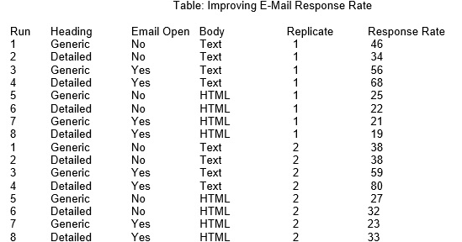

Write a two to three (2-3) page paper in which you:
- Use the data shown in the table to conduct a design of experiment (DOE) in order to test cause-and-effect relationships in business processes for the company.

- Determine the graphical display tool (e.g., Interaction Effects Chart, Scatter Chart, etc.) that you would use to present the results of the DOE that you conducted in Question 1. Provide a rationale for your response.

- Recommend the main actions that the company could take in order to increase the response rate of its e-mail advertising. Provide a rationale for your response.
- Propose one (1) overall strategy for developing a process model for this company that will increase the response rate of its e-mail advertising and obtain effective business process. Provide a rationale for your response.
Your assignment must follow these formatting requirements:

- Be typed, double spaced, using Times New Roman font (size 12), with one-inch margins on all sides; citations and references must follow APA or school-specific format. Check with your professor for any additional instructions.

- Include a cover page containing the title of the assignment, the student’s name, the professor’s name, the course title, and the date. The cover page and the reference page are not included in the required assignment page length.

The specific course learning outcomes associated with this assignment are:

- Build regression models for improving business processes.
- Design experiments to test cause-and-effect relationships in business processes.
- Use technology and information resources to research issues in business process improvement.
- Write clearly and concisely about business process improvement using proper writing mechanics.

