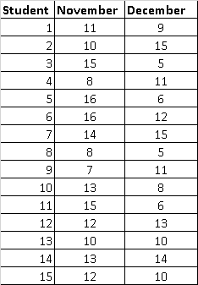
Professor McGonagall was interested in whether or not the “Cloak of Invisibility” affects how much mischief Hogwarts students get into. She allows students in her transfiguration class (N = 15) to each wear the Cloak for one day during the month of November. She records the number of points that students lose for mischief in both November (M = 12, SD = 2.95) and December (M = 10, SD =3.46).
  - What is the IV and levels?
  - What is the DV?
  - Null
  - Alternative
  - One-tailed or two-tailed?
  - Which test?
  - Df and Critical Value:
  - Compute the test statistic.
  - Compare the test statistic to its corresponding critical value. Is the null rejected? If yes, interpret the results.

Of course, Professor Snape has a slightly different theory. He believes that that those no-good Gryffindor students will get into a lot more mischief when compared with his Slytherin students. He compares the mischief points lost by Gryffindor students (n = 10) with the mischief points lost by Slytherin students (n = 10).
- What is the IV and levels?
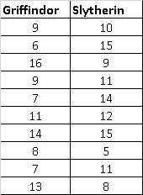
- What is the DV?
- Null
- Alternative
- One-tailed or two-tailed?
- Which test?
- Df and Critical Value:
- Compute the test statistic.
- Compare the test statistic to its corresponding critical value. Is the null rejected? If yes, interpret the results.

Now, Professor Dumbeldore does not like to take sides between his staff, and is actually more concerned with whether Harry and his friends get into more or less mischief than students typically do in the Gryffindor house at Hogwarts (regardless of the Cloak). He knows that students from Gryffindor typically lose 10 points for their house. However, in year 3, Harry, Hermione, and Ron lose an average of 15 points with a standard deviation of 2. Are Harry and his friends more or less mischievous than most Gryffindor students?
- What is the DV?
- Null
- Alternative
- One-tailed or two-tailed?
- Which test?
- Df and Critical Value:
- Compute the test statistic.
- Compare the test statistic to its corresponding critical value. Is the null rejected? If yes, interpret the results.

Boys of a certain age are known to have a mean weight of 85 pounds (sd = 11.6). A complaint is made that the boys living in a state children's home are underfed. As one bit of evidence, 25 boys (of the same age) are weighed and found to have a mean weight of 80.94 pounds.
- What is the DV?
- Null
- Alternative
- One-tailed or two-tailed?
- Which test?
- Critical Value:
- Compute the test statistic.
- Compare the test statistic to its corresponding critical value. Is the null rejected? If yes, interpret the results.

