Question: | 1 | 2 | 3 | 4 | 5 | 6 | 7 | 8
Answer:
Part A. Multiple Choice Questions: Choose only one, most satisfactory answer for each question (6 points each).
- The reserve-deposit ratio of the banks in a country is determined by:
- the country’s central bank.
- the country’s deposit insurance entity.
- business policies of the banks and the country’s laws regulating banks.
- preferences of the country’s households about the form of money they wish to hold.
- An economy’s money supply is ________ to the average reserve ratio of its banks.
- unrelated
- directly related
- inversely related
- ambiguously related (directly or inversely, depending on the situation)
- A bank’s balance sheet shows the following items:
Deposits $1,000
Reserves $ 100
Securities $ 400
Debt $ 500
Loans $2,000

What is the value of the bank’s capital?
- –$1,000
- +$500
- +$1,000
- +$1,500
- In Canada regulators put a floor on bank leverage (capital to total assets) ratio of 5 percent. Suppose a Canadian bank has a leverage ratio of 6 percent and because of a downturn in the economy some of its borrowers default on their loans such that it loses 2 percent of its assets. What would be the bank’s leverage ratio after the defaults?
- 2 percent
- 3 percent
- 4 percent
- 5 percent
- The bank leverage ratios in the U.S. are much lower than in Canada. What is the implication of this differences in leverage ratios for the relative cost of intermediation and the stability of the banking systems in the two countries?
- The cost of intermediation and the stability of the banking systems are lower in the US.
- The cost of intermediation and the stability of the banking systems are higher in the US.
- The cost of intermediation is higher and the stability of the banking systems is lower in the US.
- The cost of intermediation is lower and the stability of the banking systems is higher in the US.
- How does an exogenous increase in the expected future value of the dollar in terms of the euro shift the LM schedule if the real money supply and the real output remain unchanged?
- The shift in the LM curve depends on whether the country has a trade deficit or a surplus.
- The shift in the LM curve cannot be determined.
- The LM curve shifts downward.
- The LM curve does not shift.
- The LM curve shifts upward.
- A short-run decrease in the Chinese money supply that has no impact on the expected future exchange rates leads to
- an appreciation of the yuan in the spot market.
- no change in the value of the yuan in the spot market.
- a depreciation of the yuan in the spot market.
- an appreciation of the dollar in the spot market.
- an decrease in the interest rate on yuan deposits.
- How does an exogenous decrease in the expected future value of the yen in terms of dollar shift the LM schedule in Japan if the real money supply (i.e., money supply divided by the price level) and the real output of the economy remain unchanged?
- The shift in the LM curve depends on whether Japan has a trade deficit or a surplus.
- The shift in the LM curve cannot be determined.
- The LM curve shifts downward.
- The LM curve shifts upward.
- The LM curve does not shift.
Part B. Short-Answer and Algebraic Questions: (The numbers in square brackets give the breakdown of the points for various parts of each question. To receive full credit, please explain your answers.)
- This questions is based on the article, “Signs of a slowdown,” published by The Economist on June 6, 2015 (copied below). The article discusses the trends in the value of the yen and its consequences during 2012 and 2015. The average annual rate of inflation during 2013 and 2014 was 1.55 percent in both the US and Japan.
- Based on the numbers given in the article, how much (approximately) did the yen depreciate in nominal value vs. the US dollar during 2013 and 2014? How much did the real exchange rate of the yen depreciate vis-à-vis the dollar? [7]

- The article points out that global trade the main emerging markets except China and Hong Kong saw weaker exports in early 2015 compared to the situation during the same period in 2014. What are the causes of this sluggishness highlighted in the article? [7]

- According to the article, in the situation prevailing in 2014 and early 2015, central banks have been happy to see their currencies weaken. Why does this lead to exporting deflation to the rest of the world? [5]

- The article states that “QE means that central banks are absorbing an awful lot of new government debt.” How does this help keep sovereign-bond yields low? What are the potential problems that this policy may cause for the world economy? [7]

- This questions is based on the article, “Mario Draghi gets out his big bazooka,” published by The Economist on March 10, 2016 (copied below). The article describes the monetary policies of the European Central Bank (ECB) in 2015 and 2016.
- According to the article, which conventional monetary policy tools (open market operations, discount rate adjustment, and reserve requirement) has the ECB used in 2015 and 2016 to expand money supply and encourage lending? [6]

- According to the article, what are the unconventional monetary policy tools that the ECB has employed in 2015 and 2016 to expand money supply and encourage lending? [8]

- According to the article, what factors motivated the ECB to employ highly expansionary, conventional and unconventional, monetary policies in March 2016? [6]

- According to the article, what impact did the announcement of ECB’s policy changes on March 10, 2016, had on the euro-dollar exchange rate? Did the euro’s value decline or rise initially after the announcement? Was there any direction change in the value of the euro afterwards? What factors in the interest parity condition explain these changes? [6]


Buttonwood
Signs of a slowdown
A weaker yen poses problems elsewhere
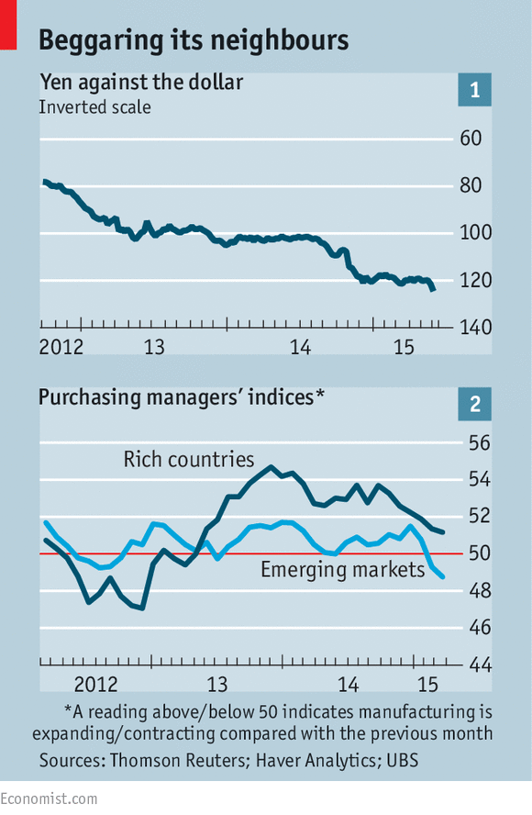
Jun 6th 2015 | From the print edition
THE efficacy of Abenomics, the reform programme of Japan’s prime minister, Shinzo Abe, is a matter of vigorous debate. There have been periods of decent economic growth and higher inflation since Mr Abe became prime minister in 2012, but they have not lasted. Japanese GDP is forecast to rise by only 0.8% this year and headline inflation is just 0.6% (the core rate is even lower, at 0.3%).
Where Abenomics has clearly made a difference is in the value of the yen. At the end of 2012 it was trading at ¥87 to the dollar; this week, it fell below ¥125, a decline of more than 30% in 30 months (see chart 1). That is down to the Bank of Japan’s massive programme of quantitative easing (QE), which involves creating new yen to buy assets; the Bank is printing ¥80 trillion ($644 billion) a year.
A weaker yen creates two challenges for the rest of the world. First, it makes Japanese exporters more competitive and thus weakens the position of rival exporting nations. That is happening at an especially inconvenient time. Over the past three months, all the main emerging markets bar China and Hong Kong have seen weaker exports than in the same period of 2014, according to UBS, a Swiss bank. Global exports fell slightly in May, the first decline in nearly two years.
Some of the recent sluggishness in global trade may be down to changes in the Chinese economy. Chinese manufacturers used to import parts from the rest of Asia and then export finished goods to the rest of the world; now China may be making more of the parts itself. The result is a decline in intra-Asian exports.
That explanation, however, is of scant consolation to other Asian exporters. South Korea’s exports have fallen 11% in dollar terms (although less by volume); export growth in the Philippines has slowed to an annual rate of 1% from 13% in the last quarter of 2014. The purchasing managers’ indices in many emerging markets have fallen below 50, indicating a contraction in manufacturing (see chart 2).
The second challenge posed by the weaker yen is the potential deflationary effect. Cheaper Japanese goods will make it more difficult for competitors to raise prices. Lower commodity prices have led to falling headline inflation rates around the world. Central banks have been cutting interest rates in response. The latest example is India, which reduced rates for the third time this year on June 2nd.
A fall in commodity prices is a benign event for consuming nations, the equivalent of a tax cut that supports demand. Fears of a plunge into deflation in Europe have eased somewhat, with both headline and core inflation now positive. But falling prices for finished goods from Asia could yet have a bigger impact. A broad-based measure of Chinese inflation, the GDP deflator, is now showing falling prices. The prices of goods produced by Chinese factories have been falling for more than three years.
The continued willingness of both the Bank of Japan and the European Central Bank to pursue QE indicates continued concern about weak demand and deflation. In such an environment, central banks are happy to see their currencies weaken. The problem is that this exports deflation to the rest of the world.
For financial markets, however, QE means that central banks are absorbing an awful lot of new government debt. That has helped keep sovereign-bond yields low, despite a recent bout of volatility, which has encouraged investors to buy risky assets and allowed stockmarkets to shrug off weak economic data.
American GDP fell in the first quarter, and early indications for the second quarter are wan: the Atlanta Fed’s GDPNow model suggests annualised growth of just 1.1%. Britain also had a weak first quarter and the euro zone, although recovering, is hardly sprinting: its composite purchasing managers’ index (covering both services and manufacturing) fell in May.
Throw in the weak emerging-market data and it might seem as if the global economy is slowing significantly. But investors remain convinced this a blip. A survey of global fund managers by Bank of America Merrill Lynch in May found that 70% expected stronger economic growth this year, and only 11% thought it would weaken. If recent trends continue, investors may be in for a nasty shock.

Mario Draghi gets out his big bazooka
The European Central Bank fires another salvo
Quantitative easing gets a further boost in the euro area, and interest rates are cut again
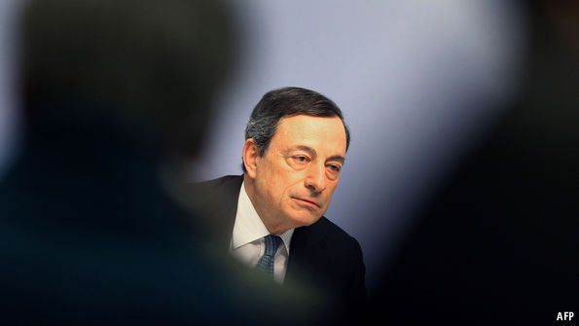
Mar 10th 2016 | Business and finance
A YEAR ago the European Central Bank (ECB) started its big programme of quantitative easing, or QE, buying €60 billion ($65 billion) of assets a month, in an attempt to stimulate the euro area’s sagging economy and prevent deflation setting in. In December it extended the programme by six months, until March 2017. Now it has raised the tempo, to €80 billion a month, starting in April.
This was the most eye-catching of the ECB’s latest set of measures to ease monetary policy, announced on March 10th. In December, it had also reduced its deposit rate, on most funds parked by banks at the ECB, further into negative territory, from -0.2% to -0.3%. Now it has lowered the rate again, to -0.4%, while also cutting its main lending rate from an already nugatory 0.05% to zero. Up till now, the asset purchases have been mainly government bonds, together with covered bonds issued by banks (typically backed by mortgages) and a small amount of asset-backed securities. Now corporate bonds are on the menu, too. The ECB will also conduct four new funding-for-lending operations between June and March 2017, each with a maturity of four years, aimed at boosting credit to the private sector by providing funding on extremely favourable terms.
The ECB is having to do more than it initially envisaged in early 2015 and then in December because growth has been flagging and prices are falling once again. When QE was launched, the recovery that had started in the spring of 2013 was picking up momentum, reaching 0.6% (an annualised rate of 2.3%) in the first quarter of 2015. But that proved to be a (not very) high point and quarterly growth has since ebbed to 0.3% in late 2015 (an annualised rate of 1.3%). The ECB is supposed to keep inflation close to 2%, but deflation has returned. The headline inflation rate sank from 0.3% in January to -0.2% in February. Although the renewed fall in energy prices was partially responsible, “core” inflation, which excludes volatile items such as energy, fell from 1.0% in January to 0.7% last month.
Underpinning the fresh stimulus was a set of new forecasts, which painted a gloomier outlook, especially for inflation, than the previous ones in December. ECB staff now expect the euro area to grow by 1.4% in 2016, lower than the 1.7% projected in December. Mario Draghi, the bank’s president, said that risks to the growth outlook were “tilted to the downside” because of heightened uncertainties about the world economy. The downgrade to the inflation outlook was substantial. Following a year of zero inflation, consumer prices will rise in 2016 by just 0.1% whereas in December they were expected to increase by 1.0%. In 2017 inflation is forecast at 1.3% compared with 1.6% at the end of last year.
Mr Draghi has clearly delivered considerably more than in December, in particular through increasing the scale of monthly asset purchases. The four new funding-for-lending operations may also help, although banks have hardly fallen over themselves to take advantage of an existing programme launched in 2014. But the cut in the deposit rate was overshadowed by Mr Draghi saying that “we don’t anticipate that it will be necessary to reduce rates further.” In fact this is not the first time that he has made such a statement, declaring in September 2014 for example (when the deposit rate was cut to -0.2%) that “now we are at the lower bound”, only for the ECB to lower the deposit rate still further in December 2015 and today. But as worries about the harm done by negative rates to bank profitability have mounted, it seems that Mr Draghi has now drawn a new line.
The ECB’s new measures signal resolve, and that Mr Draghi is still intent on, as he promised back in 2012, doing “whatever it takes” to save the euro. But increasingly, markets are doubting the efficacy of overstretched monetary policy. Foreign-exchange traders responded to the measures by first marking the euro down against the dollar and then up as the impact of Mr Draghi’s words on not lowering interest rates further sank in. Since one of the main ways in which QE has helped the euro-zone economy is through a weak currency, that does not bode well for the success of the ECB’s latest venture.

