TO: Proximity Media Teams
FROM: Fahad Binobaid
DATE: April 27, 2015
Twitter marketing report
Reaching Out to the Millennials via Twitter
Twitter is an online free microblogging and social networking site founded by Biz Stone and Jack Dorsey in 2006. It enables those using it to read and send tweets, which are 140-character short bursts of information. Users can also include in the tweets links having other content and broadcast them either publicly or privately.
Companies and many business firms are nowadays using it as a way of engagement with customers. It offers a free platform for advertising and connection with customers. In order for the brand to be successfully broadcast, the business firms or companies have to understand the use of Twitter so as to build a participatory and listening strategy that will allow a strong connection. It is extremely important that you also add the company’s website before beginning any promotional campaign. The site will act as a platform where the brand is promoted and enables engagement with the followers. Twitter charges companies doing promotion depending on the number of interactions the content generated. A budget is first set before the campaign starts and advertisers pay per retweet or click. A “bidding” system is also used for companies to compete so as to have their content placed on a specific key place.
Twitter launched new product feature numbering about two. The first product feature is the Direct Message functionality which allows groups of at least 20 users to converse privately. Unlike Facebook, which requires multiple app, with this a messaging app is created. These private conversations add a great complement to the widely public platform. Most people prefer viewing Tweets publicly but you the conversation to go private. The second feature product of Twitter is being able to upload videos of utmost 30 seconds lengthwise. Vine was being used previously to upload and share videos.
Topics
• Twitter and Millennials
• Success Rate of Twitter Ads
• Twitter Success Story on Pact Coffee
• Marketing Strategies to use in Twitter
Twitter and Millennials
- All ages are represented in twitter but the Millennials are the majority. Pew Research Centre study did a research that noted that Millennials make up more than half of Twitter users. The research noted that the presence of Millennials on social networking sites averages to more than half of total social networking sites users. Among the Millennials, Twitter usage showed insignificant usage in terms of age, race or gender and ethnicity differences (Centre, 2010).
- Millennials who are college graduates are likely to tweet more often; 9% of Twitter Millennials are those who have not attended college compared to 17% who are college graduates (Centre, 2010).
- Social networks are such as tweeter are an important part of digital lives of many millennials. This because social networks offer more than just a way connect people personal matters. A recent survey showed use of different social network as a pathway to information and news.
- A striking finding is that twitter to greater degree or degree is now a news platform. 49% of twitter users regularly read headlines or news stories posted on twitter. 33% regularly retweet headlines, news stories or story-linking tweets that are posted by other people. People who are active information and news seekers are likely to use twitter for news at least once in a day.
- Most twitter users are likely to compose their own posts that are related to news items instead of sharing news content that is seen on other websites. Thus Twitter’s reputation of real-time news source.
Marketing Strategies to use in Twitter
- In order to publicize an event, promoted tweets or trends are used. Promoted trends give advertisers a pole position because most users more often return to the homepage just to have a look what is trending. According to Adam Bain, who is the president of twitter’s Global Revenue, promoted Tweets and Trends yields customer engagement rates of 3-10% (Wasserman, 2011). 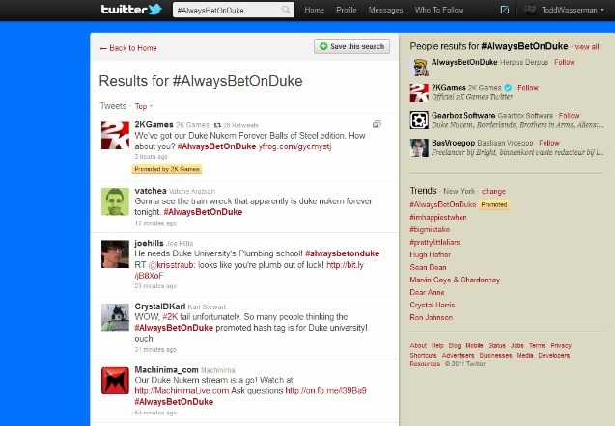
- Targeting devices which suit landing page increases the rate at which people follow your brand. Ensure your website is optimized for use in mobile or else money can be wasted on unnecessary clicks. If you don’t have the mobile version for targeting the mobile users, only focus on the desktop Twitter users.
- Using the functionality of Tailored Audience Campaign in the platform of Twitter Ads produces great success. With this, brands are allowed to create out of potential and existing customers their personal twitter groups and they engage with them using appropriate Ad messages.
Success Rate of Twitter Ads
- Twitter has grown substantially in terms of advertising revenue ever since it started the rolling out of Twitter mobile Ads (OVIDE, 2012). It has surpassed those generated from ads posted on Twitter.com. People with mobile gadgets are most likely to engage through clicking Twitter ads on their gadgets.
- An Ariz based hotel chain called Scottsdale this winter, during the promotion of Lunar New Year, decided to spend 25,000 dollars at the promotion aimed at reaching out to people on Twitter. It posted dining rewards specifically for Twitter users and additionally those who searched the term “Chinese New York” using their phones or desktops. According to the hotel chain over one million online users clicked, engaged or retweeted the Twitter ads. Most of the users were using mobile phones: about 70% of the users.
- Consumers notice ads more often on their mobile phones parts due to fact that they are still novel.
- Advertisements on twitter are an interesting mixture, a blend of paid and earned media. You can purchase a cluster of essential words on Twitter, yet an advanced tweet won't do much unless it resounds with customers and they are propelled to pass it around. From the beginning, Twitter has charged for advanced tweets on what it calls "engagement" or client activity - a retweet, reaction, tap on a connection or when a client denote a post as a "top pick." Marketers don't pay when the tweets go no place. Twitter likewise charges for the first retweet of the first; consequent retweets are "earned" and free.
- Twitter has a tendency to create the most noteworthy "snap rate" of any social stage, yet those snaps need to be assessed with a basic eye, since Twitter checks top picks, re-tweets, picture clicks, and so forth as billable occasions, though different stages just tally taps on the conveyance URL. Subsequently, Twitter change rates (snap to frame accommodation) are normally much lower contrasted with LinkedIn.
Twitter Advertising Tools
- Three devices make up the Twitter "Advance Products" suite. They are Promoted Accounts, Promoted Tweets, and Promoted Trends. These items are genuinely new and extremely extravagant to begin - a passage level crusade will cost in any event $15,000 for a three-month battle - so they're principally being utilized by extensive organizations now. Inevitably Twitter will offer more moderate publicizing alternatives so little organizations can exploit Twitter's prominence and volume of web activity.
- With this one can create a Followers Campaign. This campaign can display a promoted account to mobile and desktop users I several strategic places. These strategic areas include “Who to follow” and at the timeline upon clicking Home. This helps to reach as gain many followers as much as possible.
- Nowadays Twitter Ads enable one to promote his/her tweets directly through their profile. The quick promote is easy and fast way used by SMBs to market in the best way to more potential customers. With this following steps are used:
1. A tweet to be promoted is selected from the best performing ones using the home account dashboard.
2. A budget is chosen from the estimates of engagements received. 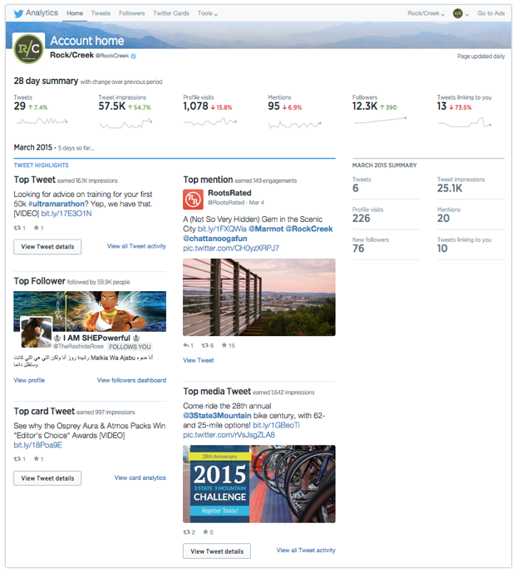
• Clicking through the rates of assessment of a website by entering into the Bitly website, one can be able to track how many people have clicked on it. It has been noted that 47% of twitter followers following a brand are more often likely to go through the brand’s website (Biz, 2007). The more one post leads and drives into that website; the more the Twitter users click through those links. A paid Twitter Ad will measure the number of clicks the web site is receiving within that Ads campaign dashboard.
• Twitter makes it possible for one to track conversations in the platform for the Twitter Ads thus allowing one to hook his/her Twitter campaigns with the website. Tracking behavior of users and engaging or viewing the Ads on the website.
• Monitoring campaign hashtags gives a holistic view of campaign success. The impact and success of the campaign are also achieved through charting of progress against already past performances.
Twitter Success Story on Pact Coffee
- Pact coffee is an online retailer trying to gain customers and build an online community that’s thriving. The pact coffee used the handle @pactcoffee and it wanted to broaden its audience by using twitter as its platform of interaction with the customer and get recommendations.
- The strategy they used to get reach likely interested people in their products @pactcoffee identified accounts that might be influential in areas to deal with food and coffee. They identified an online supermarket such as @ocado and a handle mostly followed by food lovers called @guardianfood. They used the handle @username with the aim of promoting tweets to with their products to twitter users similar to those following these two accounts. 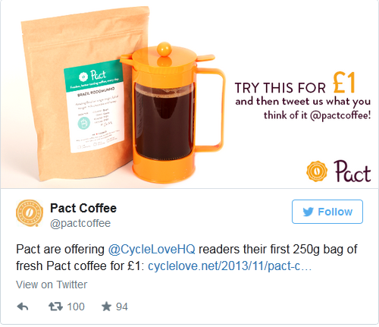 (Rapoport, 2013)
- Over this campaign course, @pactcoffee made significant growth of awareness on their products. It was successful in building a wide online community via their twitter handle. Their engagement rates improved to a peak of 5% and increased retweets too. Their followers’ base increased by 50%.
- The key to @pactcoffee’s success was due to multiple campaigns, real time monitoring and adaption of their campaigns and involvement of community.

References
- Benson, B. (2015, 3 11). New Tools to Make Twitter Advertising Simpler . Retrieved 4 26, 2015, from https://blog.twitter.com/2015/new-tools-to-make-twitter-advertising-simpler
- Biz, T. S. (2007, 4 1). The Value of a Twitter Follower. Retrieved 4 2, 2015, from http://visual.ly/twitter-follower/
- Centre, P. R. (2010, February 3). Millenials: A Potrait of Generation Next. Retrieved April 26, 2015, from Pew Research Centre: http://www.pewsocialtrends.org/files/2010/10/millennials-confident-connected-open-to-change.pdf
- OVIDE, S. (2012, June 28). Twitter's Mobile Ads Begin to Click. Retrieved 4 27, 2015, from Wall Street Journal: http://www.wsj.com/articles/SB10001424052702304458604577491170573156612
- Rapoport, S. (2013, 4 2). Success Stories. Retrieved 4 26, 2015, from https://business.twitter.com/success-stories/pact-coffee
- Wasserman, T. (2011, June 22). 5 Proven Twitter Marketing Strategies. Retrieved April 26, 2015, from mashable.com: http://www.google.com/url?sa=t&rct=j&q=&esrc=s&source=web&cd=6&cad=rja&uact=8&ved=0CEEQFjAF&url=http%3A%2F%2Fmashable.com%2F2011%2F06%2F22%2Ftwitter-marketing-guide%2F&ei=zy09Va7QN8znaPH5gegI&usg=AFQjCNGS87OBxOvqpRWrqpUjd5_ntCoR0w&sig2=I71R3bUbUdC0GLOwCYR

