American Intercontinental University
Legal and Technical Writing
Proposal-Tyrone Armstrong
Professor David Morgan


Table of Contents
Summary 3
Back Ground 3
Problem/Issues 4
Objective 4
Technical Approach Requirements 4
Access 5
Installation 5
Usage 5
Help 6
Conclusion 6
References 7

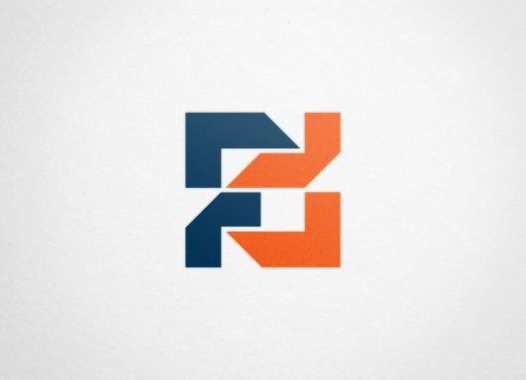
Summary
In today’s business world, there is a real demand for owners to manage every aspect of that business with as little work as possible. In this manual I will discuss the benefits of a new technology device that will manage transactions, employee login and time stamps, by simplifying the current business solutions into one easy to use interface.
Background
Clover is a Point- of- sale system that replaces the traditional point of sett system. Unlike the old model, the Clover system utilizes technology to solve the problem of inefficiency at companies’ retail centers. This point of sale is based on a smart device whose operating system is the much popular android.
Both the Clover POS and the mobile phone applications have beautiful user- friendly interfaces.
The clover system replaces the need for printers, cashiers, and use of paper based receipt system. It is thus eco-friendly. This replacement of the point of sale makes supermarkets and other self-service retail centers true to their ‘self- service’ word.
Clover automatically tracks changes to your transactions, making sure the business person has a customer data bank, while securing customers from the hassles of worrying about hackers.
The Clover system arrives ready to use, with everything loaded on to it that will be needed in normal business transactions. It accepts various modes of payment, actualizing the ‘smart world’ experience.

Problem/Issues
The problem that Strong Arm business is facing is very simple, yet; very common. The use of old POS or Point of Sale devices adds extra work on an already busy day. By implementing the Clover system into the Business, it makes it easier to manage business daily activities.
Objective
The goal of this manual is to explain all applications that can be used within the Clover and how it can assist in making every day business needs easier than ever.
Technical Approach Requirements
- The Clover System POS machine
- Mobile smart phone

Access
- The Clover payment for users is actualized by a mobile app called the ‘Clover mobile’. Clover mobile is downloadable from the various phone company markets such as the “Google Play store’, Apple store, Windows stores among others.
- One can also download the application from the first data website at https://www.firstdata.com/en_us/insights.html
Installation
Clover is a cross-platform application software. It can be installed on any operating systems, regardless of the number of users. The major Operating systems include android, iOS for apple iPhones, Blackberry OS, Microsoft OS, Symbian, Tizen, and Firefox OS among other operating system.
- Download the application from the phone’s authorized store
- Open the download folder and click install.
N/B: Some phones prompt you to install directly from the authorized website.

Usage
Mobile Clover app has an easy learning curve. It can be used with all the major payment portals, has the best technologies that are up- to- date. For example, it can communicate with the clover system and printers through Near Field communication (NFC), Bluetooth and Wi- Fi.
- At the Point- of- sale, open your application on the mobile phone
- Use the scanner feature to scan the products
- Select the favored mode of payment
- Pay and print the receipt.
Alternatively, one can use the Clover system‘s display panel to conduct their transactions. This mode is also as efficient as the smart phone app.
Help
The helplines are available through various forms as listed below
- Website’s Customer Live Chat
- Customer care mobile phone numbers listed on the website
- A helpline email provided on the website.
The helpline modes are efficient and guarantee quality of service.

Conclusion
Implementation of a newer technology will absolutely benefit the business as well as the employer. The usage of this device is simple and easy and is powered by Android technology. This manual will be easy to understand for the older generation as well as the younger.

References
https://www.firstdata.com/en_us/home.html

