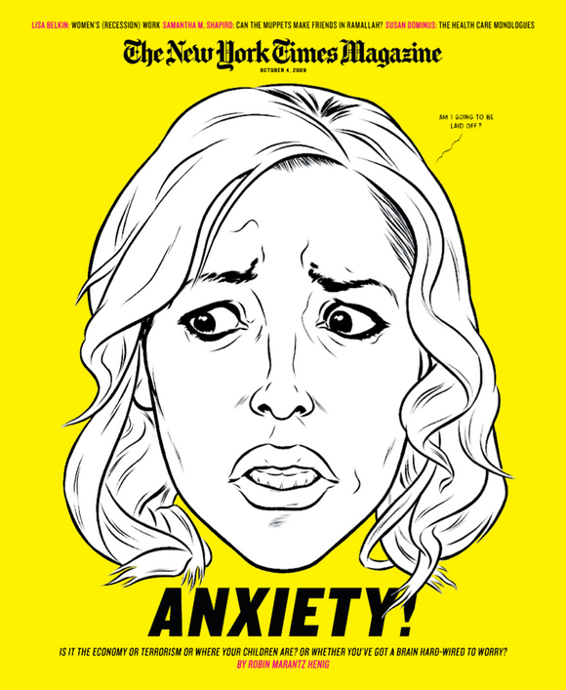In June of this year, The New York Times unveiled a major redesign of their Sunday magazine, the first in almost a decade, and one of only a handful ever in its more than 100 years. Under the leadership of Design Director Arem Duplessis, a more lithe version of the magazine (smaller by about 9% in trim size) has been greeted with much appreciation around the design community for its subtle transitions of typography and color palette that exude new energy while staying true to the NYT Magazine everyone knows and loves (and obsesses about). Almost six months later, with enough issues printed to have some room to look back, we asked Rem to talk with SPD about the redesign process and the modern magazine business at the Times these days. His generous, detailed, honest reporting after the jump...
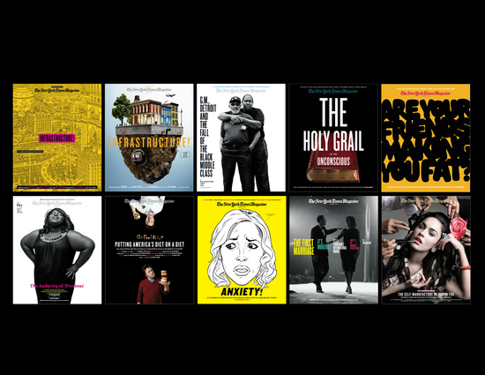You re-worked the Table of Contents then, too?
Our old table of contents was functional (a big picture from the cover story with headlines and page numbers beneath) but was a challenge from week to week. We didn't always have the right photograph, or the cover article was illustration or type, leaving us scrambling for the right image. With the redesign, we created four options for the table of contents to increase flexibility.
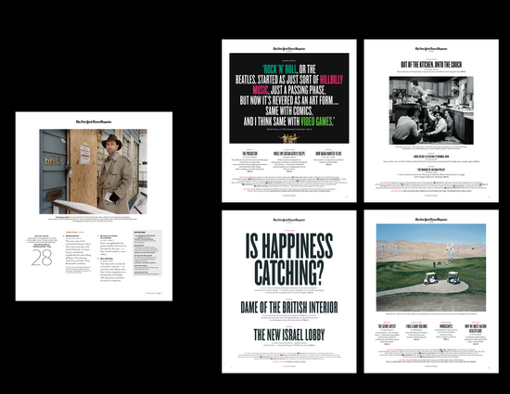(above: before redesign on left; after redesign examples on right)
Tell us about redesigning the front-of-book sections.
In the previous design the first page of our front-of-book section was dominated by a large date. By losing the date we were able to enlarge the name of the section ("The Way We Live Now"), which seems more relevant to the topics we cover in the section. Another important goal was to enlarge the photography that is featured on the opening page. We also integrated a small chart and illustration at the top of the page for visual impact.
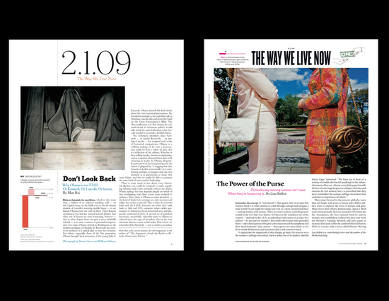
Source: http://www.spd.org/2009/12/behind-the-new-york-times-maga-1.php

