Graph

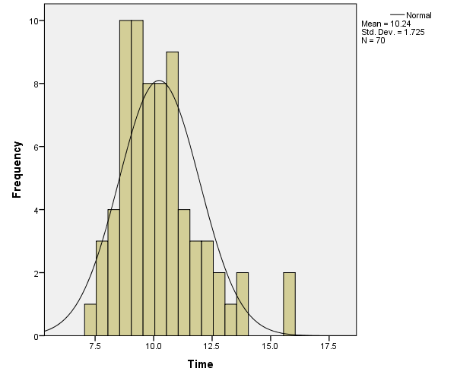

EXAMINE VARIABLES=Time
/PLOT STEMLEAF
/STATISTICS DESCRIPTIVES
/CINTERVAL 95
/MISSING LISTWISE
/NOTOTAL.

Explore

Case Processing Summary
 | Cases
 | Valid |  | Missing |  | Total
 | N | Percent | N | Percent | N | Percent
Time | 70 | 100.0% | 0 | 0.0% | 70 | 100.0%

Descriptives
 |  |  | Statistic | Std. Error
Time | Mean |  | 10.236 | .2061
Time | 95% Confidence Interval for Mean | Lower Bound | 9.824
Time | 95% Confidence Interval for Mean | Upper Bound | 10.647
Time | 5% Trimmed Mean |  | 10.125
Time | Median |  | 9.800
Time | Variance |  | 2.975
Time | Std. Deviation |  | 1.7248
Time | Minimum |  | 7.3
Time | Maximum |  | 15.7
Time | Range |  | 8.4
Time | Interquartile Range |  | 2.1
Time | Skewness |  | 1.057 | .287
Time | Kurtosis |  | 1.438 | .566

Time

Time Stem-and-Leaf Plot

Frequency Stem & Leaf

3.00 7 . 378
14.00 8 . 01345666668889
19.00 9 . 0122444555566666779
15.00 10 . 111233357778899
9.00 11 . 001355778
5.00 12 . 24467
3.00 13 . 266
2.00 Extremes (>=15.7)

Stem width: 1.0
Each leaf: 1 case(s)

* Visual Binning.
*Time.
RECODE Time (MISSING=COPY) (16 THRU HI=11) (15 THRU HI=10) (14 THRU HI=9) (13 THRU HI=8) (12 THRU
HI=7) (11 THRU HI=6) (10 THRU HI=5) (9 THRU HI=4) (8 THRU HI=3) (7 THRU HI=2) (LO THRU HI=1)
(ELSE=SYSMIS) INTO Catagories.
VARIABLE LABELS Catagories 'Time (Binned)'.
FORMATS Catagories (F5.0).
VALUE LABELS Catagories 1 '< 7.0' 2 '7.0 - 7.9' 3 '8.0 - 8.9' 4 '9.0 - 9.9' 5 '10.0 - 10.9' 6
'11.0 - 11.9' 7 '12.0 - 12.9' 8 '13.0 - 13.9' 9 '14.0 - 14.9' 10 '15.0 - 15.9' 11 '16.0+'.
VARIABLE LEVEL Catagories (ORDINAL).
EXECUTE.
FREQUENCIES VARIABLES=Catagories
/ORDER=ANALYSIS.

Frequencies

GRAPH
/HISTOGRAM=Time.
Statistics
Time (Binned)
N | Valid | 70
N | Missing | 0

Time (Binned)
 |  | Frequency | Percent | Valid Percent | Cumulative Percent
Valid | 7.0 - 7.9 | 3 | 4.3 | 4.3 | 4.3
Valid | 8.0 - 8.9 | 14 | 20.0 | 20.0 | 24.3
Valid | 9.0 - 9.9 | 19 | 27.1 | 27.1 | 51.4
Valid | 10.0 - 10.9 | 15 | 21.4 | 21.4 | 72.9
Valid | 11.0 - 11.9 | 9 | 12.9 | 12.9 | 85.7
Valid | 12.0 - 12.9 | 5 | 7.1 | 7.1 | 92.9
Valid | 13.0 - 13.9 | 3 | 4.3 | 4.3 | 97.1
Valid | 15.0 - 15.9 | 2 | 2.9 | 2.9 | 100.0
Valid | Total | 70 | 100.0 | 100.0

