Assessment 3
Case Study – Prepare Comprehensive Income Statement and Statement of Changes in Equity

Fergie Ltd incurs the following expenses and income for the year ended 30 June 2015.
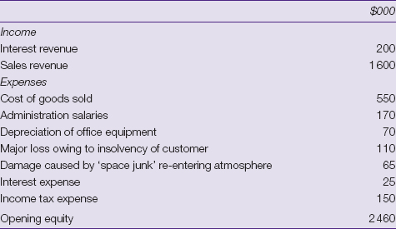
The income tax expense of $150 000 is calculated after considering a tax deduction of $21 450, which related to the damage caused by the space junk. Tax rate is 33 per cent.
During the year there has also been an increase in the revaluation surplus of $80 000 as a result of a revaluation of land of $80 000. The balance of the revaluation surplus at 1 July 2014 was $nil. A new accounting standard has also been introduced, which has a transitional provision allowing initial write-offs to be recognised as a decrease against retained earnings. The decrease against retained earnings amounts to $50 000. Retained earnings at the beginning of the financial year were $1 950 000, and dividends of $200 000 were paid during the financial year. Issued share capital at 1 July 2014 and 30 June 2015 was $510 000.
REQUIRED
Prepare an income statement (in a single statement with expenses shown by function) and a statement of changes in equity in conformity with AASB 101. Provide only those notes that can be reasonably determined from the above information

Assessment Mapping Checklist
Learner Name/ID: ___________________________________
Performance & Knowledge Evidence | C/NYC | Comments
Performance Evidence
- produce a detailed asset register and depreciation schedule
- accurately record entries for balance day adjustments
- prepare financial reports
- trace and reconcile errors systematically or seek expert advice if required
- apply double-entry principles
- complete all tasks according to organisational policies and industry standards

Knowledge Evidence
- explain double-entry bookkeeping principles
- identify general journal and general ledger entries
- list the key provisions of relevant legislation, regulations, standards and codes of practice that may preparation of financial reports
- describe organisational accounting systems
- outline relevant organisational policies, procedures and accounting standards.
- outline typical errors that can be made in processing financial transactions
- describe forms of ‘proof of lodgement’
- describe types of ‘special transactions’
Identify and describe the key features of:
- industry codes of practice
- legislative and regulatory requirements relevant to the work
- organisational policy and procedures
- explain the security procedures for handling cheques, vouchers and cash
- describe the key features of a range of reports.
Comments:
Signed by Learner:  Date: | Signed by Assessor:  Date:

