Assessment 1 - Written Examination
At 30 June 2014, E-Surfboards Limited had the following temporary differences:
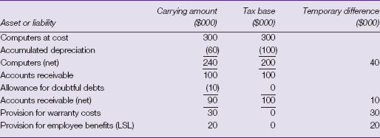
Page 659
The following information is available for the following year, the year ending 30 June 2015.
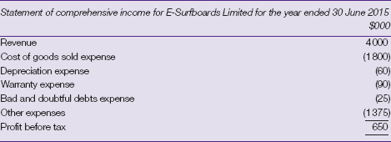
E-Surfboards Limited depreciates computers over five years in its accounting records but over three years for tax purposes. The straight-line method is used. During the year E-Surfboards wrote off bad debts amounting to $15 000. Warranty costs of $70 000 were paid during the year. No amounts were paid for long-service leave during the year. The following information is extracted from the statement of financial position at 30 June 2015:
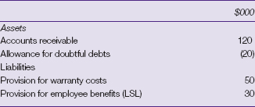
There was no acquisition of plant and equipment during the year.
The tax rate as at 30 June 2014 and 30 June 2015 was 30 per cent.
REQUIRED
(a) | Calculate the amount of each of E-Surfboards' temporary differences, if any, at 30 June 2014, and state whether it is deductible or taxable.
(b) | What is the balance of the deferred tax liability and deferred tax asset, if any, as at 30 June 2014?
(c) | Calculate E-Surfboards' taxable income for the year ended 30 June 2015.
(d) | Prepare journal entries to record current tax and deferred tax for the year ended 30 June 2015
  Assessment Mapping Checklist
  Learner Name/ID: ___________________________________
  Performance & Knowledge Evidence | C/NYC | Comments
  Performance Evidence
  - access and accurately compile data and prepare reports for corporate entities that comply with:
    - relevant accounting standards
    - statutory and other relevant requirements of reporting bodies.
  Knowledge Evidence
  - identify and explain current business taxation requirements
  - identify and explain current financial legislation and statutory requirements relating to taxable transactions and reporting requirements
  - explain the key features of integrated computerised accounting systems
  - describe a range of methods and formats for presenting financial data
  - outline options, methods and practices for recording and reporting deductions, benefits and depreciation
  - identify and explain the key principles of double-entry bookkeeping and accrual accounting
  Comments:
  Signed by Learner:  Date: | Signed by Assessor:  Date:

