The stockholders' equity section of Lachlin Corporation's balance sheet at December 31 is presented here.

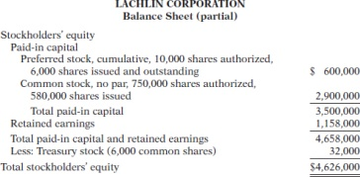

instructions
From a review of the stockholders' equity section, answer the following questions.
(a) How many shares of common stock are outstanding?
(b) Assuming there is a stated value, what is the stated value of the common stock?
(c) What is the par value of the preferred stock?
(d) If the annual dividend on preferred stock is $36,000, what is the dividend rate on preferred stock?
(e) If dividends of $72,000 were in arrears on preferred stock, what would be the balance reported for retained earnings?

