Question 1:
Kid Stars produces stars for elementary teachers to reward their students.
Kid ​Stars' trial balance on June 1​ follows:
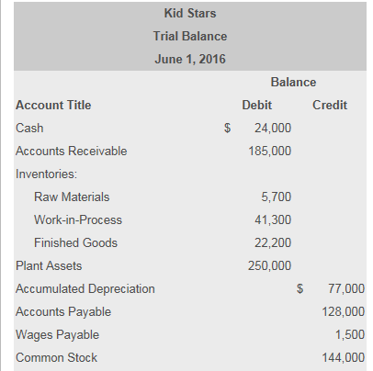
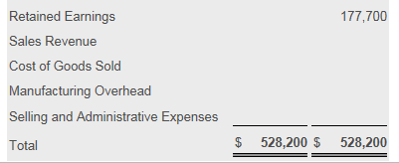

- June 1 balances in the subsidiary ledgers were as​ follows:
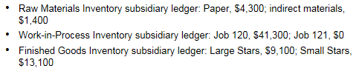

- June transactions are summarized as​ follows:
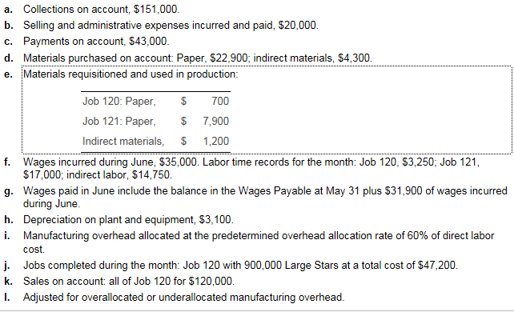

- Read the requirements:
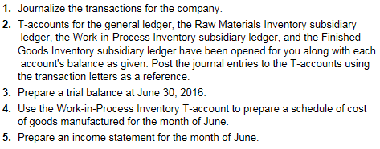

Requirement 1: Journalize the transactions for the company. ​(Record debits​ first, then credits. Exclude explanations from any journal​ entries.)

a. Collections on​ account, $ 151 comma 000$151,000

Date |  |  | Accounts | Debit | Credit
a. |  |  | (1)
 |  |  | (2)
 |  |  | (3)
 |  |  | (4)

b. Selling and administrative expenses incurred and​ paid, $ 20 comma 000$20,000

Date |  |  | Accounts | Debit | Credit
b. |  |  | (5)
 |  |  | (6)
 |  |  | (7)
 |  |  | (8)

c. Payments on​ account, $ 43 comma 000$43,000

Date |  |  | Accounts | Debit | Credit
c. |  |  | (9)
 |  |  | (10)
 |  |  | (11)
 |  |  | (12)

d. Materials purchased on​ credit: Paper, $ 22,900​; indirect​ materials, $4,300
​(Prepare a single journal entry for this​ event.)

Date |  |  | Accounts | Debit | Credit
d. |  |  | (13)
 |  |  | (14)
 |  |  | (15)
 |  |  | (16)

e. Materials requisitioned and used in​ production: Job​ 120: Paper, $700​, Job​ 121: Paper, $7,900​, Indirect​ materials, $1,200 ​(Prepare a single journal entry for this​ event.)

Date |  |  | Accounts | Debit | Credit
e. |  |  | (17)
 |  |  | (18)
 |  |  | (19)
 |  |  | (20)

f. Wages incurred during June​, $35,000. Labor time records for the​ month: Job​ 120, $3,250​; Job​ 121, $17,000​; indirect​ labor, $14,750 ​(Prepare a single journal entry for this​ event.)

Date |  |  | Accounts | Debit | Credit
f. |  |  | (21)
 |  |  | (22)
 |  |  | (23)
 |  |  | (24)

g. Wages paid in June include the balance in the Wages Payable account at May 31 plus $31,900 of wages incurred in June.

Date |  |  | Accounts | Debit | Credit
g. |  |  | (25)
 |  |  | (26)
 |  |  | (27)
 |  |  | (28)

h. Depreciation on plant and​ equipment, $3,100

Date |  |  | Accounts | Debit | Credit
h. |  |  | (29)
 |  |  | (30)
 |  |  | (31)
 |  |  | (32)

i. Manufacturing overhead was allocated at the predetermined overhead allocation rate of 60​% of direct labor cost.

Date |  |  | Accounts | Debit | Credit
i. |  |  | (33)
 |  |  | (34)
 |  |  | (35)
 |  |  | (36)

j. Jobs completed during the​ month: Job​ 120, 900,000 Large Stars at total cost of $47,200

Date |  |  | Accounts | Debit | Credit
j. |  |  | (37)
 |  |  | (38)
 |  |  | (39)
 |  |  | (40)

k. Sales on​ account: all of Job 120 for $120,000
Begin by recording the revenue from the sales on account. Do not record the expense related to the sale in this journal entry. We will do that in the next step.

Date |  |  | Accounts | Debit | Credit
k. |  |  | (41)
 |  |  | (42)
 |  |  | (43)
 |  |  | (44)

Now record the cost of goods sold related to the sale of all of Job 120.

Date |  |  | Accounts | Debit | Credit
k. |  |  | (45)
 |  |  | (46)
 |  |  | (47)
 |  |  | (48)

l. Adjusted for over allocated or under allocated manufacturing overhead.

Date |  |  | Accounts | Debit | Credit
l. |  |  | (49)
 |  |  | (50)
 |  |  | (51)
 |  |  | (52)

Requirement 2: ​T-accounts for the general​ ledger, the Raw Materials Inventory subsidiary​ ledger, the​ Work-in-Process Inventory subsidiary​ ledger, and the Finished Goods Inventory subsidiary ledger have been opened for you along with each​ account's balance as given. Post the journal entries to the​ T-accounts using the transaction letters as a reference.
Begin with posting the transactions to the general ledger accounts. Key each transaction by transaction​ letter, and calculate the ending balance of each account. ​(Post each entry by entering only one debit or credit to each​ T-account affected by the transaction. For accounts with a zero​ balance, enter a​ "0" along with a​ "Bal." reference on the normal side of the​ T-account.)

Review the journal entries you prepared in Requirement 1.
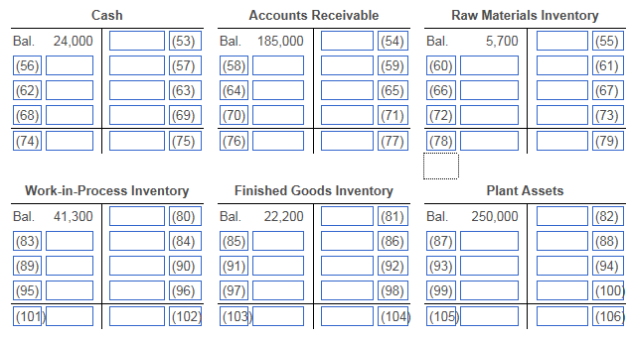
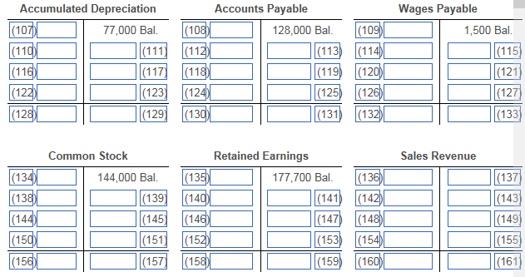
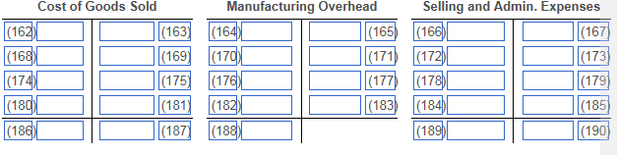

Post the transactions to the Raw Materials Inventory subsidiary ledger accounts. Key each transaction by transaction​ letter, and calculate the ending​ balance, "Bal." of each account. ​(Combine the entries for transaction​ (e) into one​ posting.)
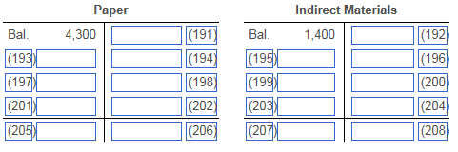

Post the transactions to the​ Work-in-Process Inventory subsidiary ledger accounts. Key each transaction by transaction​ letter, and calculate the ending balance​ "Bal." of each account. ​(For accounts with a zero​ balance, enter a​ "0" along with a​ "Bal." reference on the normal side of the​ T-account.)
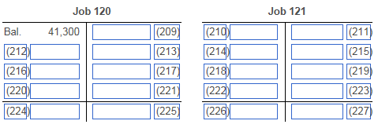

Post the transactions to the Finished Goods Inventory subsidiary ledger accounts. Key each transaction by transaction​ letter, and calculate the ending balance​ "Bal." of each account.
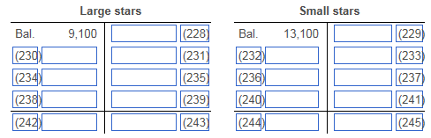

Requirement 3: Prepare a trial balance at June 30​, 2016.
​ (Leave both the Debit and Credit column cells blank for accounts with a zero balance at June 30​.)

Review the general ledger accounts you prepared in Requirement 2.

Kid Stars
Trial Balance
June 30, 2016
 | Balance
Account Title | Debit | Credit
Cash
Accounts Receivable
Inventories:
Raw Materials
Work-in-Process
Finished Goods
Plant Assets
Accumulated Depreciation
Accounts Payable
Wages Payable
Common Stock
Retained Earnings
Sales Revenue
Cost of Goods Sold
Manufacturing Overhead
Selling and Administrative Expenses
Total

Requirement 4: Use the​ Work-in-Process Inventory​ T-account to prepare a schedule of cost of goods manufactured for the month of June.
Review the Work-In-Process Inventory general ledger account you prepared in Requirement 2.
Review the Raw Materials Inventory general ledger account you prepared in Requirement 2.5

Kid Stars
Schedule of Cost of Goods Manufactured
Month Ended June 30, 2016
(246)
(247)
(248)
(249)
(250)
(251)
(252)
(253)
(254)
(255)
(256)
(257)
(258)
Cost of Goods Manufactured

Requirement 5: Prepare an income statement for the month of June.
Review the trial balance you prepared in Requirement 3.
Review the journal entry for underallocated manufacturing overhead you prepared in Requirement 1.6

Kid Stars
Income Statement
Month Ended June 30, 2016
(259)
(260)
(261)
(262)
(263)
(264)
(265)
(266)
Cost of Goods Sold
Gross Profit
(267)
Net Income (Loss)

1: Data Table

Kid Stars
Trial Balance
June 1, 2016
 | Balance
Account Title | Debit | Credit
Cash | $24,000
Accounts Receivable | 185,000
Inventories:
Raw Materials | 5,700
Work-in-Process | 41,300
Finished Goods | 22,200
Plant Assets | 250,000
Accumulated Depreciation |  | $77,000
Accounts Payable |  | 128,000
Wages Payable |  | 1,500
Common Stock |  | 144,000
Retained Earnings |  | 177,700
Sales Revenue
Cost of Goods Sold
Manufacturing Overhead
Selling and Administrative Expenses
Total | $528,200 | $528,200

2: More Info
- Raw Materials Inventory subsidiary​ ledger: Paper, $4,300​; indirect​ materials, $1,400
- ​Work-in-Process Inventory subsidiary​ ledger: Job​ 120, $41,300​; Job​ 121, $0
- Finished Goods Inventory subsidiary​ ledger: Large​ Stars, $9,100​; Small​ Stars, $13,100

3: More Info
a. | Collections on​ account,$151,000.
b. | Selling and administrative expenses incurred and​ paid, $20,000.
c. | Payments on​ account, $43,000.
d. | Materials purchased on​ account: Paper, $22,900​; indirect​ materials, $4,300.
e. | Materials requisitioned and used in​ production:
  Job 120: Paper, | $700
  Job 121: Paper, | $7,900
  Indirect materials, | $1,200
f. | Wages incurred during June​, $35,000. Labor time records for the​ month: Job​ 120, $3,250​; Job​ 121,  $17,000​; indirect​ labor, $14,750.
g. | Wages paid in June include the balance in the Wages Payable at May 31 plus $31,900 of wages incurred during June.
h. | Depreciation on plant and​ equipment, $3,100.
i. | Manufacturing overhead allocated at the predetermined overhead allocation rate of 60​% of direct labor cost.
j. | Jobs completed during the​ month: Job 120 with 900,000 Large Stars at a total cost of $47,200.
k. | Sales on​ account: all of Job 120 for $120,000.
l. | Adjusted for over allocated or under allocated manufacturing overhead.

4: Requirements
1. | Journalize the transactions for the company.
2. | ​T-accounts for the general​ ledger, the Raw Materials Inventory subsidiary​ ledger, the​ Work-in-Process Inventory subsidiary​ ledger, and the Finished Goods Inventory subsidiary ledger have been opened for you along with each​ account's balance as given. Post the journal entries to the​ T-accounts using the transaction letters as a reference.
3. | Prepare a trial balance at June 30​, 2016.
4. | Use the​ Work-in-Process Inventory​ T-account to prepare a schedule of cost of goods manufactured for the month of June.
5. | Prepare an income statement for the month of June.

5: Reference

Raw Materials Inventory
Bal. | 5,700 |  |  | 9,800 | (e)
(d) | 27,200
Bal. | 23,100

6: Reference

l. | Cost of Goods Sold | 6,900
 | Manufacturing Overhead |  | 6,900

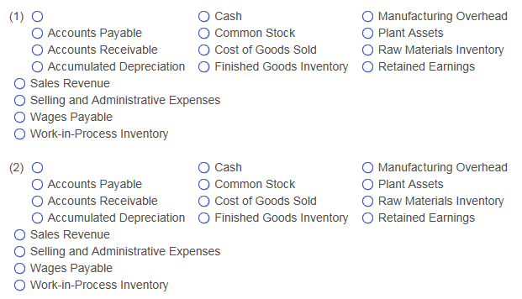
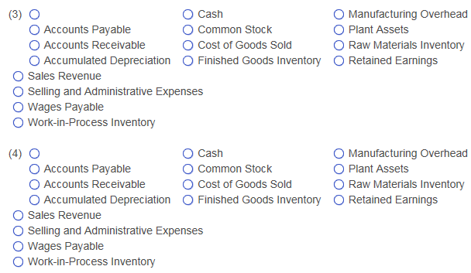
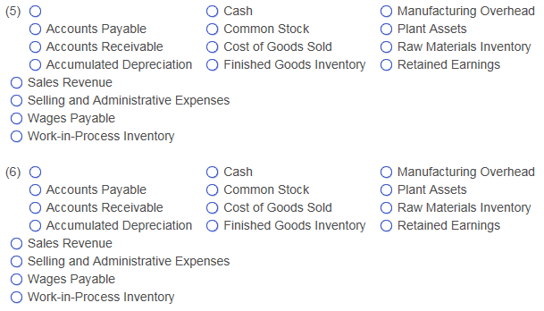
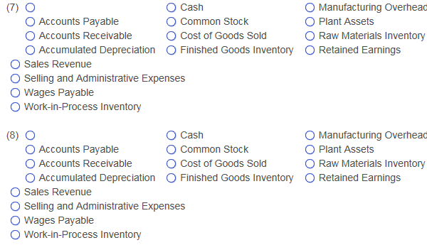
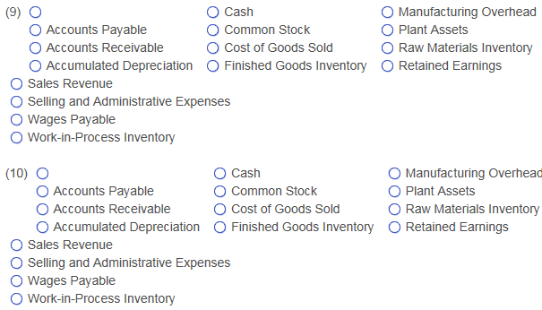
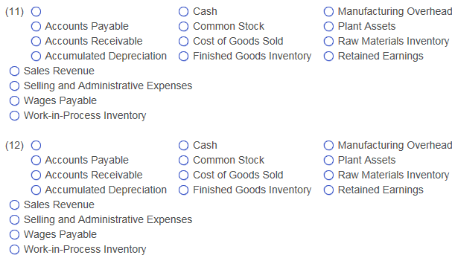
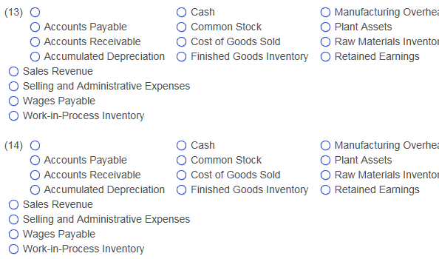
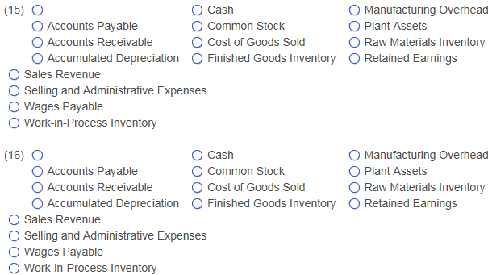
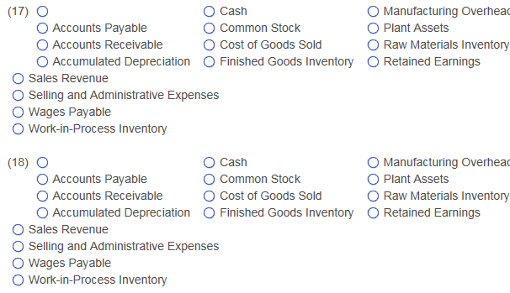
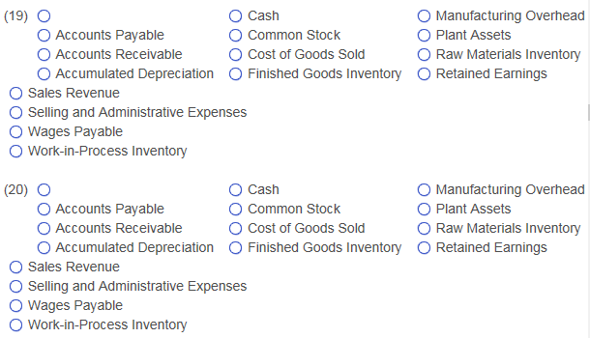
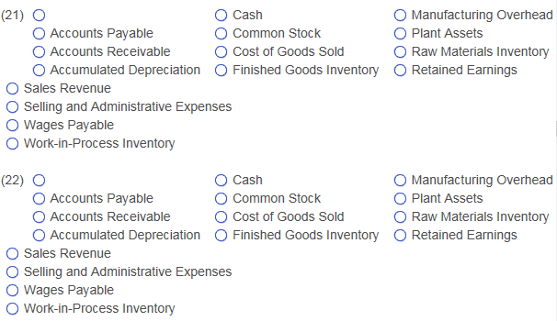
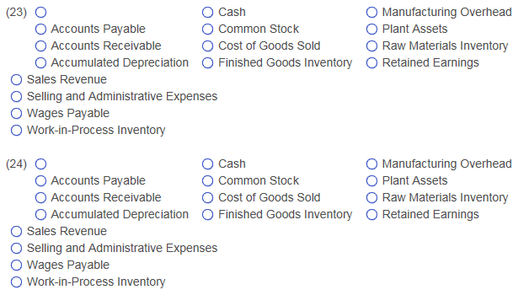
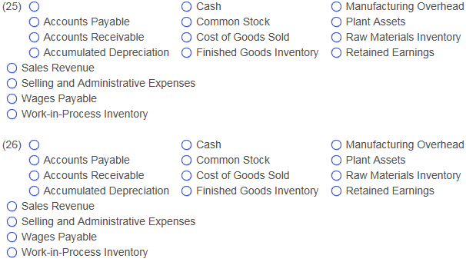
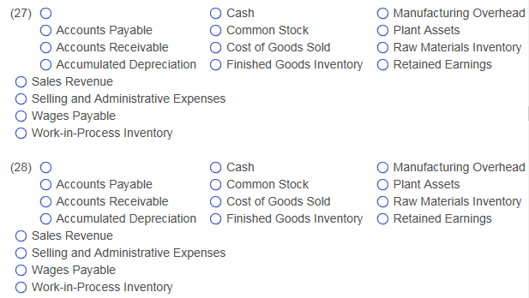
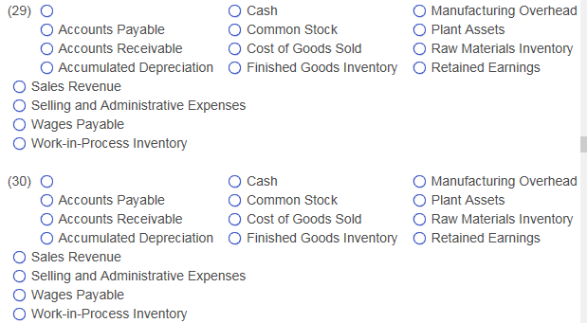
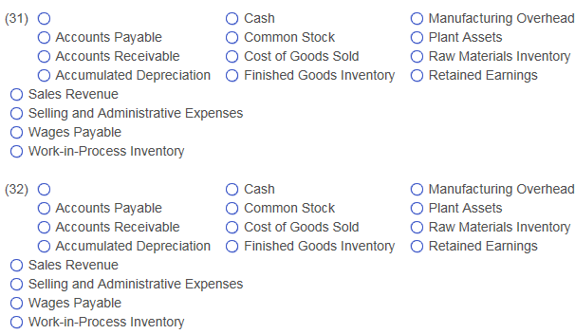
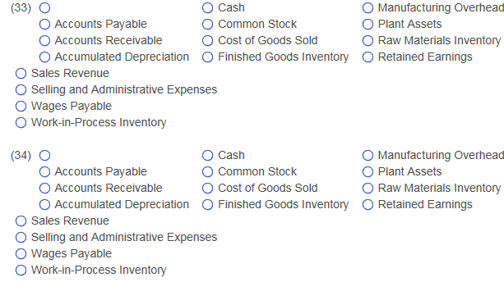
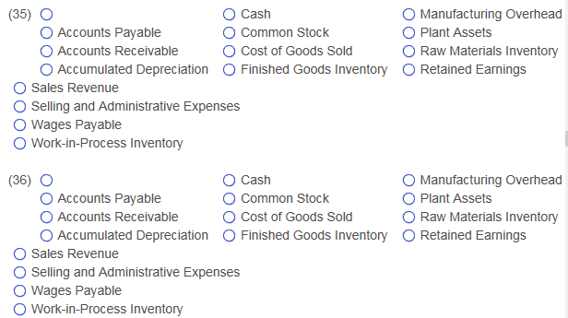
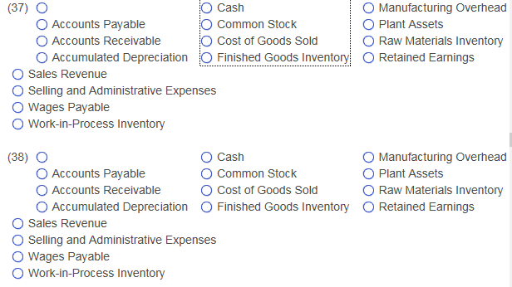
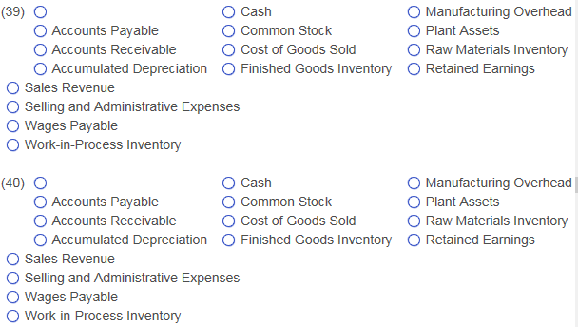
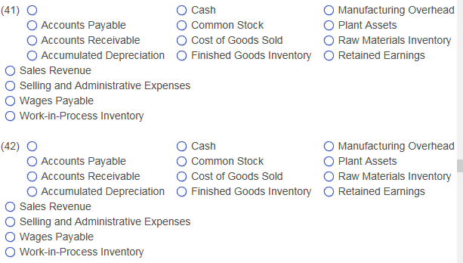
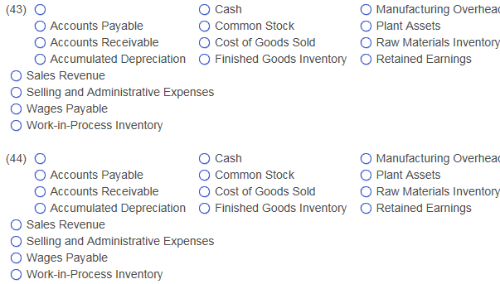
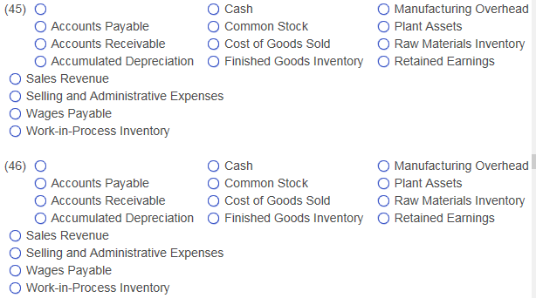
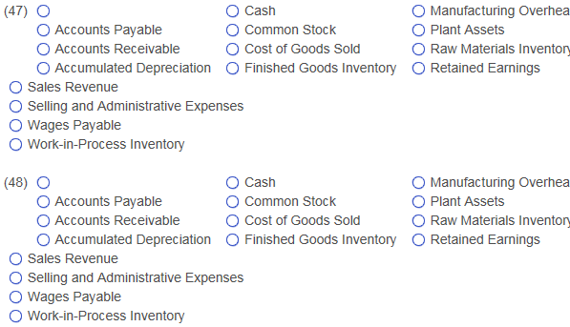
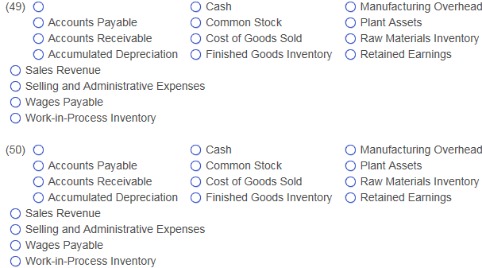
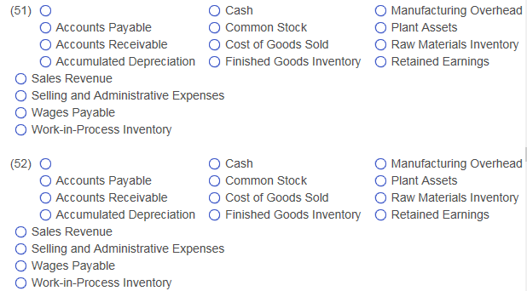
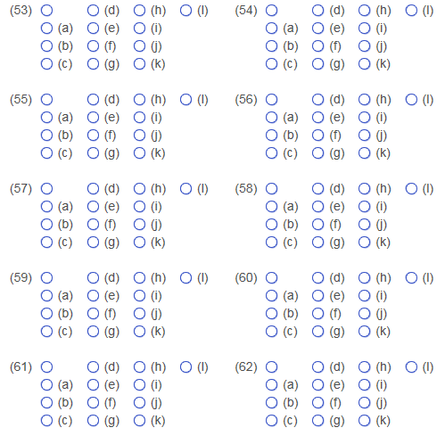
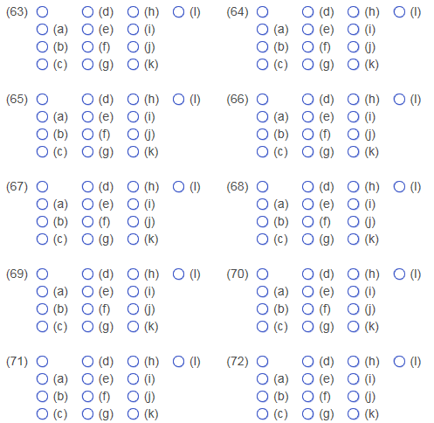
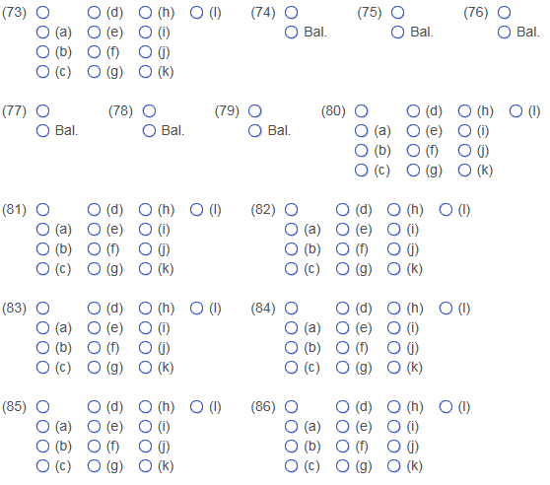
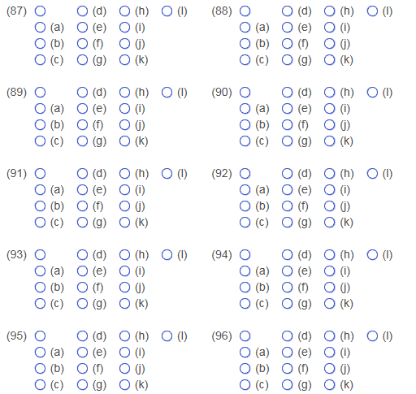
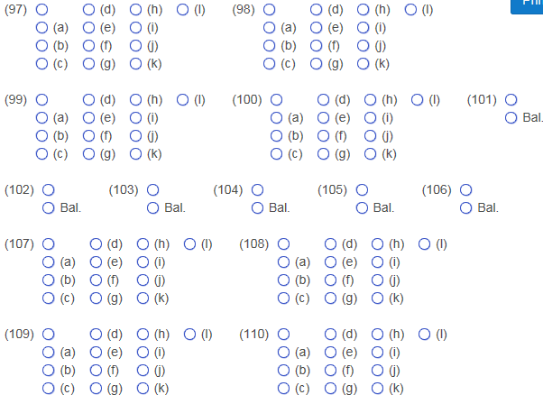
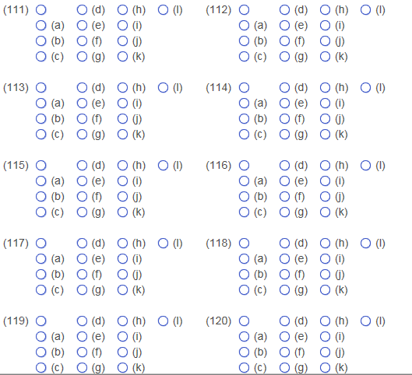
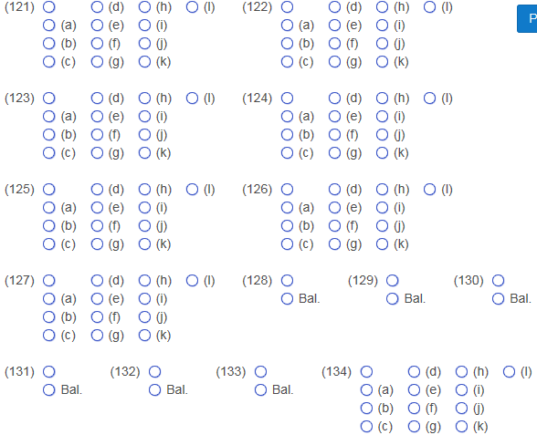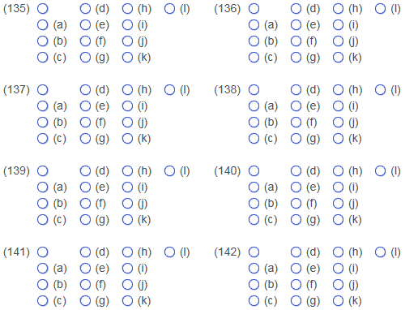
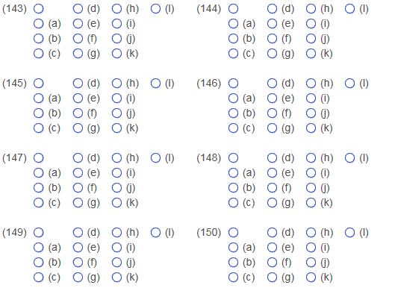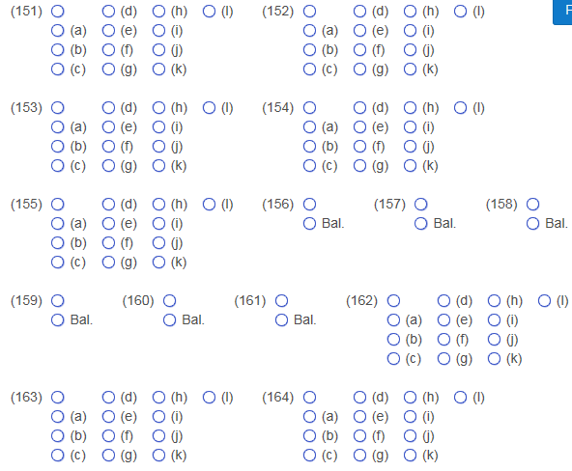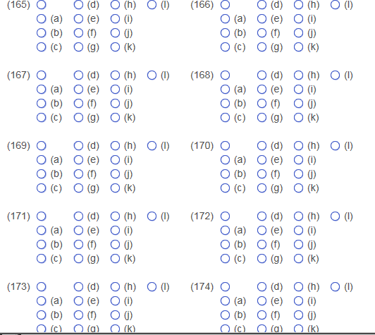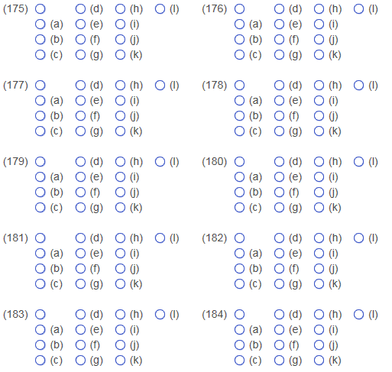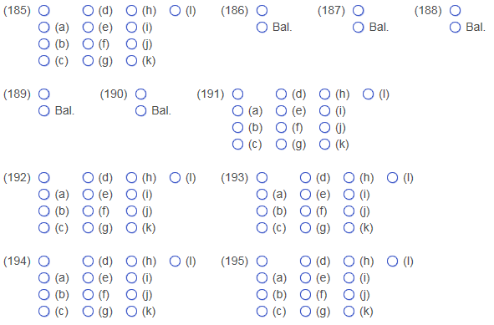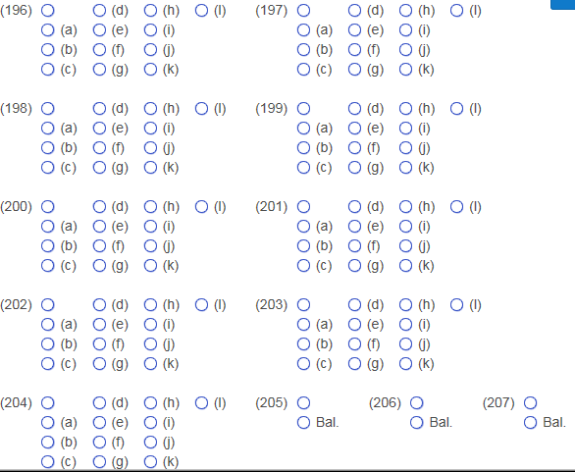
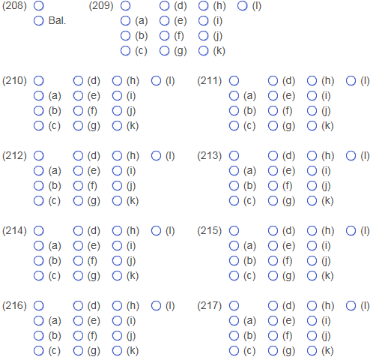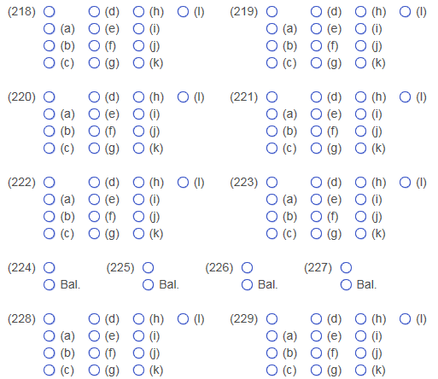
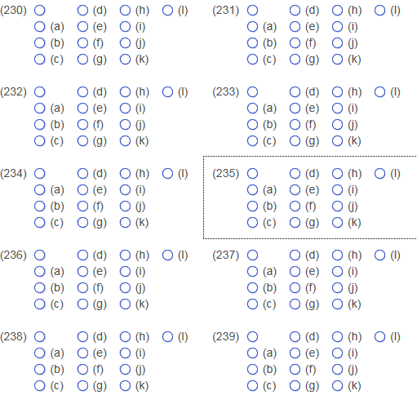
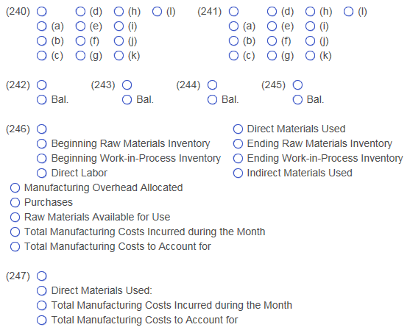
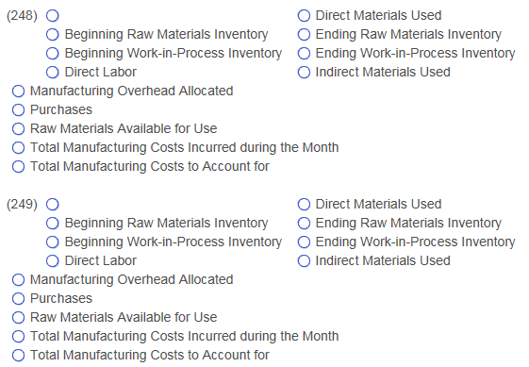
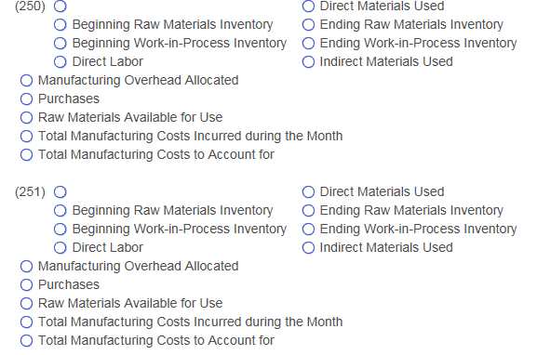
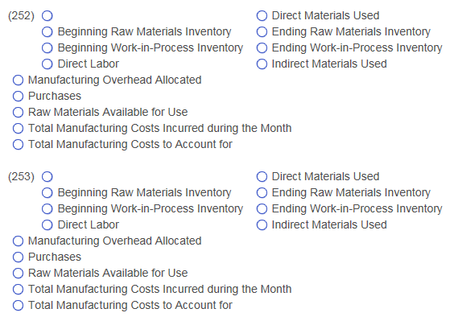
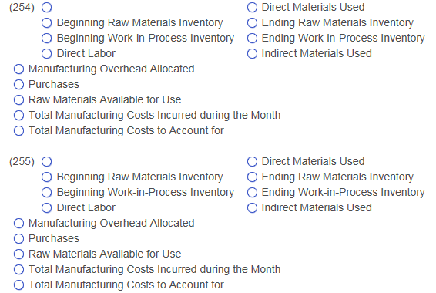
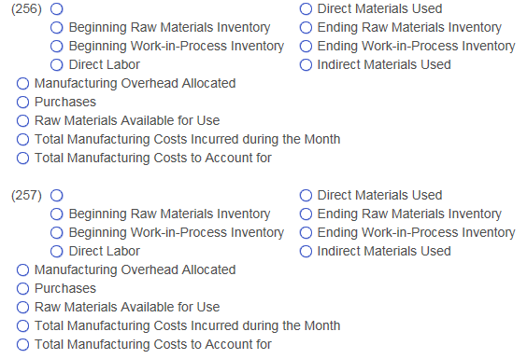
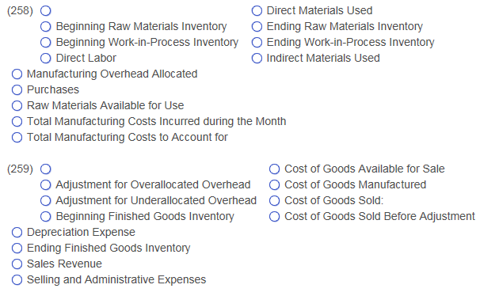
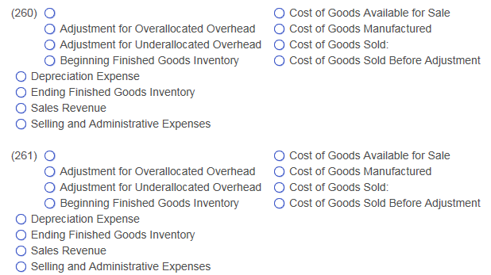
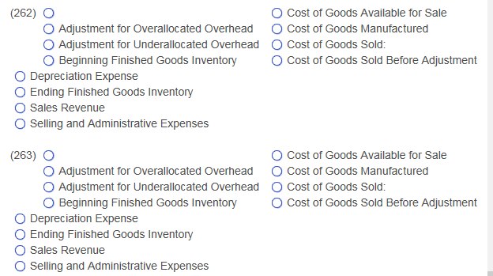
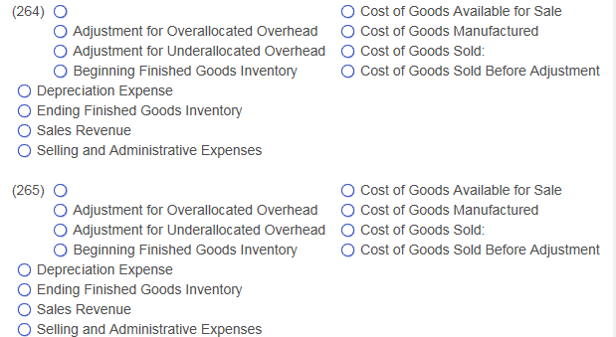
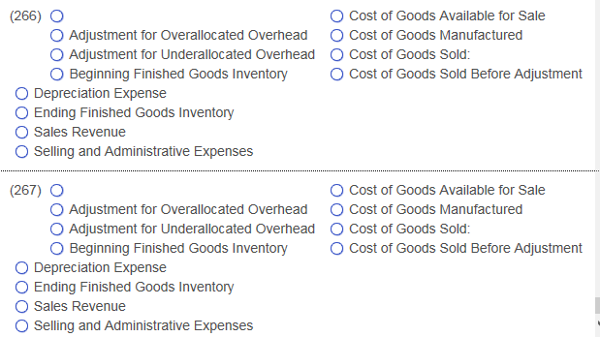

Question 2:
Donnelly Consulting uses a job order costing system in which each client is a different job. Donnelly assigns direct​ labor, meal per​ diem, and travel costs directly to each job. It allocates indirect costs to jobs based on a predetermined overhead allocation rate, computed as a percentage of direct labor costs. At the beginning of 2018, the controller prepared the following budget:
  - Prepared Budget:
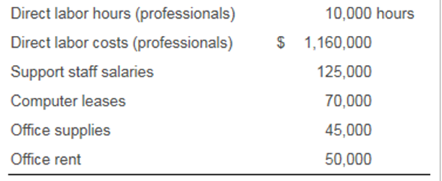

In November 2018, Donnelly served several clients. Records for two clients appear here:

  - Records for Two Clients:
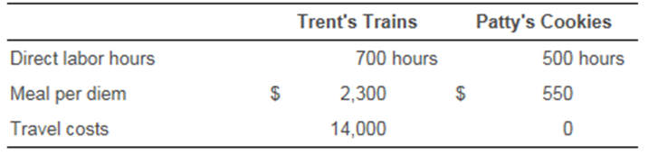
- Read the requirements:

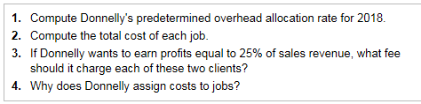

Requirement 1: Compute Donnelly’s predetermined overhead​ (OH) allocation rate for 2018.
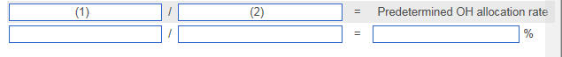

Requirement 2: Compute the total cost of each job.
​First, enter the direct costs for each job. Then enter in the indirect costs and compute the total cost for each job. ​(Complete all answer boxes. Enter a​ "0" for any zero balances. Round all currency amounts to the nearest whole​ dollar.)
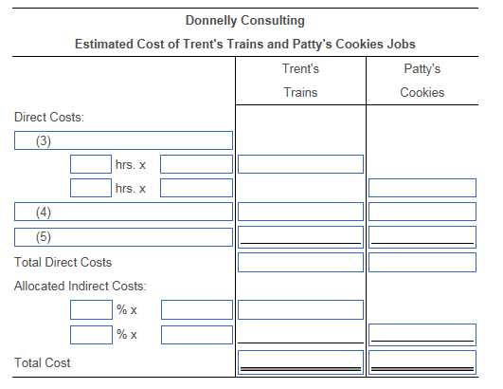

Requirement 3: If Donnelly wants to earn profits equal to​ 25% of sales​ revenue, what fee should it charge each of these two​ clients?​ (Round your answers to the nearest whole​ dollar.)
 | Trent's Trains: | ​$
 | Patty's  ​Cookies: | ​$

Requirement 4: Why does Donnelly assign costs to​ jobs?
Donnelly assigns costs to jobs to help the company (6) that cover all costs and contribute to profit. Assigning costs to (7) also can help Donnelly Consulting to control costs.

1: Data Table

Direct labor hours (professionals) | 10,000 | hours
Direct labor costs (professionals) | $1,160,000
Support staff salaries | 125,000
Computer leases | 70,000
Office supplies | 45,000
Office rent | 50,000

2: Data Table

 | Trent's Trains |  | Patty's Cookies
Direct labor hours | 700 | hours | 500 | hours
Meal per diem | $2,300 |  | $550
Travel costs | 14,000 |  | 0
- 3: Requirements
1. | Compute Donnelly​'s predetermined overhead allocation rate for 2018.
2. | Compute the total cost of each job.
3. | If Donnelly wants to earn profits equal to​ 25% of sales ​revenue, what fee should it charge each of these two ​clients?
4. | Why does Donnelly assign costs to​ jobs?
(1) Actual direct labor costs
Actual direct labor hours
Actual OH costs
Estimated direct labor costs
Estimated direct labor hours
Estimated OH costs
(2) Actual direct labor costs
Actual direct labor hours
Actual OH costs
Estimated direct labor costs
Estimated direct labor hours
Estimated OH costs
(3) Computer leases
Direct labor
Meal per diem
Office rent
Office supplies
Support staff salaries
Travel costs
(4) Computer leases
Direct labor
Meal per diem
Office rent
Office supplies
Support staff salaries
Travel costs
(5) Computer leases
Direct labor
Meal per diem
Office rent
Office supplies
Support staff salaries
Travel costs
(6) Increase labor hours
Lower employee wages
Set fees
(7) A grouping of clients
individual

Question 3:
For each of the following products or​ services, indicate if the cost would most likely be determined using a job order costing system or a process costing system.

a. |  |  |  |  | Soft drinks | (1)
b. |  |  |  |  | Automobile repairs | (2)
c. |  |  |  |  | Customized furniture | (3)
d. |  |  |  |  | Aluminum foil | (4)

e. | Lawn chairs | (5)
f. | Chocolate candy bars | (6)
g. | Hospital surgery | 7)
h. | Pencils | (8)
(1) (2) (3)
Job order costing Job order costing Job order costing
Process costing Process costing Process costing

(4) (5) (6)
Job order costing Job order costing Job order costing
Process costing Process costing Process costing

(7) (8)
Job order costing Job order costing

Process costing Process costing

Question 4:

Carol Carpet manufactures broadloom carpet in seven ​processes: spinning,​ dyeing, plying,​ spooling, tufting, latexing and shearing. In the Dyeing​Department, direct materials​ (dye) are added at the beginning of the process. Conversion costs are incurred evenly throughout the process. Information for November 2016 follows:

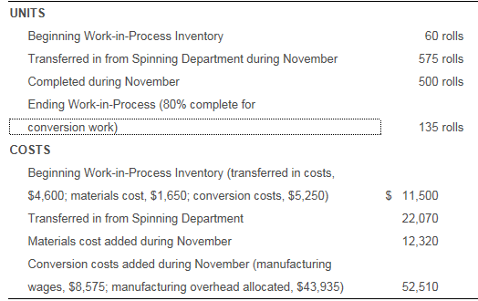

Read the requirements2.
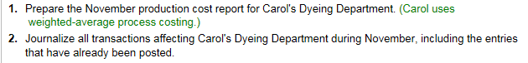

Requirement 1. Prepare the November production cost report for Carol​'s Dyeing Department. ​(Carol uses​ weighted-average process costing. Round all cost per unit amounts to the nearest cent and all other amounts to the nearest whole dollar. Abbreviation​ used: EUP​ = equivalent units of​ production.)

Carol Carpet
Production Cost Report - Dyeing Department
Month Ended November 30
 |  |  |  |  |  | Equivalent Units
 |  |  |  |  | Whole | Transferred | Direct | Conversion
UNITS |  |  |  |  | Units | In | Materials | Costs
Units to account for:
(1)
(2)
Total units to account for
Units accounted for:
(3)
(4)
Total units accounted for

 |  | Transferred | Direct | Conversion | Total
COSTS |  | In | Materials | Costs | Costs
Costs to account for:
(5)
(6)
Total costs to account for
(7)
Cost per equivalent unit

Costs accounted for:
(8)
(9)
Total costs accounted for

Requirement 2. Journalize all transactions affecting Carol​'s Dyeing Department during
November including the entries that have already been posted.

Begin with a summary journal entry to record the assignment of costs transferred from the Spinning​ Department, direct​ materials, direct​ labor, and the allocation of manufacturing overhead to the Dyeing Department. ​(Prepare a single compound journal entry. Record debits​ first, then credits. Exclude explanations from journal​ entries.)

Date |  | Accounts | Debit | Credit
Nov. | 30 | (10)
 |  | (11)
 |  | (12)
 |  | (13)
 |  | (14)
 |  | (15)

Prepare the journal entry to record the cost of the units completed and transferred out of the Dyeing Department.

Date |  | Accounts | Debit | Credit
Nov. | 30 | (16)
 |  | (17)
 |  | (18)
 |  | (19)

1: Data Table

UNITS
Beginning Work-in-Process Inventory | 60 | rolls
Transferred in from Spinning Department during November | 575 | rolls
Completed during November | 500 | rolls
Ending Work-in-Process (80% complete for
conversion work) | 135 | rolls
COSTS
Beginning Work-in-Process Inventory (transferred in costs,
$4,600; materials cost, $1,650; conversion costs, $5,250) | $11,500
Transferred in from Spinning Department | 22,070
Materials cost added during November | 12,320
Conversion costs added during November (manufacturing
wages, $8,575; manufacturing overhead allocated, $43,935) | 52,510
2: Requirements
1. | Prepare the November production cost report for Carol​'s Dyeing Department. ​(Carol uses​ weighted-average process​ costing.)
2. | Journalize all transactions affecting Carol​'s Dyeing Department during November​,  including the entries that have already been posted.
(1) (2)
Beginning work-in-process Beginning work-in-process
Completed and transferred out Completed and transferred out
Ending work-in-process Ending work-in-process
Transferred in Transferred in

(3) (4)
Beginning work-in-process Beginning work-in-process
Completed and transferred out Completed and transferred out
Ending work-in-process Ending work-in-process
Transferred in Transferred in

(5) (6)
Beginning work-in-process Beginning work-in-process
Completed and transferred out Completed and transferred out
Costs added during the period Costs added during the period
Ending work-in-process Ending work-in-process

(7) (8)
Divided by: Total costs accounted for Beginning work-in-process
Divided by: Total EUP Completed and transferred out
Divided by: Total units to account for Costs added during the period
Ending work-in-process
(9)
Beginning work-in-process
Completed and transferred out
Costs added during the period
Ending work-in-process

(10)
Manufacturing Overhead
Raw Materials Inventory
Wages Payable
Work-in-Process Inventory—Dyeing
Work-in-Process Inventory—Plying
Work-in-Process Inventory—Spinning

(11)
Manufacturing Overhead
Raw Materials Inventory
Wages Payable
Work-in-Process Inventory—Dyeing
Work-in-Process Inventory—Plying
Work-in-Process Inventory—Spinning

(12)
Manufacturing Overhead
Raw Materials Inventory
Wages Payable
Work-in-Process Inventory—Dyeing
Work-in-Process Inventory—Plying
Work-in-Process Inventory—Spinning

(13)
Manufacturing Overhead
Raw Materials Inventory
Wages Payable
Work-in-Process Inventory—Dyeing
Work-in-Process Inventory—Plying
Work-in-Process Inventory—Spinning

(14)
Manufacturing Overhead
Raw Materials Inventory
Wages Payable
Work-in-Process Inventory—Dyeing
Work-in-Process Inventory—Plying
Work-in-Process Inventory—Spinning

(15)
Manufacturing Overhead
Raw Materials Inventory
Wages Payable
Work-in-Process Inventory—Dyeing
Work-in-Process Inventory—Plying
Work-in-Process Inventory—Spinning

(16)
Manufacturing Overhead
Raw Materials Inventory
Wages Payable
Work-in-Process Inventory—Dyeing
Work-in-Process Inventory—Plying
Work-in-Process Inventory—Spinning

(17)
Manufacturing Overhead
Raw Materials Inventory
Wages Payable
Work-in-Process Inventory—Dyeing
Work-in-Process Inventory—Plying
Work-in-Process Inventory—Spinning

(18)
Manufacturing Overhead
Raw Materials Inventory
Wages Payable
Work-in-Process Inventory—Dyeing
Work-in-Process Inventory—Plying
Work-in-Process Inventory—Spinning

(19)
Manufacturing Overhead
Raw Materials Inventory
Wages Payable
Work-in-Process Inventory—Dyeing
Work-in-Process Inventory—Plying
Work-in-Process Inventory—Spinning

