NAME
Obsessive-Compulsive Disorder and Trauma-Related Disorders

Directions: Please answer the following questions.

- Please BRIEFLY summarize the diagnostic criteria for Obsessive-Compulsive Disorder.
A
Obsessions are defined by (1) and (2):
1
2
Compulsions are defined by (1) and (2):
1
2
B
C
D

- Common Types of Obsessions and Compulsions. Please complete the chart below. Table 7.2, p. 198
Type of Obsession | Example | Type of Compulsion | Example

- Below are 4 pictures likely depicting 4 different obsessive-compulsive-related disorders. Using information from the textbook, please indicate which disorder is shown AND briefly describe it.
A B C D
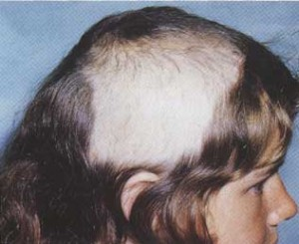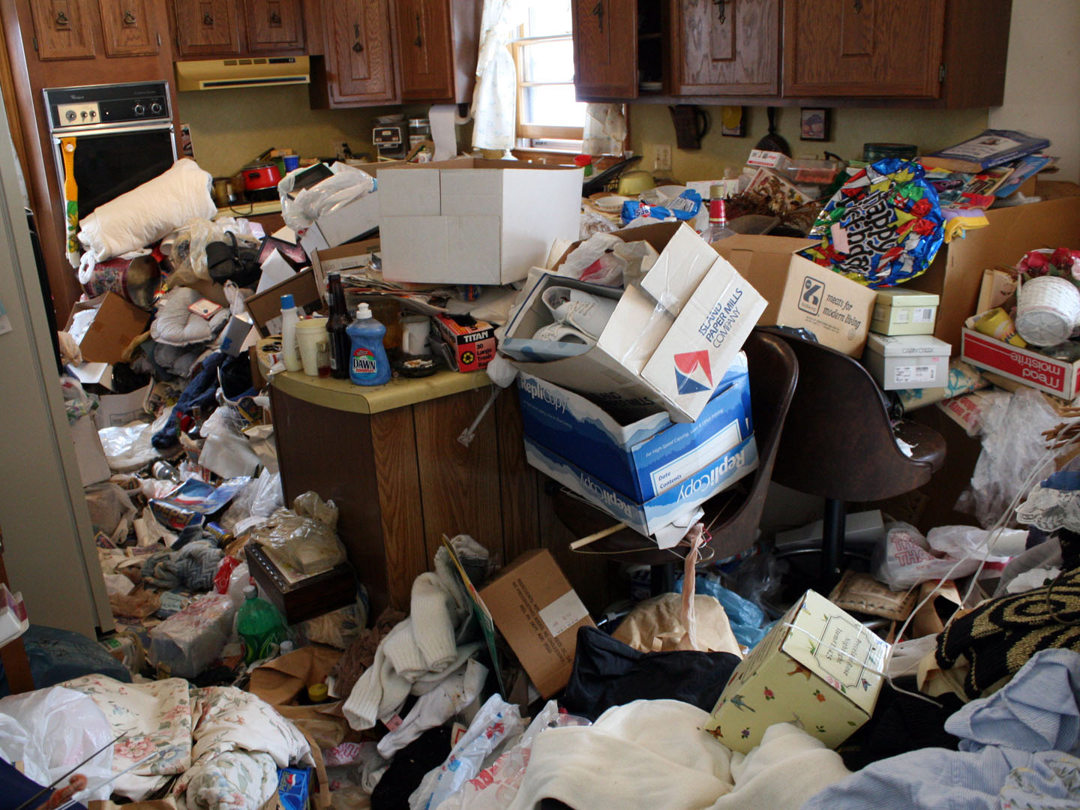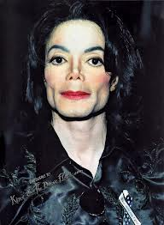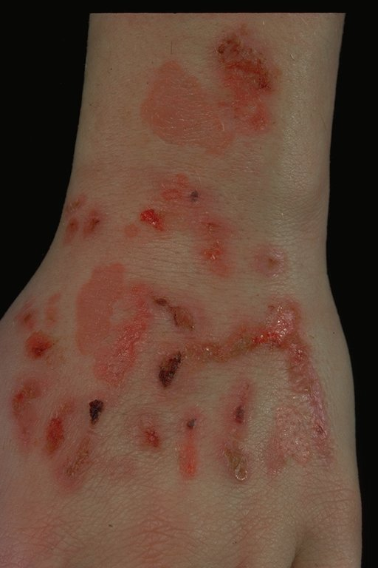

A ENTER ANSWER
B ENTER ANSWER
C ENTER ANSWER
D ENTER ANSWER

- Please BRIEFLY summarize the diagnostic criteria for Body Dysmorphic Disorder
A
B
C
D

Trauma Related Disorders

- Please BRIEFLY summarize the diagnostic criteria for Posttraumatic Stress Disorder.
A
1
2
3
4
B
1
2
3
4
5
C
1
2
D
1
2
3
4
5
6
7
E
1
2
3
4
5
6
F
G
H

- According to the textbook there several factors that affect whether a trauma related disorder will develop following a traumatic event. What are the four factors?

- As you can see, there significant overlap between the diagnostic criteria for Posttraumatic Stress Disorder and Acute Stress Disorder. What is the main difference between these two disorders? (Hint: duration).

- Please complete the Holmes-Rahe Life Stress Inventory (found in the Content Section of Module 5). What have you learned about yourself?

- View the Captain Phillips Trauma Reaction video (found in Module 5 of Content Section). This is a true story about a boat captain who was taken hostage by Somali pirates. Please describe your emotional reactions, and list the symptoms you observe. Based on my clinical experience, this is one of the best depictions of a stress reaction you will see.

