In prior iterations, you have framed your design by providing a list of structural business rules as well as a conceptual ERD. You have also received additional feedback from your facilitator, and have continued augmenting your database skills with additional course material and experience. Your design is well on its way! You are ready to create a logical ERD for your project. Recall that logical ERDs are tied to relational model, and contain primary and foreign key constraints. Further recall that entities are normalized in logical ERDs.

To make sure your logical ERD works both in theory and in practice, now would be a good time to write SQL for the first two use cases, #1a and #1b, required by the project. You will first need to identify and create the tables and data needed to address those use cases. As you begin writing the SQL for these use-cases, you may realize that your design must be altered or enhanced in order to support the data and relationships needed, which is perfectly reasonable.

This work is summarized in the steps below.

- Make any enhancements and corrections to your business rules and provide the updated list below.

- Each patient may see more than one physician; a physician sees more than one patient
- Each patient can be on a waiting list, a waiting list can have many patients
- Each physician has one schedule; each schedule corresponds to one physician
• Each physician works in one building; a building may have more than one physician working
• Each physician has a waiting list, each waiting list is associated with one physician
• Each patient visit is with one physician; a physician may have more than one patient visit
• Each patient visit is with one patient; a patient may have more than one patient visit
• Each insurance plan can be associated with many patients, a patient may have an insurance plan

2. Make any enhancements and corrections to your conceptual ERD and provide the updated ERD below.
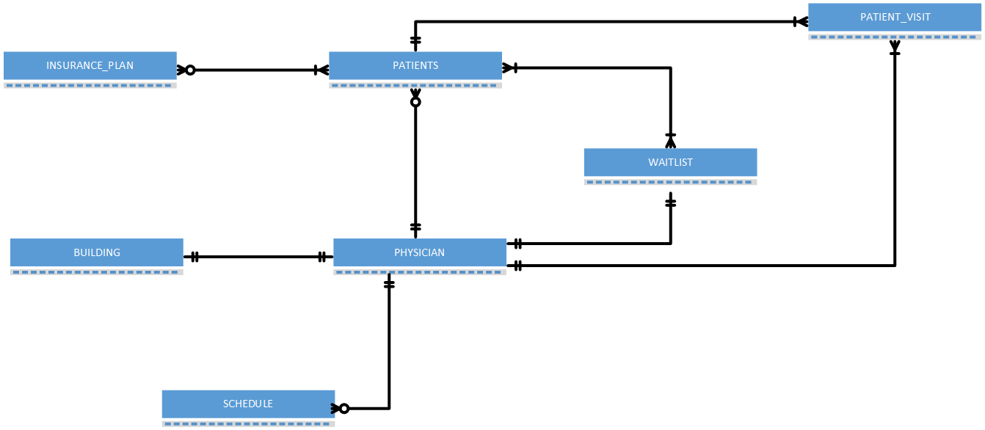
3. Submit a logical entity-relationship diagram for your term project database below.
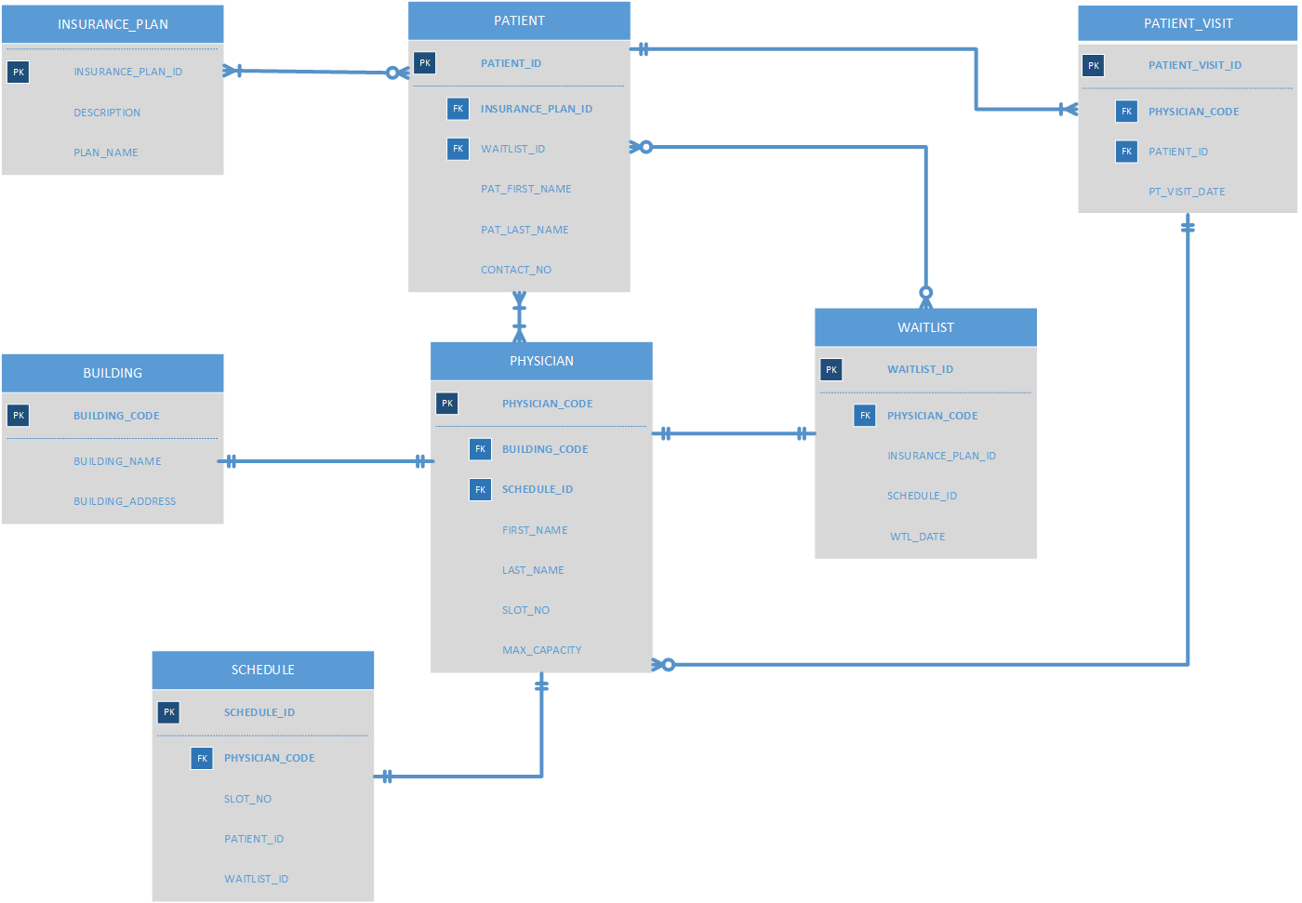
4. Using SQL, create the tables and data needed to address the first two use cases. It is not necessary to provide screenshots of this work. Just provide a list of tables you create and a brief explanation of their purpose.

CREATE TABLE BUILDING – LIST OF THE BUILDINGS WHERE PATIENTS ARE SEEN

CREATE TABLE PATIENT – LIST OF PATIENTS

CREATE TABLE PHYSICIAN – LIST OF PHYSICIANS

CREATE TABLE PATIENT_VISIT – LIST OF PATIENT VISITS WITH PATIENT AND PHYISICIAN INFO

CREATE TABLE INSURANCE_PLAN -PATIENT INSURANCE INFO

5. Write the SQL for the first two use cases. Paste in screenshots demonstrating their execution below.

I’m still working on the tables (as clearly confusing tables above) and building the queries and procedures. I will email that to you as soon as I can.

This iteration is not your final term project submission. You have the opportunity to modify all sections of your term project before the final submission at the end of the course.

Use the Ask the Facilitators Discussion Forum if you have any questions regarding the how to approach this assignment.

Save your assignment as lastnameFirstname_iteration4.doc and submit it in the Assignments section of the course.
For help uploading files please refer to the Technical Support page in the syllabus.

