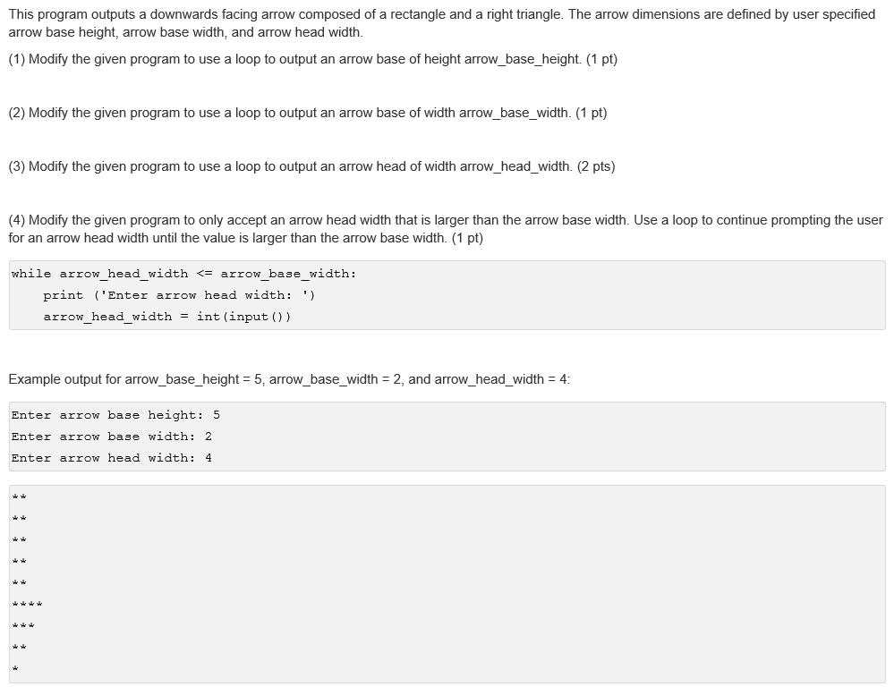

print ('Enter arrow base height: ')
arrow_base_height = int(input())
print ('Enter arrow base width: ')
arrow_base_width = int(input())
print ('Enter arrow head width: ')
arrow_head_width = int(input())

print ('**')
print ('**')
print ('**')
print ('**')
print ('**')
print ('****')
print ('***')
print ('**')
print ('*')

