Name: _________________ _____/50
- This quiz is closed book and closed notes
- No calculators permitted
- Use cell references whenever possible.
- You should only have one answer for each problem on your answer sheet. If you have more, be sure to circle the correct answer or it will not be graded!

EXCEL SYNTAX

Functions
AVERAGEIF(range, criteria, [average_range])  AVERAGEIFS(average_range,criteria_range1,criteria1,…)  COUNTIF(range, criteria)  COUNTIFS(criteria_range1,criteria,…)  SUMIF(range, criteria, [sum_range])  SUMIFS(sum_range,criteria_range1,criteria1,…) | ROUND(number,num_digits)  SMALL(array, k)  LARGE(array, k)  RANK.EQ(number,ref,[order])  SUMPRODUCT(array1, [array2],[array3],…)

  - On the next page is a spreadsheet that contains employee information. The spreadsheet consists of two worksheets.

Employees: This worksheets lists the employee’s name, job title, department, their performance rating, their hourly pay rate, and the average number of hours the employee works per week.

Analysis: You will be using Excel to complete some analysis based on the figures in the Employees worksheet.

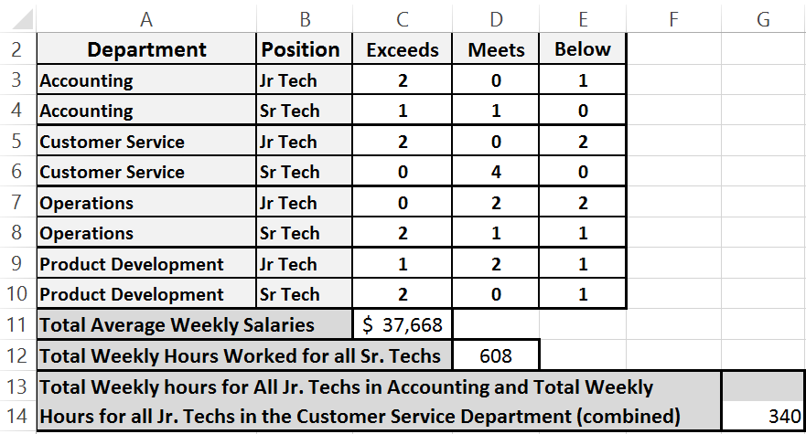
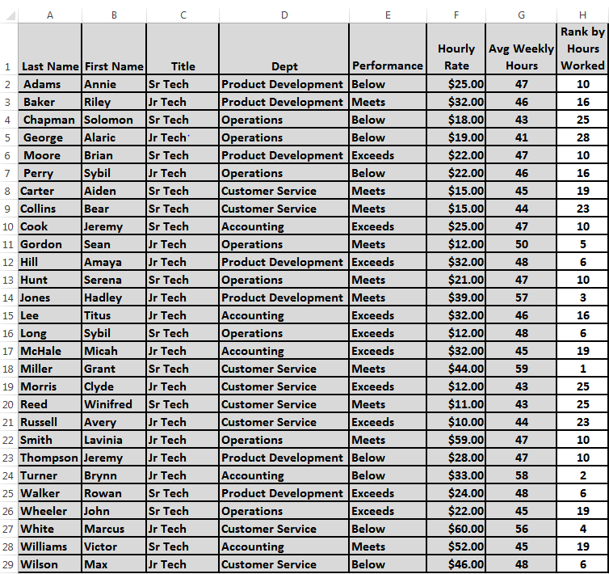
Name_________________________
Analysis
Stats
Employees
Question corrections highlighted in Red.
Name_________________________
- (5 points) Write an Excel formula in cell Employees!H2 , which can be copied down the column, to rank each employee by the average hours they worked (in descending order).

- (15 points) Write an Excel formula in cell Analysis!C3, to determine the number of Junior Technicians in the Accounting department who exceeded in their job performance. The formula should be copied down to cell C10 and over to cell E10, to determine the number based on the respective department, performance, and position.

- (10 points) Write an Excel formula in cell Analysis!C11, to determine the total average weekly salaries of all the employees based on their pay rate and the average number of hours worked.
(Round to the nearest whole number.)

- (10 points) Write an Excel formula in cell Analysis!D12, to determine the total average weekly hours of all Sr. Techs.

- (10 points) Write an Excel formula in cell Analysis!G14, to determine the total weekly for all Jr. Technicians in the Accounting department and all Jr. Technicians in the Customer Service Departments, combined.

